Supplementary ACHD Echo Acquisition Protocol for
Ventricular Septal Defects

The following protocol for echo in adult patients with Ventricular Septal Defects is a guide for performing a comprehensive assessment of this group of patients. It is intended as a supplementary guide to the ISACHD echo protocol and sequential analysis and all regular measurements should be included. It highlights areas of interest in each view specific to unrepaired and repaired VSDs.

Background
- VSDs represent the most common congenital cardiac malformation (approx. 30% of congenital heart defects).
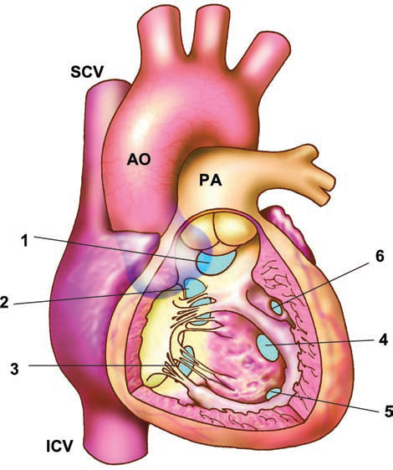
Diagram: Anatomic location of ventricular septal defects (VSD), viewed from the right ventricle.
1 - Doubly committed VSD;
2 - perimembranous VSD
3 - inlet VSD
4 - muscular central VSD
5 - muscular apical VSD
6 - muscular marginal VSD.
SCV - Superior vena cava; ICV – inferior vena cava; AO - aorta; PA - pulmonary artery
Diagram from Popelova et al.
- Depending on the location of the defect within the ventricular septum and the relationship to the membranous septum, perimembranous defects, doubly committed defects (also called supracristal or subarterial outlet VSDs) and muscular defects are distinguished.
  - Perimembranous defects border the membranous septum and represent the most common form (approx. 80%). These VSDs are subaortic and subtricuspid and are characterized by fibrous continuity between the aortic and the tricuspid valve. However, the defect can extend into the inlet or outlet part of the ventricular septum.
  - Muscular VSDs account for approx. 15-20% of VSDs in adults and are completely surrounded by ventricular musculature. They can occur within the inlet, apical (trabecular) or outlet portion of the RV. They may be multiple.
  - Doubly committed or outlet VSDs are characterized by a defect in the fibrous continuity between the aortic and pulmonary valves and are located directly beneath the semilunar valves. Doubly committed VSDs are typically associated with aortic cusp prolapse (usually the right coronary cusp) and AR.
  - Inlet or AVSDs: see AVSD echo protocol.
  - Gerbode defects: deficiency of the atrioventricular membraneous septum and represents a shunt from the left ventricle to the right atrium. These defects can be native or can occur post AVSD repair.
- Disruption of normal aortic valve function, namely regurgitation due to prolapsing of the right or non-coronary cusp is a recognised complication of doubly committed VSDs and also (but less commonly) in perimembranous outlet VSDs.
- A double chambered RV may develop or progress during adult life; especially in perimembranous VSDs. Particular attention is required to not overlook this lesion.
- In cases where VSDs become haemodynamically significant, it is left atrium and left ventricle which are affected by volume overload, in contrast to the right heart overload seen in atrial septal defects.

Common associations
- Left atrial and ventricular volume overload
- Elevated pulmonary artery pressure, or Eisenmenger’s physiology
- Aortic sinus prolapse and aortic valve regurgitation
- Double-chambered right ventricle

Surgical or trans-catheter approaches
- Surgical patch
- Percutaneous occluder

Residual haemodynamic lesions and complications in repaired VSD
- Residual shunt
- Persistent LV dilatation and systolic or diastolic dysfunction
- Residual elevated pulmonary artery pressure
- Residual aortic valve abnormalities and regurgitation
- Double-chambered RV
- Device location and interference with surrounding structures

VSD Haemodynamics

The peak pressure gradient across the VSD is obtained with CW Doppler and is useful in estimating PA systolic pressure (in the absence of RV outflow obstruction) when compared with the patient’s systolic blood pressure. In the absence of LV outflow obstruction, the systolic blood pressure is used as a surrogate for left ventricular systolic pressure. It is important to exclude pulmonary hypertension which can have a significant impact on treatment. This method of estimating RV pressure is particularly useful in cases where the VSD jet is directed towards the tricuspid valve and so contaminates the TR Doppler signal.

RVSP = BP_{systolic} – peak VSD gradient

A restrictive VSD describes the haemodynamic situation of the defect rather than referring to the anatomy. The term is used when a high pressure difference between left & right ventricles is maintained suggesting that RV pressure is normal and so the amount of blood passing through the defect is small.
In adults with increased LV diastolic pressure, left to right shunt may also occur during diastole which can contribute to further left heart volume overloading
Imaging protocol for ventricular septal defect
Subcostal views | - Establish abdominal and atrial situs, cardiac position & direction of apex  - Assess IVC size & collapse to estimate RA pressure  - Hepatic venous Doppler to assess venous flow pattern and flow reversal  - Identification of VSD location and size (perimembranous, muscular, doubly committed)  - Examine for multiple defects  - Retrograde flow in abdominal aorta (in cases where significant AR present)
Parasternal views | - Identification of VSD location:  - 2D & colour Doppler sweeps of entire septum  - PLAX (perimembranous inlet/outlet, muscular)  - PSAX at level of great vessels  - 9-12 o’clock perimembranous VSD  - 12-3 o’clock outlet VSD  - PSAX all levels (muscular VSDs may require atypical views)  - 2D measurement of defect  - Peak CW Doppler gradient of VSD flow to assess RV pressure  - Assessment of Aortic valve cusp prolapse  - Colour Doppler assessment for AR  - Pulmonary valve anatomy & function, degree of PR  - Doppler of pulmonary valve & estimation of PA mean & end-diastolic pressure  - Anatomy of RVOT and main pulmonary artery and proximal branches  - Doppler of RVOT for double-chambered RV (interference of VSD jet may complicate interpretation)  - Assessment tricuspid valve (aneurysmal transformation of VSD, pseudo aneurysm)  - Tricuspid regurgitation. CW for RV systolic pressure (if increased TR velocity, then need to exclude double-chambered RV)  - LV size
Apical views | - Identification of VSD location and size: apical 4 & 5 chamber views (perimembranous, inlet/outlet, muscular)  - Left atrial size  - Detailed LV function assessment.  - Assessment of aortic valve function  - RV size and function  - Assessment of tricuspid valve function and regurgitation (be aware that VSD jets can sometimes be confused with the TR jet depending on VSD jet direction).
Suprasternal views | - Retrograde diastolic flow in descending aorta in the presence of AR.

VSD Reporting
Key points to include in transthoracic echo report:
- VSD
  - Location
  - Measurement
  - Direction of shunting
  - Systolic pressure gradient
  - Presence of diastolic flow >1m/sec suggests diastolic disease
- LV size/degree of dilatation and systolic function
- LA size
- RVSP or mean PA pressure
- Associated lesions specific to type of VSD
- For perimembraneous VSD, aortic valve function
- If associated with a double chambered RV, then gradient within the RV.

Post repair:
- LV size & function as a function of remodelling
- VSD patch/occluder integrity and residual leaks
- Presence of aortic valve regurgitation

Key views specific to VSD patients:

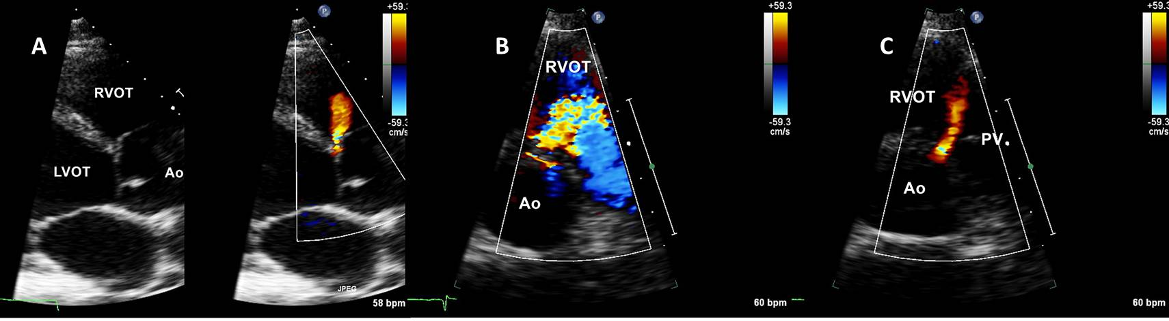
Fig. 1
- parasternal long axis view of a subarterial VSD. Note that the right aorta sinus is already showing signs of prolapse. The flow through VSD shows clearly that the defect is subaortic.
- Parasternal short axis view systolic frame: showing the high jet velocity crossing the VSD and the laminar flow in the RVOT
- Parasternal short axis view diastolic frame: Absent septal tissue between aortic valve and pulmonary valve is characteristic of doubly committed sub-arterial VSD. The jet through VSD is very close to the pulmonary valve. Confirming that it is a subarterial VSD.

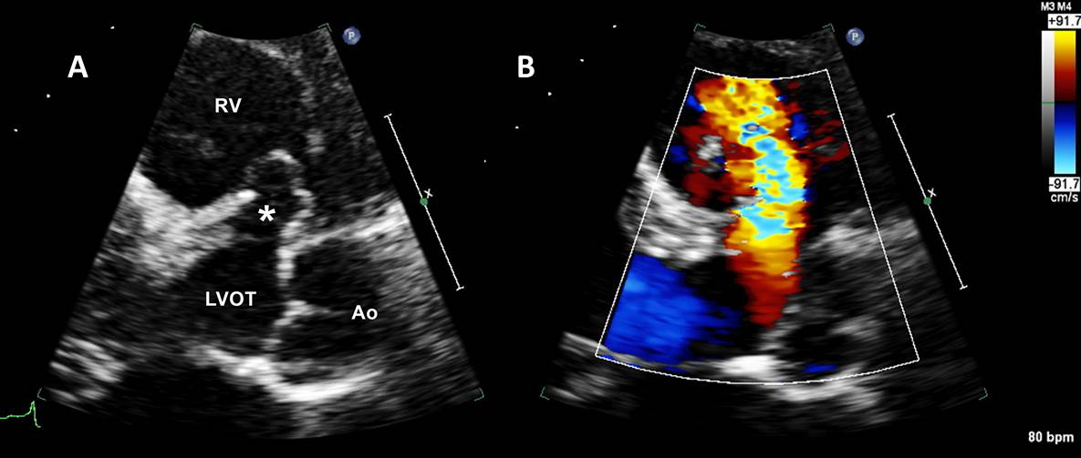
Fig. 2
Parasternal long axis view (zoom mode) showing a perimembranous VSD with:
- aneurysmal formation (pseudo aneurysm), tricuspid valve tissue spontaneously closing the defect.
- high velocity colour flow Doppler through the defect
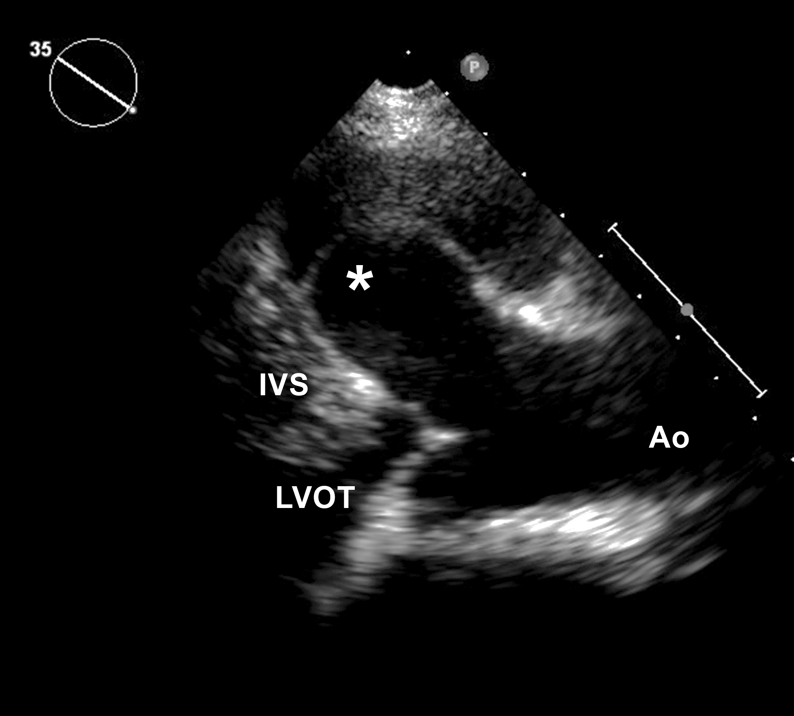
Fig 3
Prolapse of the right coronary sinus (*) through a subarterial VSD sealing the VSD completely.

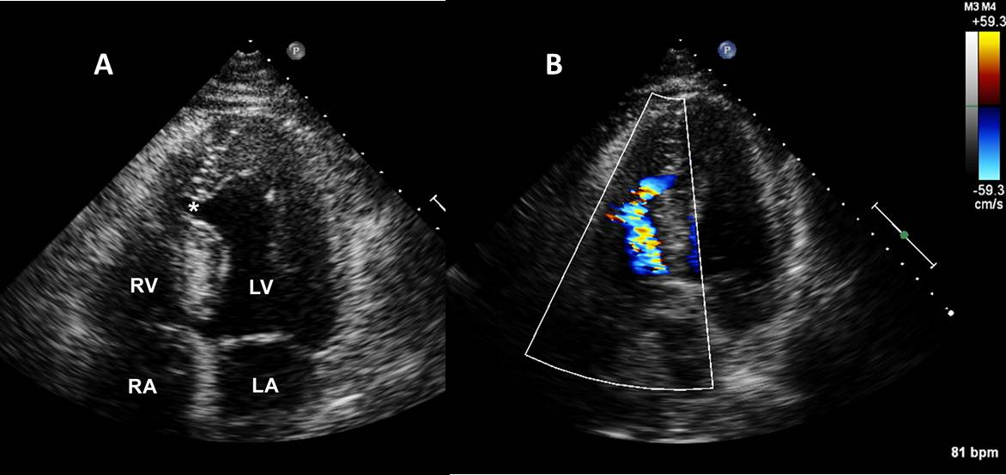
Fig. 4
Apical four chamber view
- Mid-muscular VSD (*)
- High velocity colour flow Doppler through the defect. The direction of this jet can cause problems for the correct interpretation of the CW Doppler from the tricuspid regurgitation.
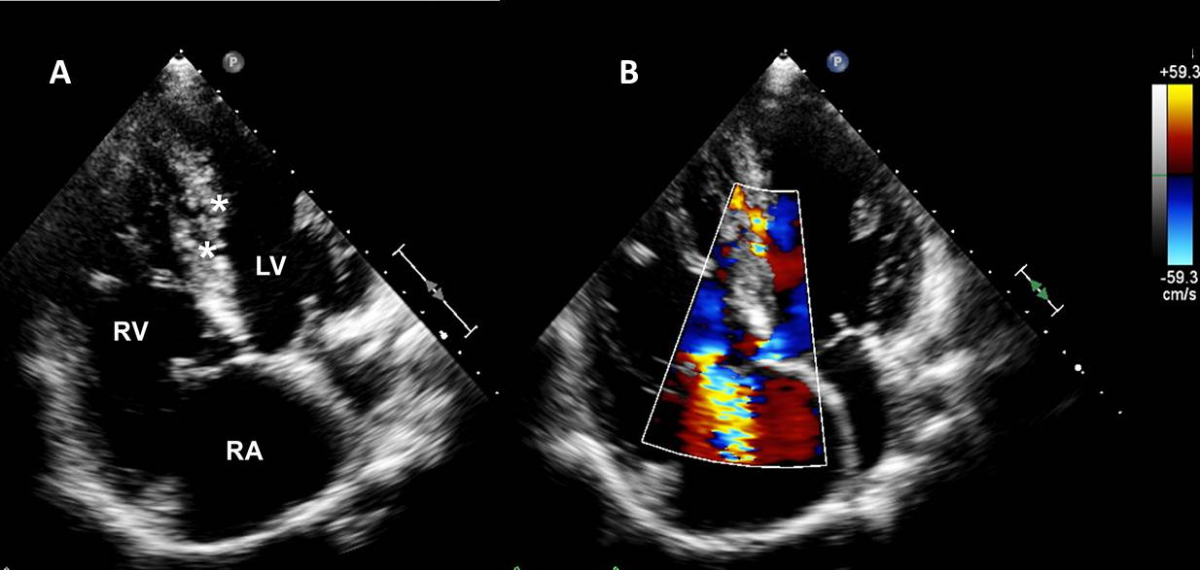
Fig 5
Focused apical RV view
- Multiple mid muscular VSDs (*)
- Colour flow Doppler confirming the defects and showing moderate tricuspid regurgitation.

A B C 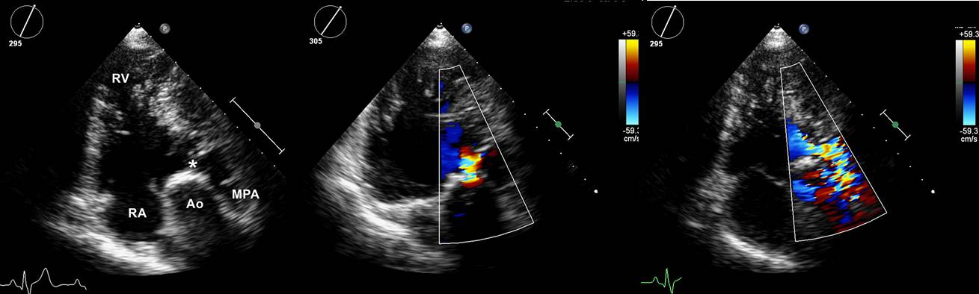
Fig 6. With the use of iRotate this unorthodox view can be acquired
- Gives the landmarks with an asterisk marking a subvalvular narrowing. This results from the jet lesion of a small VSD and form DCRV.
- Early systole the residual VSD jet is seen entering the RV-RVOT
- Late systole high velocity jet from the DCRV obstruction is shown. The severity of the obstruction can also be calculated using the Vmax from the tricuspid regurgitation jet velocity.

