

**Supplementary ACHD Echo Acquisition Protocol for**

*Rastelli repair*

***The following protocol for echo in adult patients with a Rastelli procedure and is intended as a guide for performing a comprehensive assessment of this group of patients. It is intended as a supplementary guide to the ISACHD echo protocol and sequential analysis and all regular measurements should be included. It highlights areas of interest in each view specific to Rastelli repair.***

**Rastelli Operation - Surgical Technique:**

Rastelli operations are performed most commonly in patients with a variety of congenital abnormalities, the common theme being the presence of a ventricular septal defect frequently associated with right ventricular outflow tract obstruction:

* Double outlet right ventricle with a VSD
* Transposition of the great arteries with a VSD
* Truncus arteriosus



**Diagram.** Rastelli operation

*diagram adapted from Popelová et al*

The procedure uses a patch to deviate blood from the left ventricle, across the native ventricular septal defect, to the aorta (which in VA discordance remains in its anterior position). The preoperative location of the VSD is important; VSDs which are committed to the great arteries fare better than remotely located VSDs, which are difficult to use in the re-routing of LV outflow.

Where present, the native pulmonary artery is disconnected proximally and a valved right ventricular to pulmonary artery conduit is inserted. The location of the conduit is usually very anteriorly in close proximity to the sternum, which often necessitates the use of non-standard imaging windows to profile with echocardiography.

**Post-operative Sequelae:**

* LV outflow obstruction
* RV-PA conduit dysfunction
* VSD patch leak
* Aortic root dilatation
* Bi-ventricular dysfunction
* Arrhythmias

**Imaging Protocol**

|  |  |
| --- | --- |
| Parasternal views | * Assess integrity of VSD patch * Exclude LVOT gradient -often better alignment than in apical views due to acutely angulated LVOT. * Use high parasternal views to assess RV-PA conduit as is an extracardiac conduit – it is usually located very anteriorly and requires non standard views. Aim to interrogate both proximal & distal ends of the conduit as it can narrow at either end. It may be useful to palpate for the thrill associated with the conduit stenosis and to place the transducer at that location. * Assess for aortic root dilatation |
| Apical views | * Note serpiginous route of LV outflow, exclude obstruction & assess aortic valve function. * Assess integrity of VSD patch * Ventricular function in the setting of arrhythmias * Obtain RVSP using TR jet. RVSP>2/3 systemic blood pressure suggests significant RVOT obstruction or presence of pulmonary hypertension. |

**Rastelli Repair Report**

Key points to include in transthoracic echo report:

* Clearly state the original anatomy. Rastelli operations can be used for other anatomies as well as dTGA.
* VSD patch integrity
* LV outflow haemodynamics
* Aortic root size
* RV-PA conduit haemodynamics & assess for regurgitation
* Estimate of RV systolic pressure

**Key views specific to Rastelli Repair:**

**Parasternal views:**

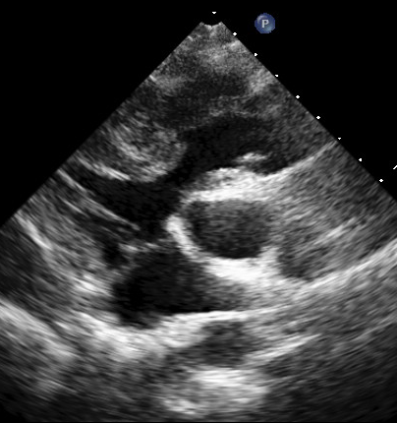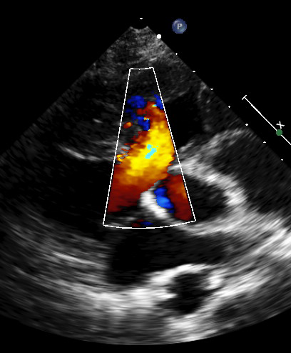

AoV

VSD patch

VSD

Figure 1 The aorta remains in its anterior position and the LV outflow is through the VSD. The LVOT becomes elongated and sometimes acutely angulated. It is important to identify LVOT obstruction using colour and Doppler.

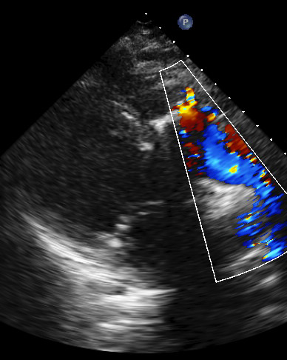

VSD

Figure 2 A residual VSD patch leak. The patch re-routes the flow from the LV to the anterior aorta, and so can be quite long.

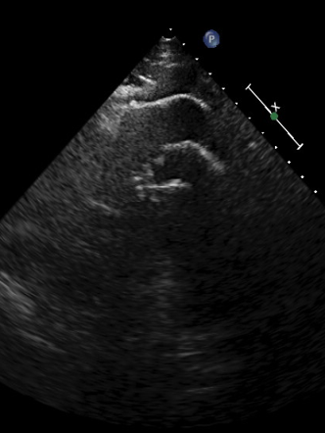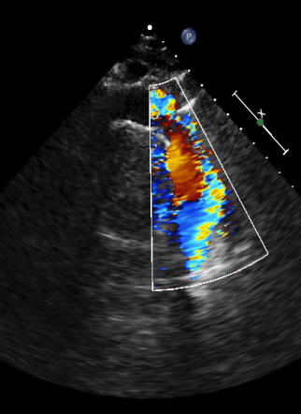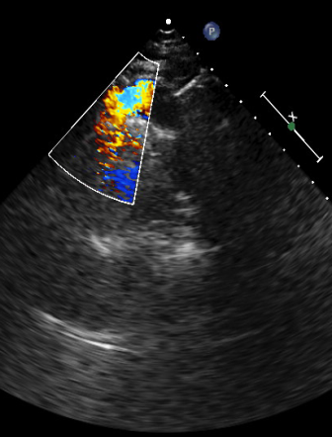

Figure 3 RV-PA conduit: this is usually positioned right underneath the sternum and requires very high parasternal views. The conduit is long and can narrow at either end, hence assessing the length of the conduit is important and may require multiple views as seen here.

**Apical views:**

Figure 4 The elongated LVOT has increased musculature at the VSD site which causes LV outflow obstruction.

