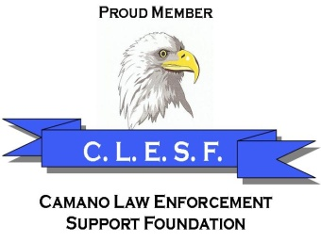
Camano Law Enforcement Support Foundation
P. O. Box 763
Stanwood, WA 98292
________________________________________________

CAMANO LAW ENFORCEMENT SUPPORT FOUNDATION
MEMBERSHIP APPLICATION

Name__________________________________________ Date___________
Phone number: __________________________________________________
E-mail : _________________________________________________________
Spouse’s name ____

Special Interest (check below):
Media Fundraising Marketing Administrative
Other ___________________________________________________________

C.L.E.S.F. holds monthly meeting in the evening. All are welcome.

Camano Law Enforcement Support Foundation--A Nonprofit Public Charity
EIN 90-0669835, UBI# 603-089-676
State of Washington, Secretary of State’s Registration #: 32049
Rev. 1.0 January 2019

