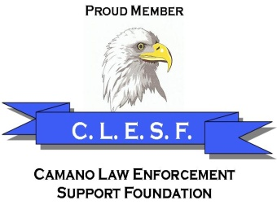
Camano Law Enforcement Support Foundation
P. O. Box 763
Stanwood, WA 98292
________________________________________________

January 2019

The Camano Law Enforcement Support Foundation (C.L.E.S.F.) was established in April 2011 and received the nonprofit 501(c) (3) status in September of 2011. The purpose of the foundation is to operate as a charitable organization for the planning, fundraising, development, implementation, and support of programs and activities for the two Law Enforcement agencies on Camano Island: the County Sheriff’s Office – East Precinct, and the Island’s Washington State Parks.

SOME OF THE ITEMS PURCHASED BY C.L.E.S.F.

1. A gun safe for the Camano Sheriff’s Precinct.
2. An outside storage container for garbage cans and small item storage for the Precinct.
3. Overtook the purchasing of uniforms for the Camano Citizen Patrol volunteers from the Sheriff’s Office.
4. Items for the Citizen Patrol vehicle, such as flash lights, warning light, and G.P.S. unit, phone holster.
5. A portable radar speed indicator (radar unit) for the Park Rangers in 2012 ($3,500).
6. A radar trailer for the Camano Sheriff’s East Precinct in 2014 ($5,700), which is used by the volunteers to place on the public and private streets.
7. Two portable police radios, one as a backup for the Camano Sheriff Precinct, and the other given to the Camano State Park Rangers.
8. A protective “bullet proof vest” for the Camano Sheriff’s Volunteer Chaplain. This chaplain often rides with deputies and is dressed in the same work uniform.
9. A metal detector for the deputies and park rangers in 2015.
10. Purchase of 4 “trail cameras” for deputies and park rangers to “catch garbage dumpers, and thieves”.
11. A State approved breathalyzer for Camano Park Rangers.
12. Christmas “Shop with a Cop” program for 2017 - provided $200.00 each for seven elementary students who participated with a deputy. In 2018 we allocated $1,900.00 for this program.
13. C.L.E.S.F. has sponsored four free basic handgun safety classes, and a female self-defense class including one which is coming up in March 2019.
14. Safety Vests to support “Be visible, Be safe” program – during 2018 we purchased 137 vests costing $1028.26.
15. Holster for new car phone for SCP 740.
16. Viking booster kit (jump starting cars) for SCP 740
17. A sum of $900.00 provided to Deputies and $300.00 to Rangers in the form of Cash Card to help Camano separated family members due to distress.
18. Purchased a Decatur handheld radar gun for park Rangers.

As Citizens of this beautiful island community, we greatly value the dedication of the ten to fifteen enthusiastic members and volunteers serving the community through Camano Island’s law enforcement agencies. This is an opportunity to show our appreciation.

Thank you,
The Board of Directors and members

Camano Law Enforcement Support Foundation--A Nonprofit Public Charity
EIN 90-0669835, UBI# 603-089-676
State of Washington, Secretary of State’s Registration #: 32049

