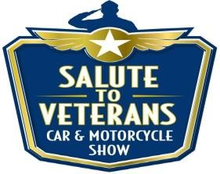
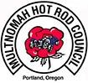
10th ANNUAL

SALUTE TO VETERANS CAR & MOTORCYCLE SHOW
WASHINGTON COUNTY FAIR COMPLEX AUGUST 14th, 2021

RAFFLE REGISTRATION FORM
Deadline Aug. 13th, 2021
Company or Individual Donor______________________________ Contact Name________________________
Phone___________________________Email_____________________________________________________
Address______________________________________City_______________________________St______Zip_________

 | Raffle Donation Items
Quantity | Item Description | $ Value

Signature_________________________________________ Date____________________

Notes:_________________________________________________________________________________________________________________________________________________________
Please email this form to lynnkirwan1@comcast.net
or mail to Veterans Car & Motorcycle Show Or 4931 SW 76th Ave. #151 Portland 97225

Questions: Contact Lynn (503) 780-4679 email: lynnkirwan1@comcast.net
501 (c) 3 # 83-2091271

