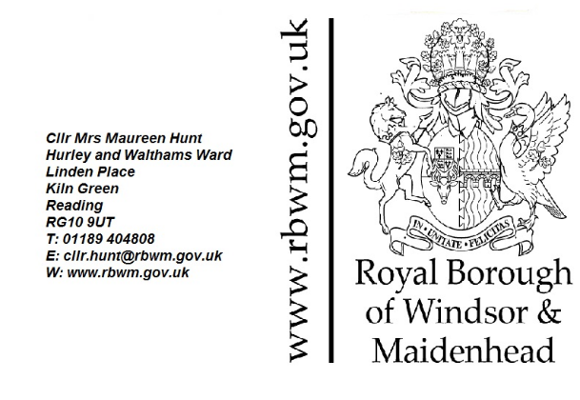

JOINT CENTRAL AND EASTERN BERKSHIRE WASTE AND MINERALS PLAN REGULATION 18 CONSULTATION
OCTOBER 2018
Response in Objection to the proposed continuation of waste collection and treatment with potential recovery operations and increase in capacity
For:
GRUNDON SITE AT KNOWL HILL

11TH October 2018

Dear Sir
I am one of the Borough Councillors for the adjoining Ward in which this site is located. The site is on the boundary between Wokingham and The Royal Borough of Windsor & Maidenhead.

I write this letter in strong objection as the site is in Green Belt, it is too close to residents, the access is very narrow for the HGV’s and the double decker HGV’s and the type of operation involving waste treatment is not conducive for this location. There is also a vehicle operating license at the site.

As each operation is considered separately there has not been an assessment of the full impact of the cumulative traffic throughput in Star Lane accessing this site. The width of Star Lane access is mentioned below.

As recommended for waste facilities ‘All waste treatment facilities are compatible with industrial estates’ i.e. not near residential dwellings.
Waste sites should be located well away from residential properties where they have a detrimental impact on the quality of life for residents (as it currently does in Knowl Hill) due to pollution, noise impacts and vehicle movements. As Knowl Hill is a residential village in the green belt, waste facilities should not be located near residential properties. The effects of an increase in capacity at the site would be a substantial increase in odours, vehicle noise, light pollution, pests, and importantly the impact on family life.

Any extension to this site will negatively impact on the flora and fauna of the six local wildlife sites, the ancient woodland and the protected species.

The sites inclusion for an increase in waste treatment must be looked at pragmatically and its past record should be noted.

Unfortunately, the site has a long history of detrimental impact to residents in parts of my Ward due to environmental issues.
I must stress that the site is in very close proximity to many residents in Knowl Hill and due to the prevailing winds odour is carried over many miles in these rural parts.

Past and Current detrimental issues for residents

I have been involved since 2007 shortly after I was elected, as residents were complaining of the dreadful smell urine and rotting materials coming from the site and the noise from the landfill. During July of that year they were subjected to the overwhelming smells from the landfill.

There are two operations concerned with waste on the site – landfill and waste treatment which was done by Hydroclaves (the largest in the world at that time).
The landfill – in July 2007 there was a huge landslide of waste from a prepared cell into an unprepared cell. This caused monumental problems for residents as the smell was pretty unbearable.
The Hydroclaves – all the others in the world had been placed well away from residential areas. These were placed within 50 metres to the nearest resident as can be seen in the picture below:
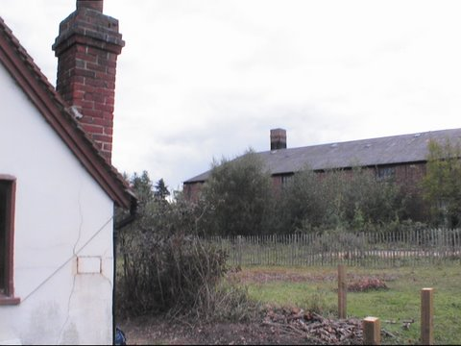

They were housed in an old single skinned brick building which was full of holes. The system steam cleans the clinical waste which was then taken to the landfill.

From my perspective I am elected by my residents to work for my residents and as such this is an operation I knew very little about at that time but quickly needed to know. I contacted the EA for the permits and waste management license, I contacted RBWM officer and after site visits with the officer and meetings with EA found some of the conditions on the permit for the Hydroclaves not adhered to. I represented my residents when there was a landslide at the landfill which caused residents all over Knowl Hill and beyond to suffer months and months a terrible odour. No windows open – no sitting in the garden – no putting clothes out – no children being able to play out etc. etc.
With the urine smell from the Hydroclaves permeating all over the area, I collated many emails informing me of children vomiting, people having headaches and in some cases more severe ailments.

I kept our MP updated and visited the site with her. I have met with the Director of the RBWM and outlined the seriousness of the detrimental issues from this site to our residents. I have put a motion to Full Council requesting representatives from the Royal Borough work with Wokingham Borough Council, Grundon, the two Parish Councils, residents and the EA to ensure there is a modicum of closure of the detrimental issues (it is noted by the EA that there will always be odour from a landfill) and to ensure all authorities work in the best interest of our residents relating to this site.

This motion was unanimously agreed and regular meetings took place.

However, there followed a fire at the Hydroclaves and a new abatement system was put in.
There followed many years of me pushing for the Hydroclave building to be a double skinned operation after it was decided just to plug the holes in the old brick building with DIY expandable foam.

Even after all this work there is still unfortunately more than too often a very strong smell of urine that permeates over the area and this can especially affect the residents in the surrounding area and the walkers on the public footpaths. No resident in the nearby region can plan for entertaining in their garden they can’t sit outside or have windows open. Walkers have mentioned that their walk was not pleasant due to the urine smell. This detrimental odour is from the waste treatment plant.

I have watched our residents put up with the noise of the plant machinery on the landfill, the noise from the HGV’s delivering and collecting waste treatment from the Hydroclaves, the noise from the doors of the Hydroclaves banging open and shut. I have watched this with the knowledge that an end date was in sight as have the residents.

The end date is in sight for the landfill BUT the treatment of waste which should have come to an end with the landfill is looking to continue. Not just to continue as it is but with the huge increase from 10,000 tonnes per year to 100,000 tonnes per year. No information has been submitted as to how the waste is to be treated.

As it stands the site is far too close to residential properties. The closest residential property is only 50 metres away. There are still problems which have not been overcome with odour from the waste being treated. Are the residents going to be subjected to another trial and error process that they have been with the Hydroclaves. Are our residents going to be subjected to huge environmental detrimental issues with this 90,000 tonnes increase.

As there are still detrimental odour issues and noise issues with the present waste treatment plant, any increase should not be looked at and the allocation of this site should be removed.

With regards to access to the site this is via Star Lane. At the narrowest point Star Lane is 507cm wide. See below No. 1.

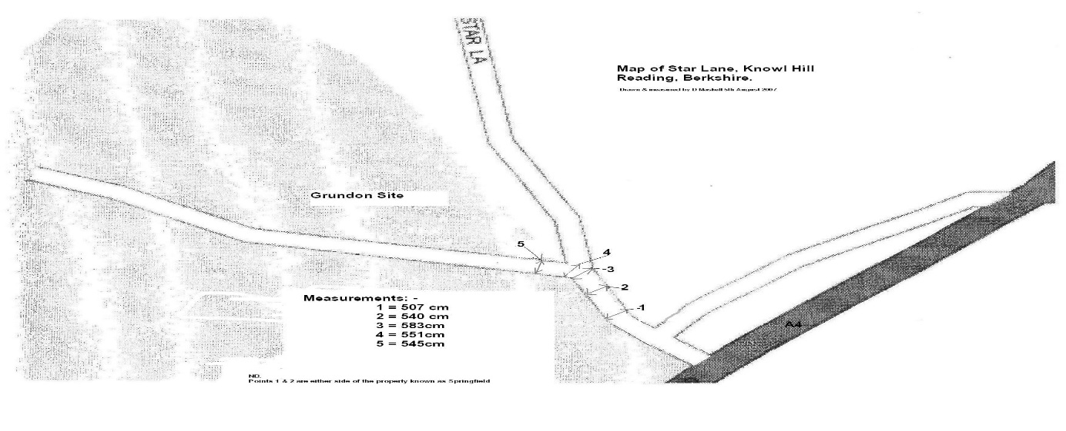
Access to Star Lane is Via the Bath Road (A4) which used to be the main road between London and Bristol before the M4 was constructed. The Bath Road is the main alternative route for use when the M4 is closed. It is the main route used by many drivers when the M4 has traffic problems. It is the main route used by drivers from Twyford, Charvil, Sonning, Wargrave, Crazies Hill, Knowl Hill and all the villages along the Bath Road to access the M4 or M40 or Maidenhead.

The peak hour traffic is substantial without any issues on the M4. There will be an increase in HGV movements from the waste treatment plant. The landfill is near completion and the traffic movements from this separate operation should not be taken into consideration.

All waste from the treatment plant went to the landfill on site.
Any material that is to be treated in the waste treatment plant at Knowl Hill will now have to be brought to the site and then removed from the site after treatment. This is far from a sustainable method and if this site is not removed from the allocations list, there will be the large increase in double decker HGV’s on this very busy Bath Road with an already high level of accidents.

The traffic mitigation put forward is the landfill will be finished 2021/22 and the traffic figures used for landfill plus the waste treatment plant will only be 20,000 tonnes per year extra. Therefore there will be minimal traffic increase of HGV’s.
However, in 1994 when the appeal for the landfill was allowed by the Secretary of State he commented on the amount of traffic for the landfill and stated: An overall limit on HGV traffic would be necessary in the interest of the local community.
He made these comments in the full knowledge that there was a time line for the landfill when there were no other operations on the whole site.

Since then Wokingham Borough Council have taken consideration for residential amenities and The Royal Borough of Windsor and Maidenhead have in the past been consulted and have likewise agreed with Wokingham BC to restrict vehicle use due to the poor access (Star Lane is a Bridleway with no footpath) and the detrimental environmental effects to the residents living in this rural part of Berkshire.

The site has a complicated planning history since Grundon purchased. In 1994 Grundon applied for landfill. The pre-existing vehicle movements from/to this site were 28 per day (i.e. 14 each way). Wokingham Borough Council refused the application. The landfill application was allowed on appeal and the vehicle movements were increased to 90 per day (42 extraction and 48 importation of waste). BUT it was only for this operation which had an end time.

In 2003 Grundon applied for a proposed change of use of building from manufacture of concrete to the recycling and recovery of materials from waste electrical and electronic equipment. This was permitted (but not implemented by Grundon). However, there were 21 conditions on the permission and five are pertinent to vehicle use and noise:

Condition 6 – No development shall take place…….and design of an additional 3 metres high acoustic fencing along the southern boundary of the site has been submitted to and approved in writing …. Reason: in the interests of satisfactory noise attenuation.
Condition 9 – The number of lorry movements associated with fridge recycling and other waste electronic and electrical goods recycling shall not exceed 14 per day… Reason: To limit the volumes of traffic in the interests of local amenity.
Condition 11 – All plant, machinery and equipment installed or operated …..shall be so enclosed and/or attenuated that noise therefrom does not exceed a level of 5dB(A) below the existing background level (or 10dB(A) below if there is a particular tonal quality) when measured according to British Standard BS4142 1997, at a point 1 metre enternal to the nearest noise sensitive property, at any time. Reason: In the interest of the residential amenity.
Condition 15 – Commercial vehicles shall not be started up manoeuvred, operated, loaded or unloaded except between 07.00 hours and 20.00 hours Monday to Friday, 07.00 hours and 13.00 hours Saturday and at no time on Sundays or bank or other public holidays…. Reason: In the interest of residential amenity.
Condition 16 – Commercial vehicles visiting the site…. Shall only arrive on site between 08.00 hours and 18.00 hours Monday to Friday, 08.00 hours and 13.00 hours Saturday and at no time on Sundays or bank or….. Reason: In the interest of residential amenity.

In 2004 Grundon proposed Use of Existing Tile Kiln Buildings for Clinical Waste Hydroclave. Permission was not required for the proposed use so long as it was wholly accommodated with existing buildings and in the absence of a specific planning permission there were no specific planning conditions regulating the use. However, Wokingham Borough Council state: In terms of highways consideration had a planning application been necessary, it is likely that a condition would have been imposed limiting the daily vehicular movements. However with an annual tonnage limit imposed by the waste management licence and in view of the nature of the proposed facility this Authority considers that in effect the use will require that there is a fairly even number of movements throughout the week…….

In 2008 there was an application to increase the goods vehicles and trailers on the Goods Operator License which was held by Grundon but operated by another company which had left the site.
VOSA allowed this increase and there are now permitted 20 goods vehicles and 18 trailers on and off the site accessing via Star Lane.

RBWM POLICIES

In all RBWM policies there is a strong presumption against locating any waste facility/treatment plant in or close to residential areas. Please see highlighted extracts from public documents below and policies which fully support waste treatment should not be in residential areas.

Recycling and recovery activities which predominantly take place in the open
(outside buildings) or involve large areas of open air storage include biological
waste treatment (including composting), construction, demolition and
excavation (CD&E) recycling, end-of-life vehicle processing and some
Household Waste Recycling Centres. Because these activities can create
noise, odours and other emissions, they are not easily assimilated in built-up
areas.

Larger scale enclosed premises (typically requiring sites of 2-4 hectares, with a
throughput in excess of 100,000 tonnes per annum) and facilities with a stack
are likely to be located on larger industrial estates or suitable brownfield sites.

Some industrial estates will not be considered suitable for certain waste management facilities because for instance the units are small, the estate is akin to a business park or it is located close to residential properties.

Policy DM3
Protection of Habitats and Species
Minerals and waste development that will contribute to the conservation, restoration
or enhancement of biodiversity will be permitted.
Development that is likely to result in a significant effect, either alone or in
combination with internationally designated sites including Special Protection
Areas, Special Areas of Conservation, Ramsar sites; sites identified to counteract
adverse effects on internationally designated sites; and European Protected
Species will need to satisfy the requirements of the Habitat Regulations
The following sites, habitats and species will be protected in accordance with the
level of their relative importance:
a) nationally designated sites including Sites of Special Scientific Interest and
National Nature Reserves, nationally protected species and Ancient
Woodland (including semi-natural and replanted);
b) local interest sites including Local Wildlife Sites, and Local Nature Reserves;
a) habitats and species of principal importance
b) priority habitats and species listed in the national and local Biodiversity
Action Plans
c) trees, woodlands, ancient woodland, aged and veteran trees, and hedgerows; andc) features of the landscape that function as ‘stepping stones’ or form part of a
wider network of sites by virtue of a coherent ecological structure or function,
or importance in the migration, dispersal and genetic exchange of wild

The development of permanent waste management facilities will be judged on the locational needs of the development and the impact on the area, landscape, biodiversity and other issues. This, together with the wider environmental and economic benefits of sustainable waste management are material considerations that should be given significant weight in determining whether proposals for waste management facilities on Green Belt land should be given planning permission

When considering any planning application, the planning authority will ensure that substantial weight is given to protection of the Green Belt. ‘Very special circumstances’ will not exist unless the potential harm to the Green Belt by reason of inappropriateness, and any other harm, is clearly outweighed by other considerations.

A processing plant, although commonly associated with mineral extraction, is unlikely to preserve openness, owing to its size, height and industrial appearance and would therefore be inappropriate development.

Elements of many renewable energy projects will also comprise inappropriate development. In such cases developers will need to demonstrate very special circumstances if projects are to proceed.
Protecting Public Health, Safety and Amenity

Minerals and waste development can have impacts on the environment and local communities. The use of machinery and lighting can result in noise, light and air pollution and also affect the amenity and public health of nearby communities and businesses and other land uses such as sport, recreation or tourism.

Policy DM9

Protecting Public Health, Safety and Amenity
Planning permission will be granted for minerals and waste development only where it can be demonstrated that it will not generate unacceptable adverse impacts on the public health, safety and amenity of local communities and the environment.
Minerals and waste development should not:
a) Release emissions to the atmosphere, land or water (above appropriate standards);
b) Have an unacceptable impact on human health;
c) Cause unacceptable noise, dust, lighting, vibration or odour;
d) Have an unacceptable visual impact;
e) Potentially endanger aircraft from bird strike and structures;
f) Cause an unacceptable impact on public safety safeguarding zones;
g) Cause an unacceptable impact on:
i. Tip and quarry slope stability; or
ii. Differential settlement of quarry backfill and landfill; or
iii. Subsidence and migration of contaminants;
iv. Cause an unacceptable impact on public strategic infrastructure;
v. Cause an unacceptable cumulative impact arising from the interactions between minerals and waste developments, and between mineral, waste and other forms of development.

Implementation

The screening of sites and other mitigation measures are often required to ensure an acceptable degree of potential impact of minerals and waste developments on the habitats, landscape, townscape and local communities. It is recommended practice for operational mineral extraction and inert waste recycling sites to have a minimum buffer zone of 100 metres, where appropriate, from the nearest sensitive human receptors, such as homes and schools, though this distance will be reviewed on a case-by-case basis.

Planning permission will be granted for minerals and waste developments where the cumulative impact would not result in significant adverse impacts on the environment of an area or on the amenity of a local community, either in relation to the collective effect of different impacts of an individual proposal, or in relation to the effects of a number of developments occurring either concurrently or successively

Sustainable Transport Movements

The impact of transporting minerals and waste materials by road can, if not controlled, be significant for sensitive environments and on communities both inside and outside of the central and eastern Berkshire area. A key priority of this Plan is minimising and managing the impact of traffic as traffic can give rise to noise, dust, vibration, congestion and carbon dioxide (CO2) emissions.

Policy DM11
Sustainable Transport Movements
Minerals and Waste development will be expected to demonstrate good connectivity for the movement of materials. A Transport Assessment or Statement of potential impacts on highway safety, congestion and demand management will be required.
Specifically, the assessment should explore how the movement of minerals and/or waste within and outside the site will not be detrimental to road safety and would not have an unacceptable impact on the environment or local community and determine whether highway improvements may be required to mitigate impacts associated with increased vehicle movements.
Where minerals and waste development will require significant road transport, the development will be expected to address alternatives to road-based methods of transportation such as rail, inland waterways, conveyors, pipelines and the use of reverse logistics.

Yours faithfully,

Cllr Maureen Hunt

