The Lone Sailor 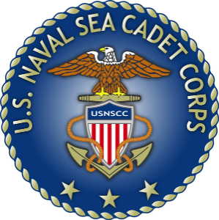
  - Quarterly NEWSLETTER
Aug-Oct INAUGURAL ISSUE
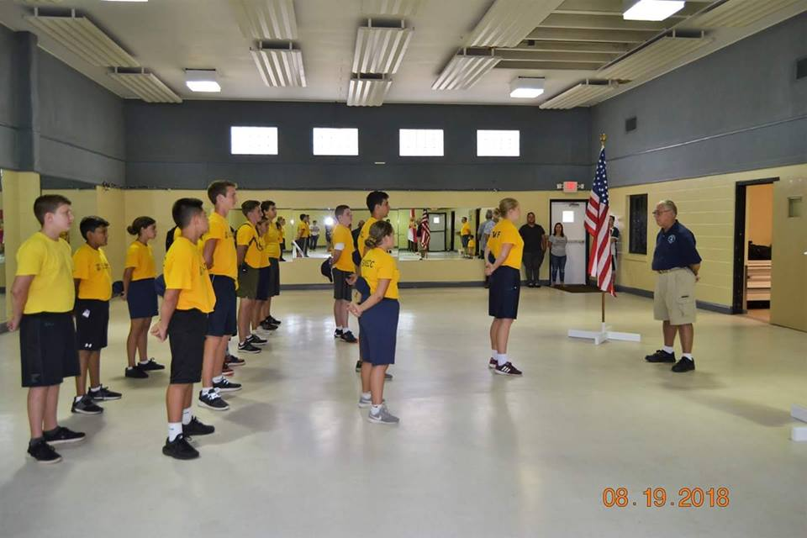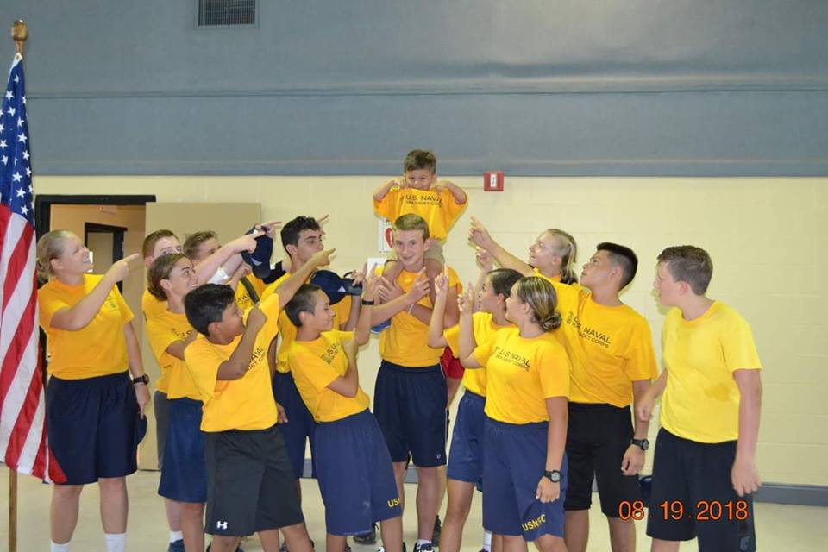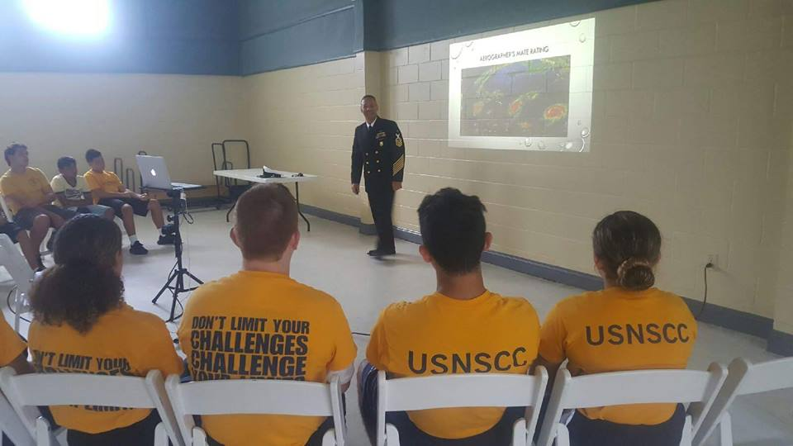
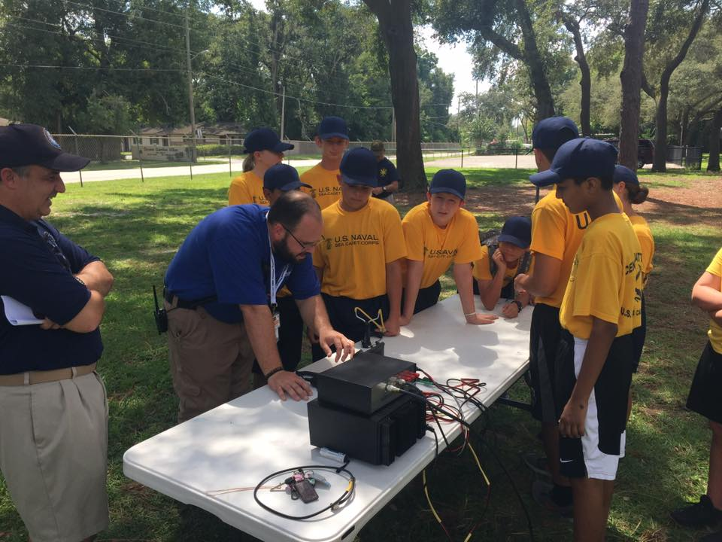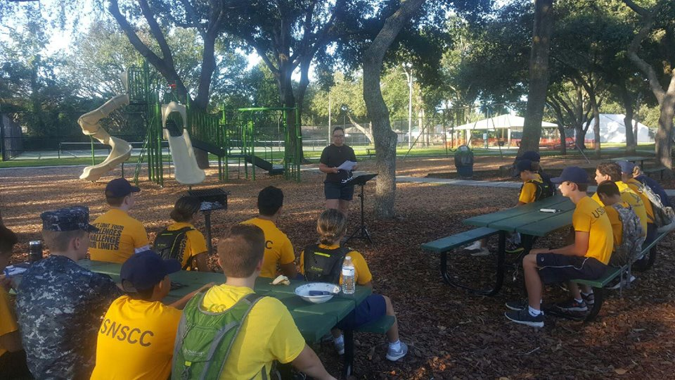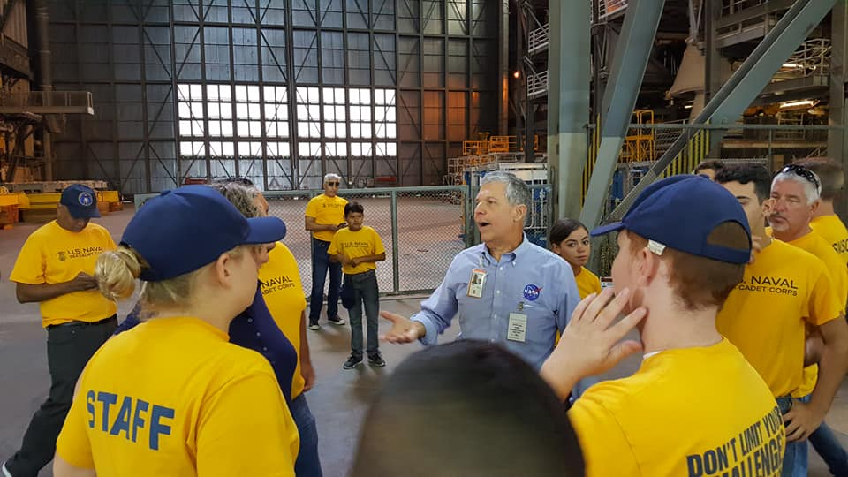
Great Beginnings  UNIT FORMED  Under the Leadership of LT. Billy Dover USNSCC Lone Sailor Division had its ribbon-cutting ceremony at Ocoee’s Vignetti Center this past August. Thank all who supported us. | Growth  FIVE NEW MEMBERS  Recruits Box, Hosein, Raut, Fritzler, and Gutierrez joined Lone Sailor Division and have been active in drills as well as events. Hooyah to all our new Recruits. Welcome Aboard.  We’re at 16 and growing | Learning  FEATURED CLASSES  Ham Radio Operation  Swimming Techniques  Navy Aerography Mate Basics  Police Room Entry Tactics  Knot Tying & Flag Folding  NASA Orion Engineering

AUGUST-OCTOBER PROMOTIONS
CADETS
Petty Officer First Class – LPO Carter Lopes
STAFF
Lieutenant – Commanding Officer Billy Dover
Ensign – Executive Officer Rafael Lopes

Our Website & Facebook pages are officially up  OFFICIAL UNIT WEBSITE:  WWW.USNSCC-Lone-Sailor-Division.Org  “USNSCC LONE SAILOR DIVISION” (Unit Private Page)  “USNSCC LONE SAILOR DIVISION PUBLIC PAGE” (Public) | 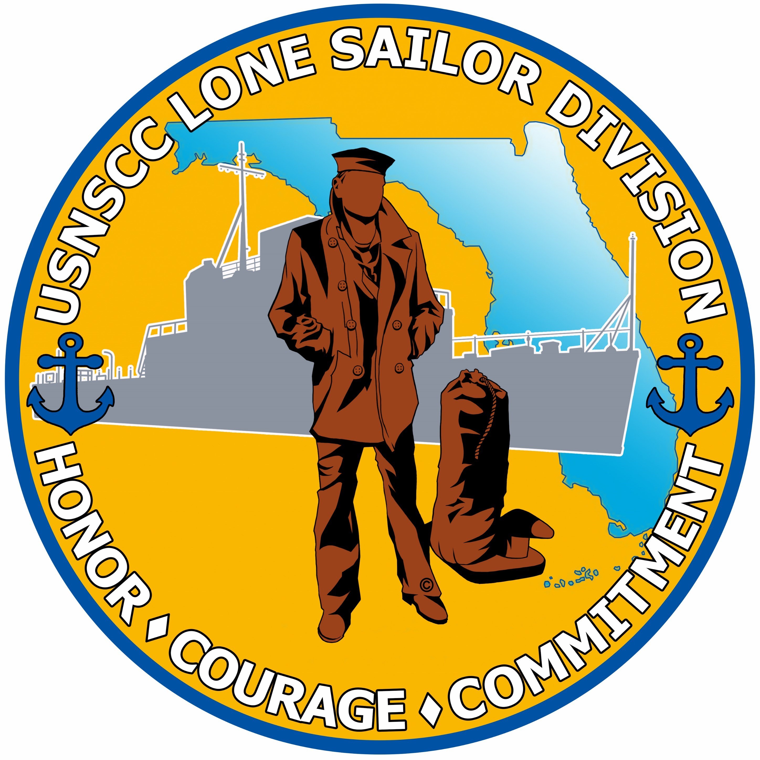
KENNEDY SPACE CENTER TOUR  Our Unit took a day trip to KSC and thanks to CPO Woods, NASA Avionics Mgr. Glenn Perez took us on an exciting and educational special tour.  What an incredible honor.  Our Lone Sailors had a lot of fun | 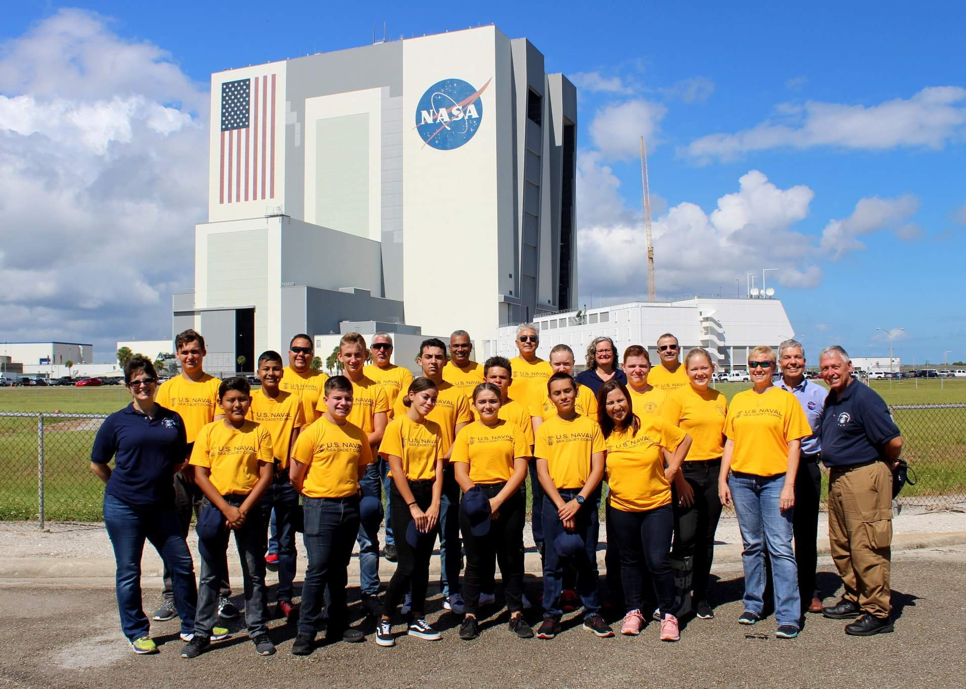

SWIMMING CLASS AND QUALS
National Training Center Instructor Lauren Gave the Cadets a swim & rescue class, following it we had them test and 90% of the unit passed all 4 Tests up to First Class Swimmer. Hooyah!
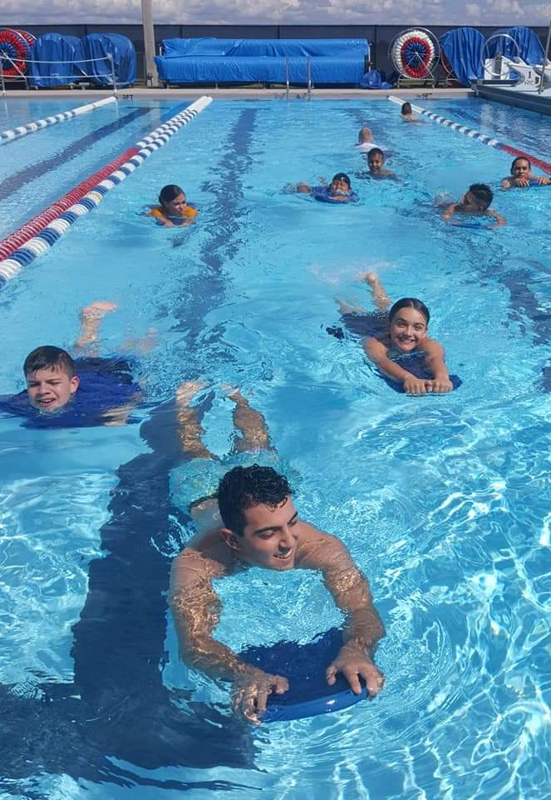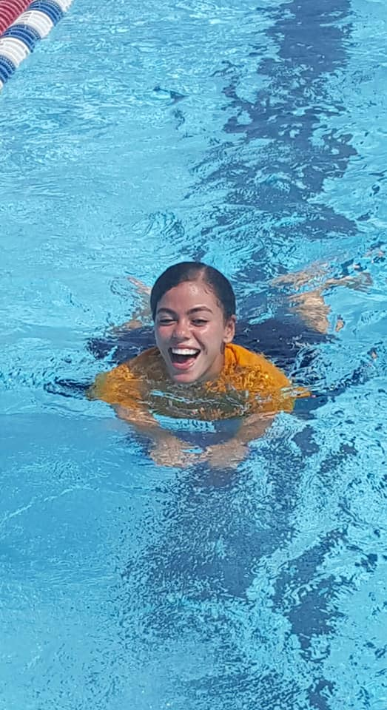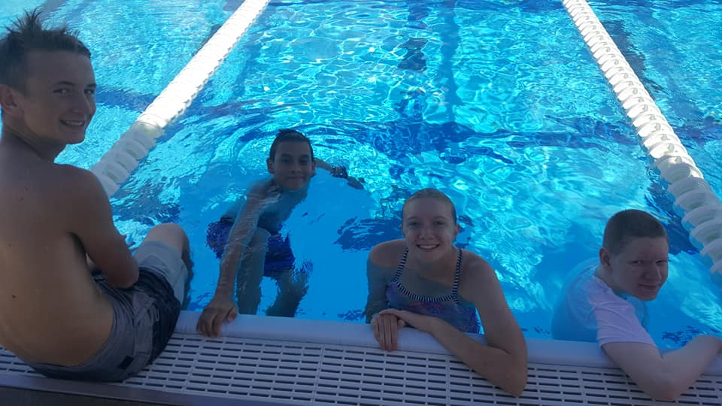

CAR WASH FUNDRAISER  Inst. Lisa Collazo and our Fundraising Committee put together a FUNdraiser  Donation Car Wash  Cadets and Staff had a lot of fun and raised some funds for our unit.  Our Second Car Wash is this Saturday, the 27th at Tijuana Flats  13770 West Colonial Drive | 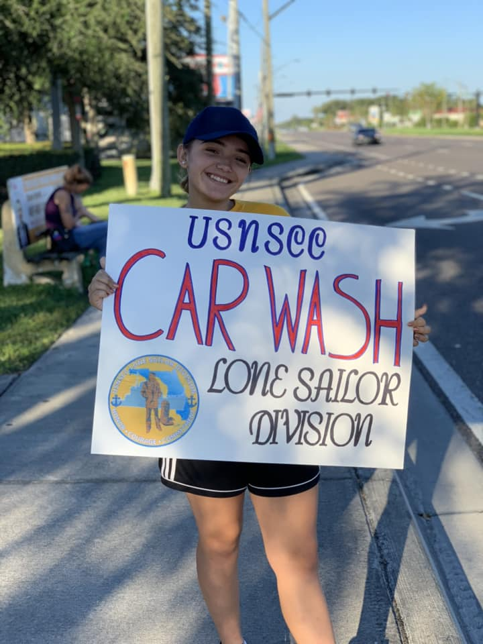  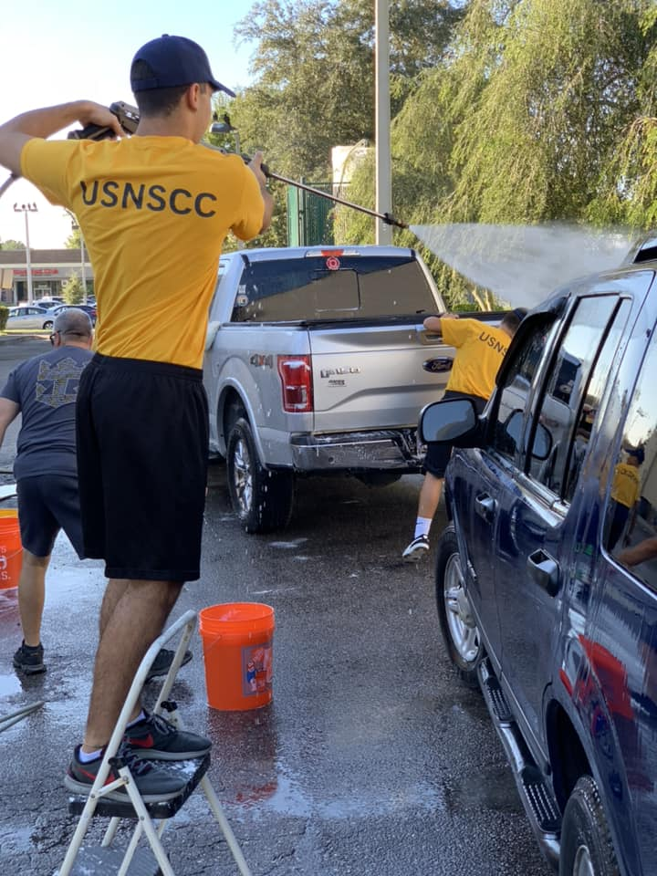

THANK YOU CENTRAL FLORIDA NAVY LEAGUE
This past month Troy Edwards presented Lone Sailor Division with a $1000 check from our Navy League to help start up the unit. It already has gone a long way toward uniforming our Cadets.
Thank you President Townsend, Lisa Coe, Rick Lecky, Mike Motko, Andy Mohler, Troy Edwards, Carla Hoskins, Bill Reuter, and Enrique Gonzalez for your kindness.

We are available to serve our CFNLUS whenever the Board calls on us.
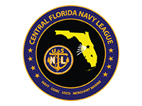

SKYZONE FIELD TRIP
The Cadets had the opportunity to visit SKYZONE trampoline park. They performed the obstacle course and played team dodgeball. A “bouncing” good time by all.
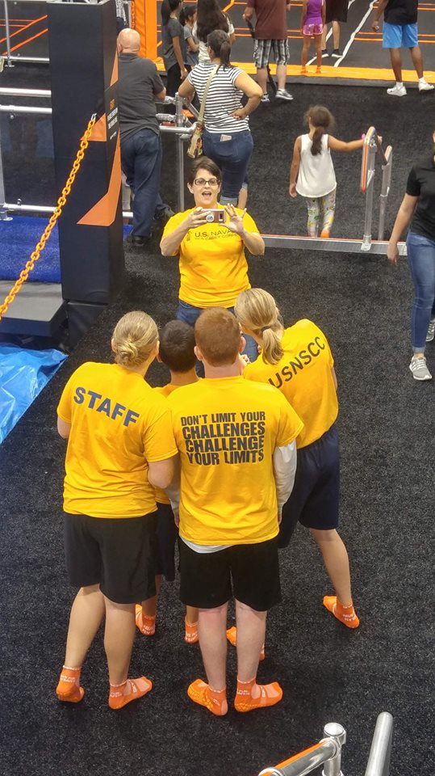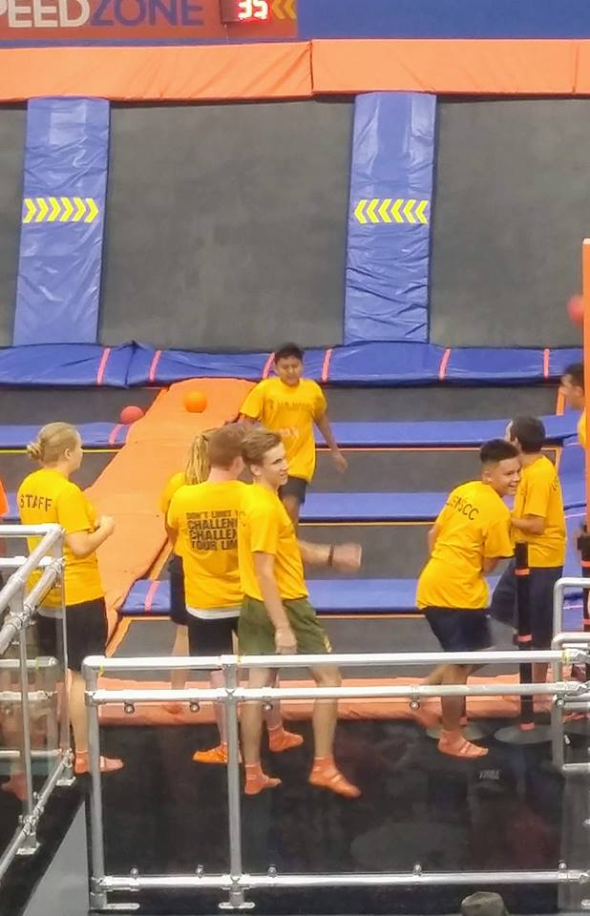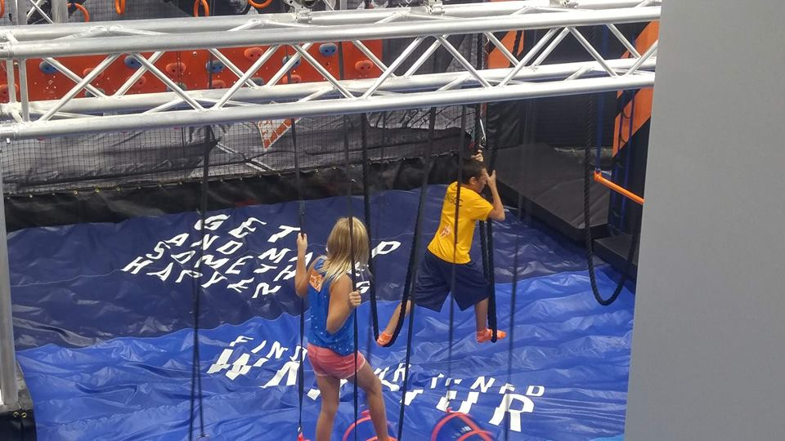

HAM RADIO & AEROGRAPHER’S MATE CLASSES
The Cadets had Ham Radio Expert, Matt Hopple teach how they work, running antennas, and even got the cadets to connect to Central America.
CFNLUS’s Senior Chief Enrique Gonzalez Was asked to be our units inaugural speaker, and gave the cadets insight into Navy Aerographer Mate billet, and General Navy promotion/ranking.
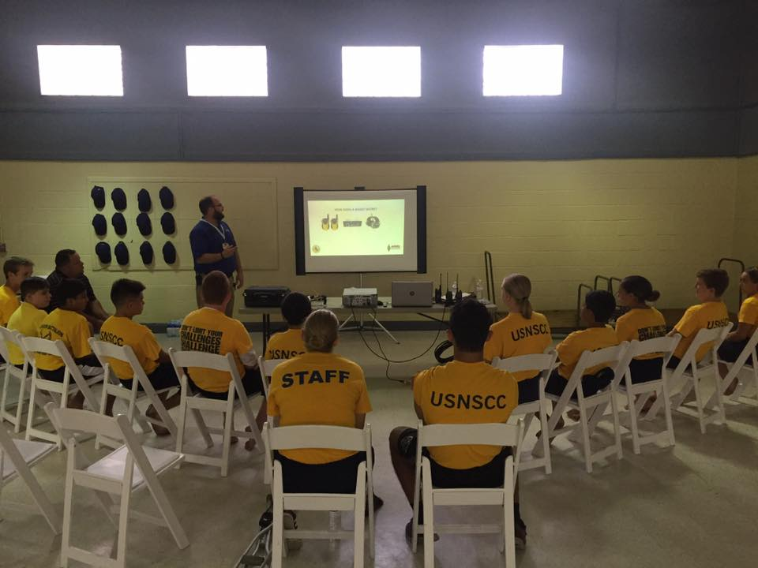
Aug-Oct FEATURED CADETS
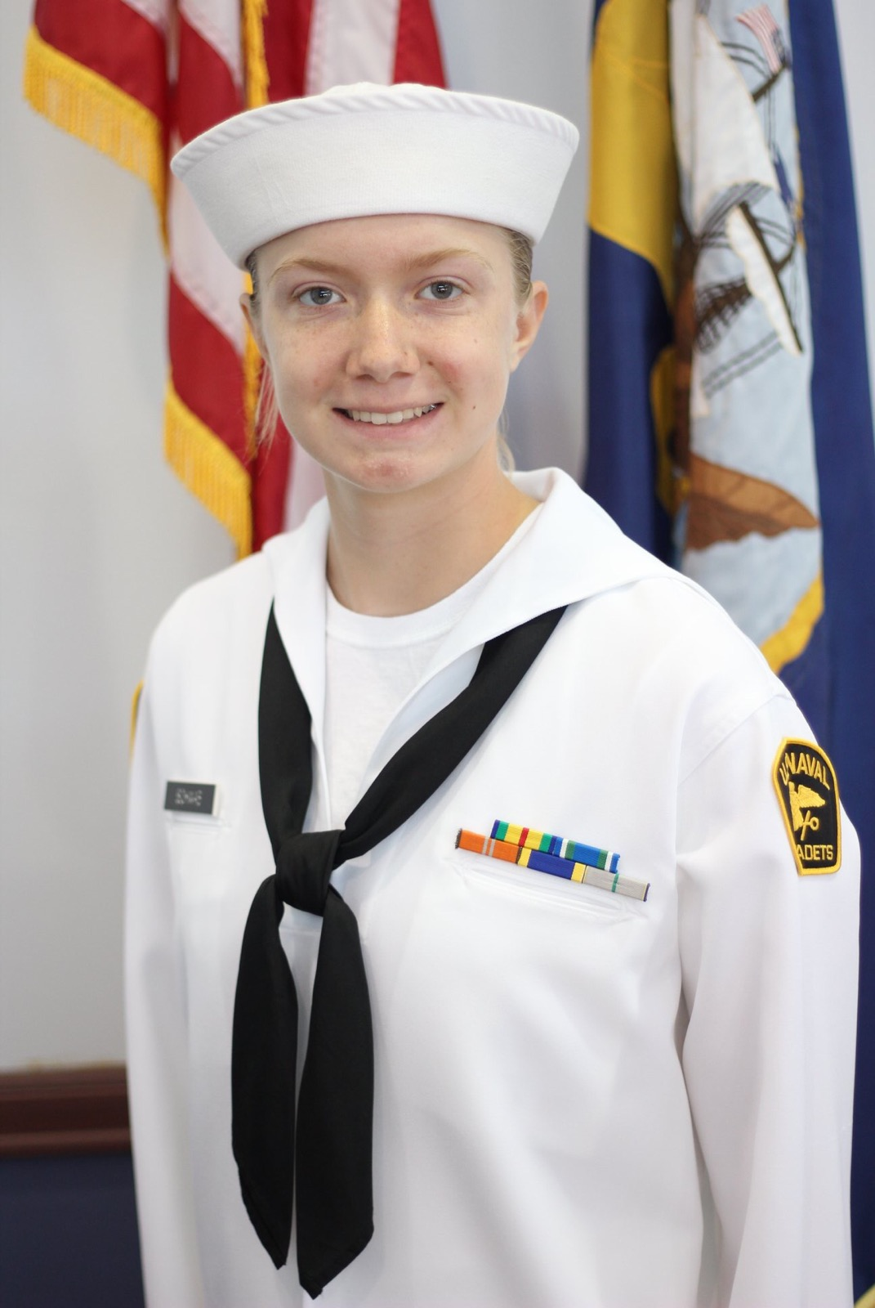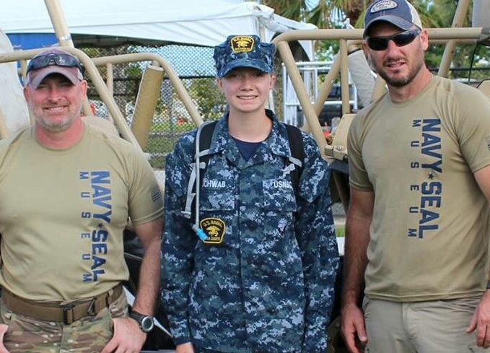

USNSCC S.A. OLIVIA SCHWAB

Where Are You From?
Lincoln Nebraska
Favorite Cadet Memory?
Navy Seal Muster Demonstration
Why Lone Sailor Division?
Very Organized and great Plan Of The Day
What’s Your Plan?
Join the Navy and become an Aerographer (Meteorology)

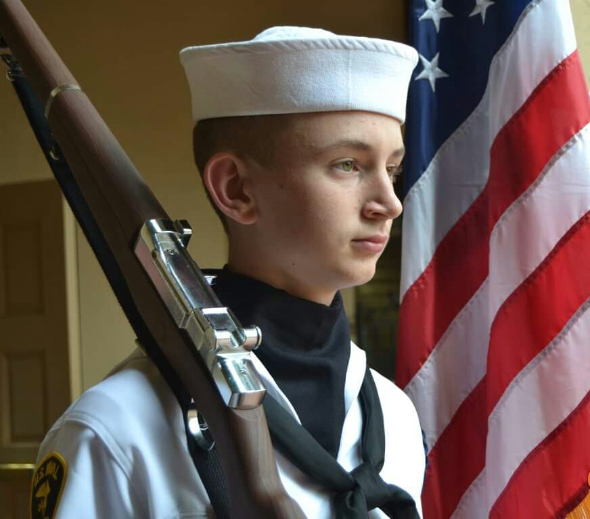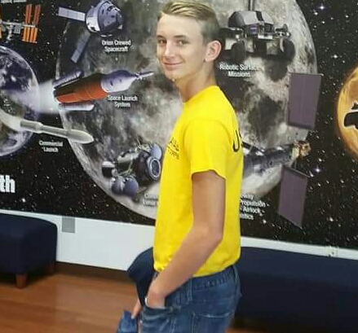
USNSCC S.A. TY LILLY
Where Are You From?
Winter Park Florida
Favorite Cadet Memory?
Beach PT with Other Units
Why Lone Sailor Division?
Awesome and positive environment
What’s Your Plan?
ROTC Criminal Justice and Psychology

UNIT CALENDAR
Oct. 27th UNIT CAR WASH FUNDRAISER
NOV. 2nd & 3rd OCOEE FOUNDERS DAY DRILL WEEKEND
Nov. 17th AMERICAN LEGION Challenge 22 Ruck-Walk
MAKING MEMORIES
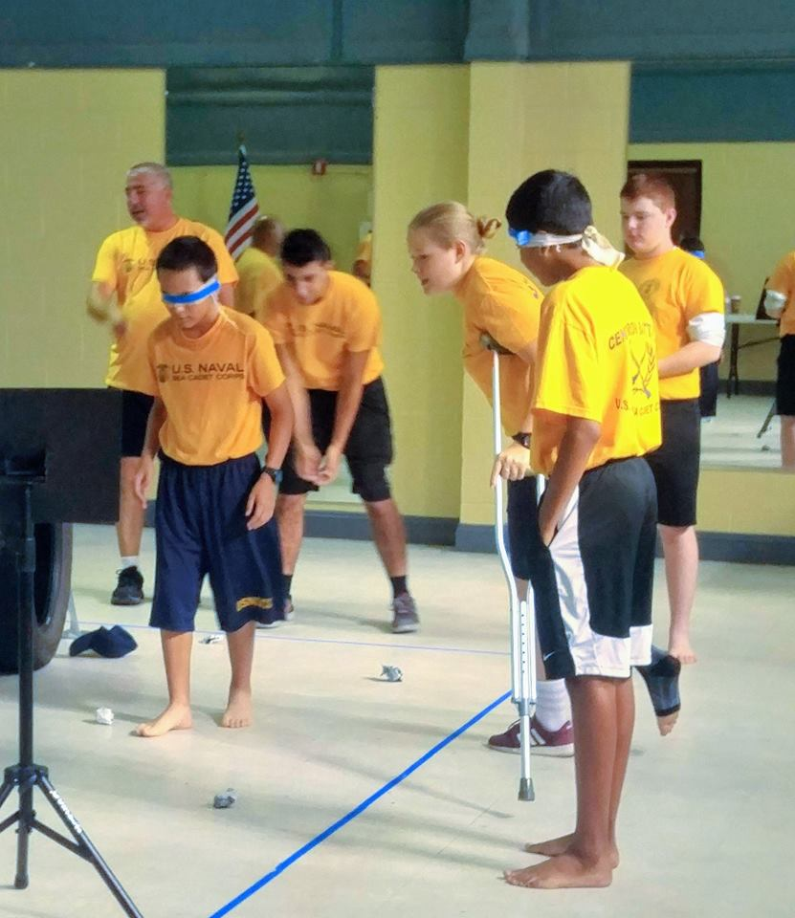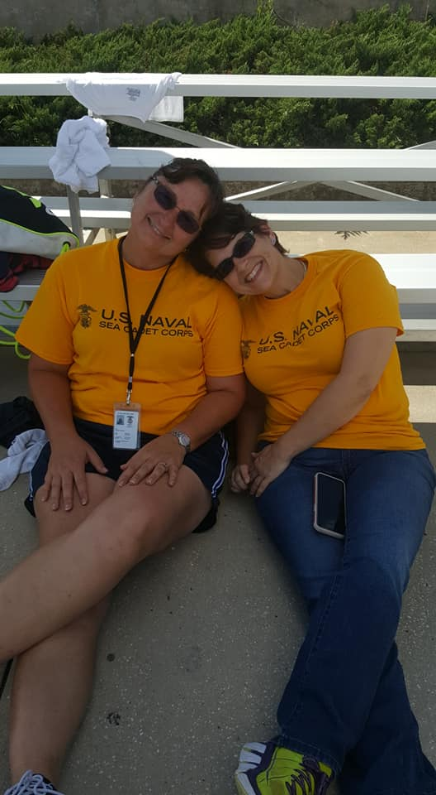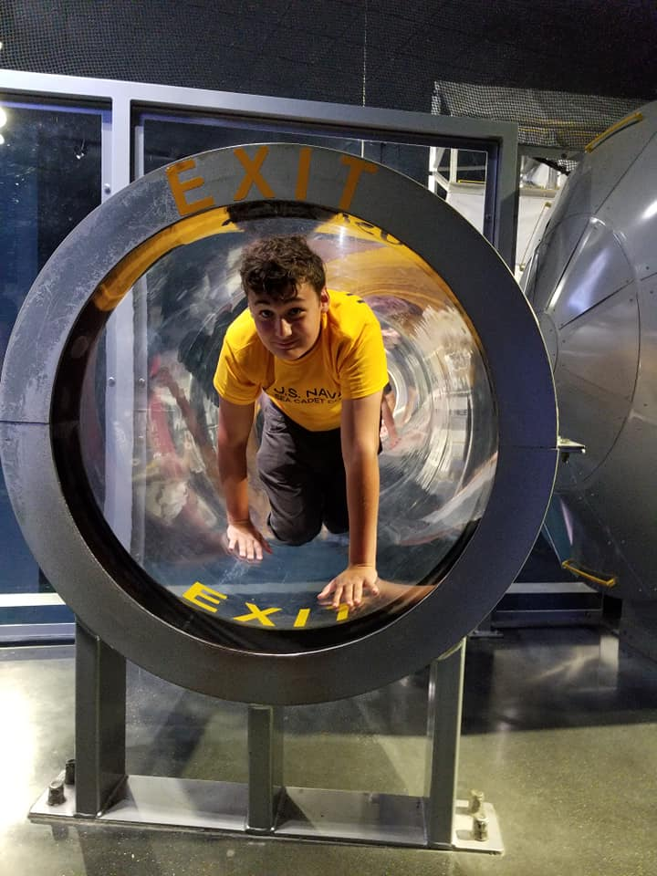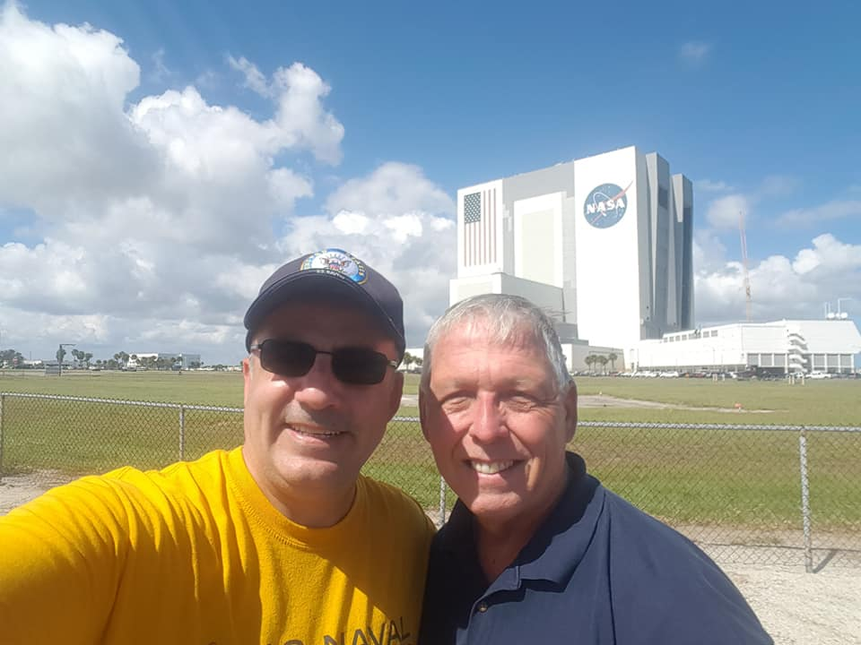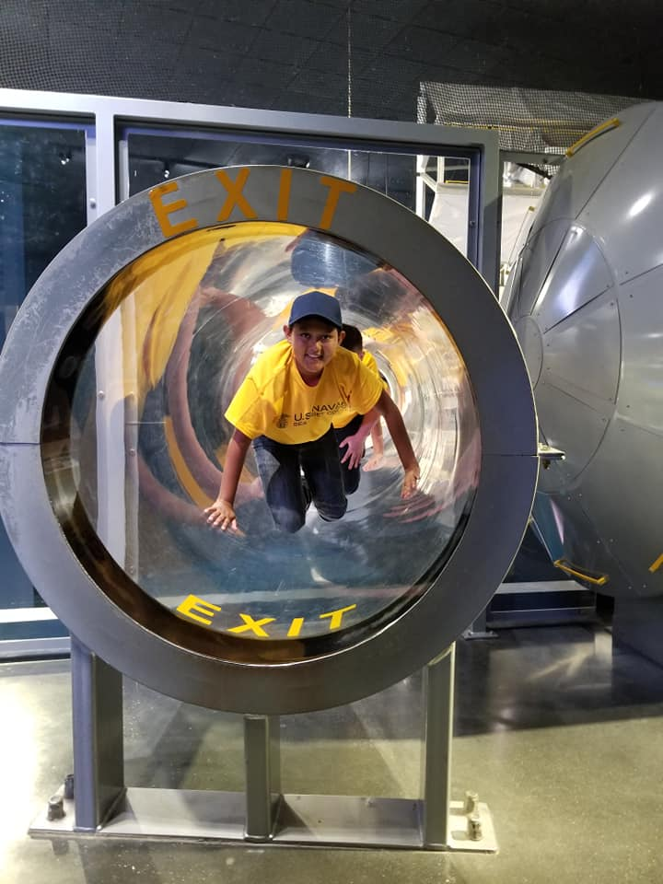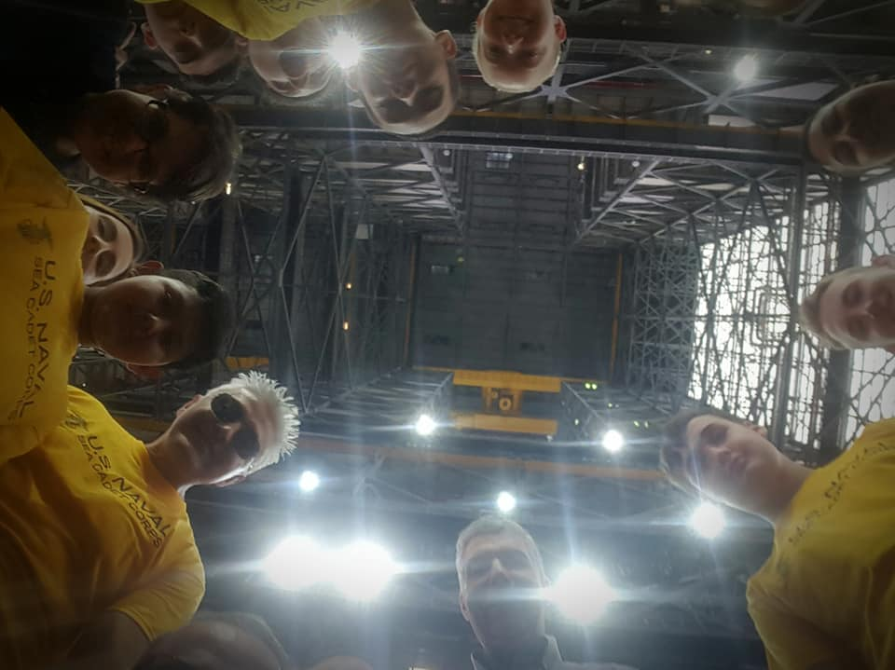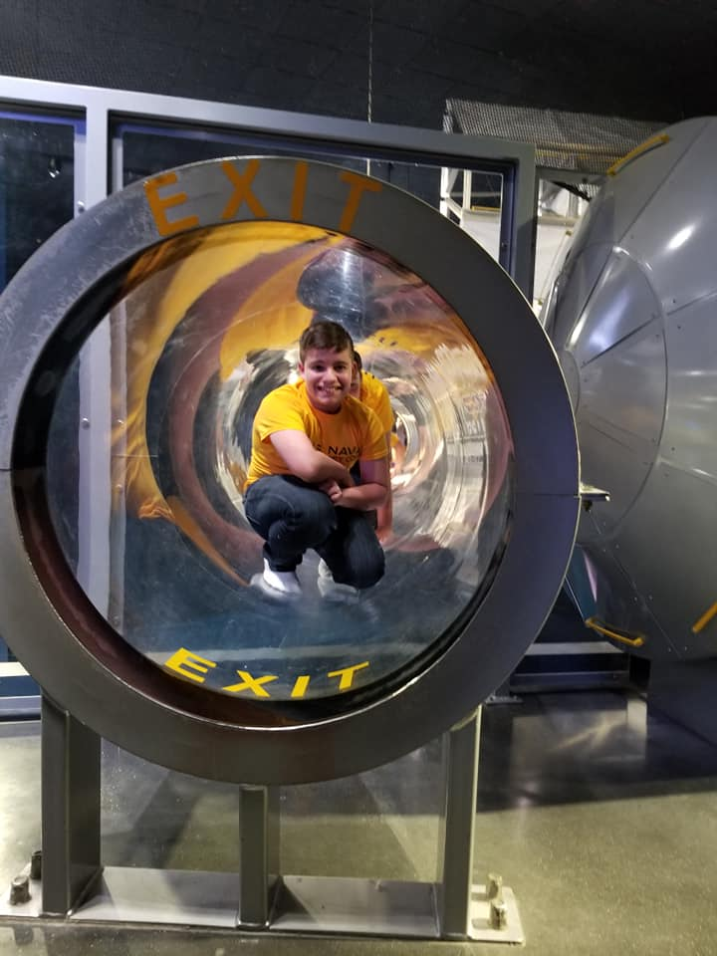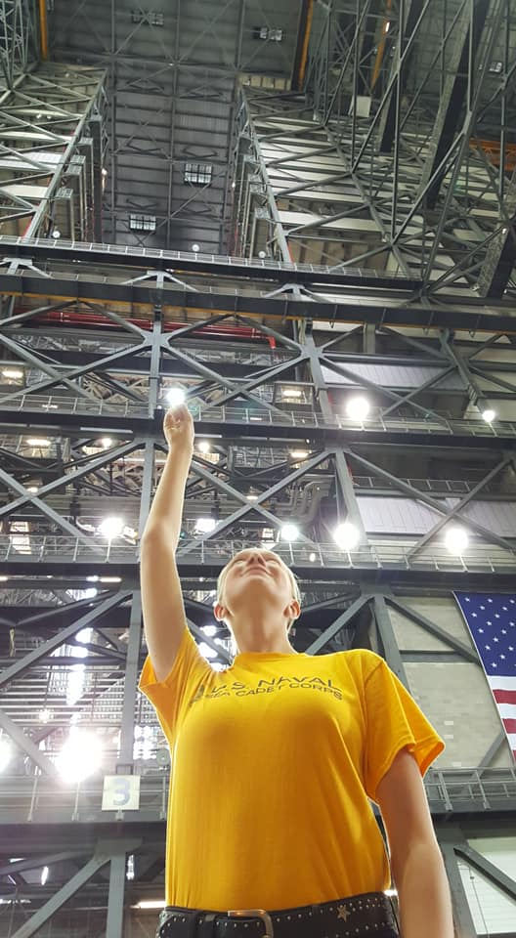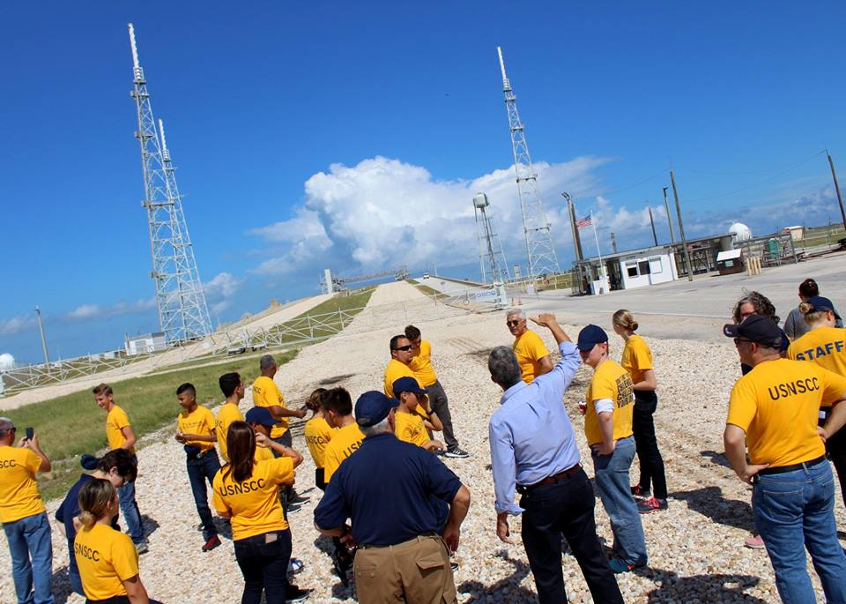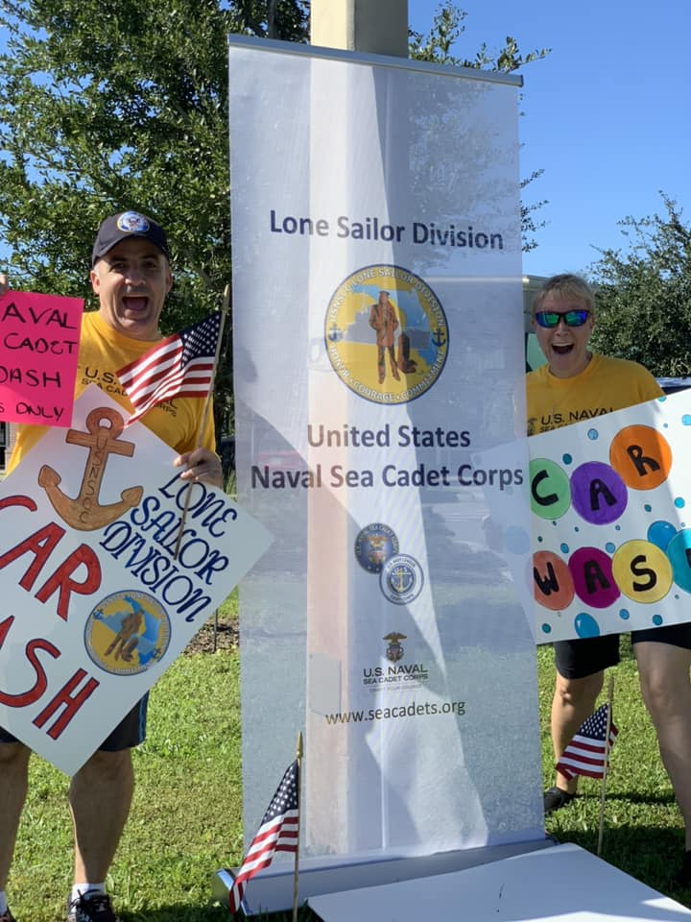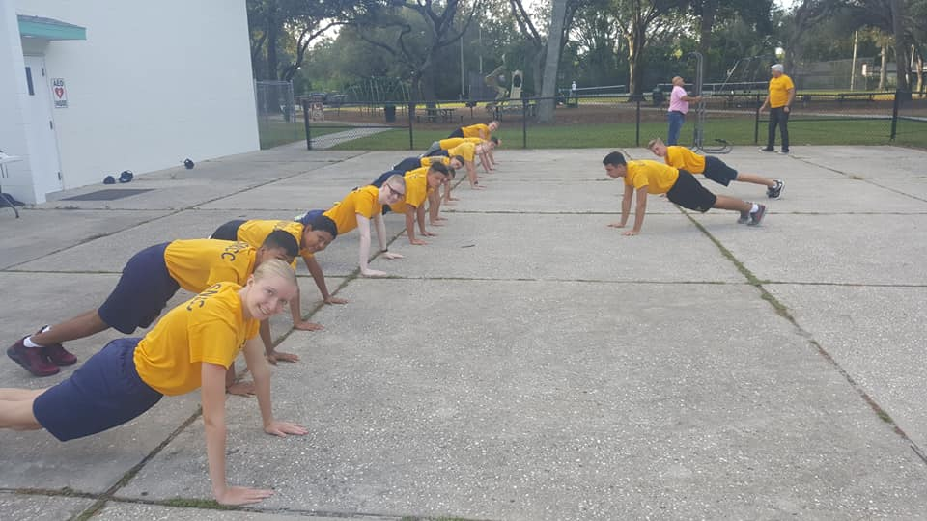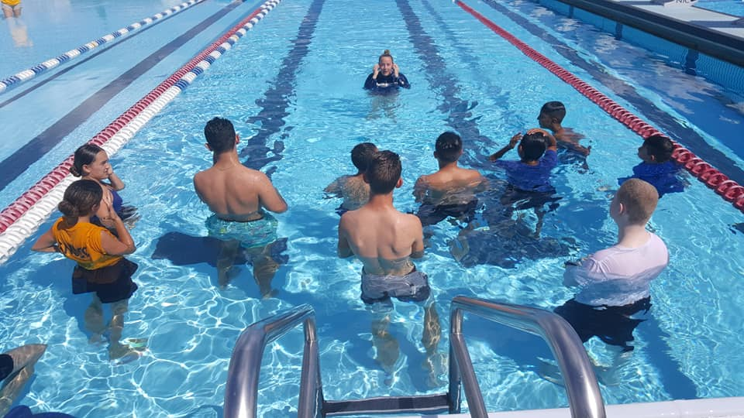
A big Hooyah to Parents, Board Members, Staff, & Supporters who are committed to help our growth and maintaining the best environment with the best quality drills and events for our Lone Sailor.

