ER25 NarvaWatMan
Contribution to the Activity A.T3.2
Workshop on chemical parameters and limits, results of questionnaire (online)
December 14, 2020
11:00 Moscow time (10:00 - Tallinn)

Minutes from the Workshop

11:00-11:15 - Opening and self-introduction of the participants. 14 participants were attended the workshop (Annex 1).

11:15-11:55 - Enn Loigu (TalTech) and Olga Zadonskaya (SHI) introduced the national procedures for estimation of the water-quality (WQ) parameters in the Narva river catchment area. (Annex 2)

11:55-12:25 - Kati Roosalu (TalTech) and Olga Zadonskaya (SHI) introduced the results of national questionnaires on chemical parameters and limits. (Annex 3)

12:25-12:35 - Technical break.

12:35-15:25 - Discussion of the results and proposals for each parameter and its limit.
Moderator Olga Zadonskaya.
Continuation of the discussion from all participants. Proposed list of parameters and limits was corrected and agreed by all experts from both countries (Annex 4).
It was decided that:
- chemical parameters and limits marked with yellow color and/or question marks should be analyzed deeply or additionally till the end of January 2021;
- all rivers should be divided in two groups depending on their color;
- data on small Estonian rivers in Pepsi lake catchment should be added;
- in February experts should finally decide on list of chemical parameters and its limits for different types of rivers. If it’s needed new workshop may be organized.
15:25-15:30 - In the Workshop closing remarks Olga Zadonskaya and Alvina Reihan thanked the participants for their active and valuable contribution to the Workshop. It was underlined the importance of such cooperative discussion

Annex 1. List of Participants
1. Alvina Reihan, Taltech, Tallinn, Estonia
2. Enn Loigu, TalTech, Tallinn, Estonia
3. Arvo Iital, TalTech, Tallinn, Estonia
4. Kati Roosalu, TalTech, Tallinn, Estonia
5. Marija Klõga, TalTech, Tallinn, Estonia
6. Hille Allemann, Estonian Environmental Research Centre (EKUK), Tartu Unit, Tartu, Estonia
7. Jelena Molodtsova, Narva city Municipality, Narva, Estonia
8. Lea Tuvikene, Estonian University of Life Sciences, Tartu, Estonia
9. Külli Kangur, Estonian University of Life Sciences, Tartu, Estonia
10. Olga Zadonskaya, State Hydrological Institute, S.-Petersburg, Russia
11. Tatiana Potapova, State Hydrological Institute,
12. Grigory Frumin, Herzen State Pedagogical University, S.-Petersburg, Russia
13. Sergei Fedorov, Pskov Region Centre for Hydrometeorology and Environmental Monitoring, Pskov, Russia
14. Sofia Kozhevnikova, St. Petersburg University, S.-Petersburg, Russia
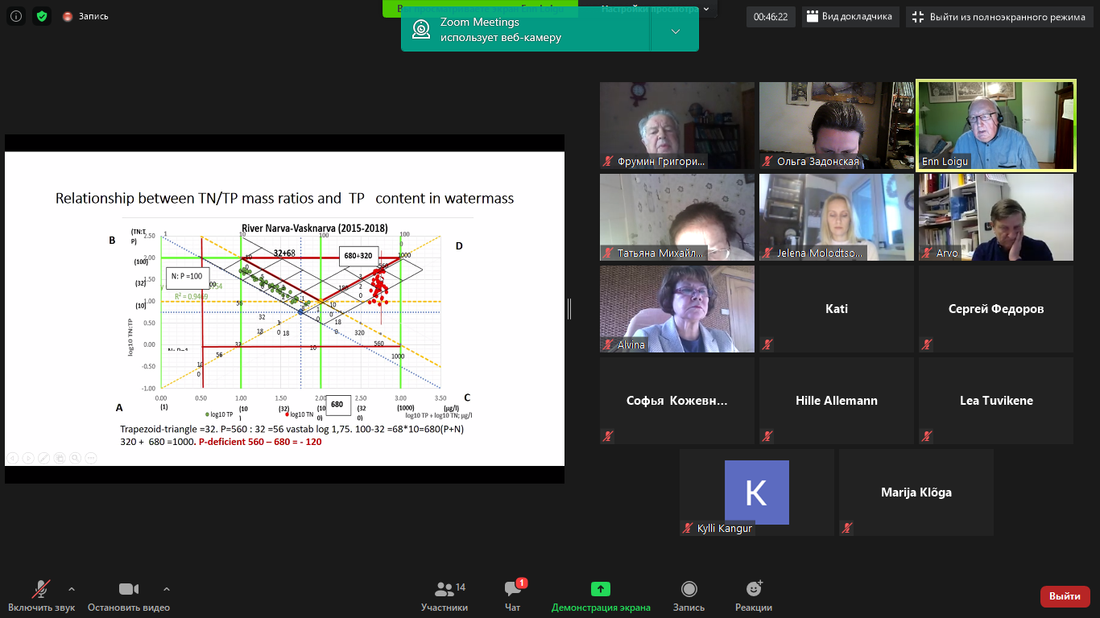
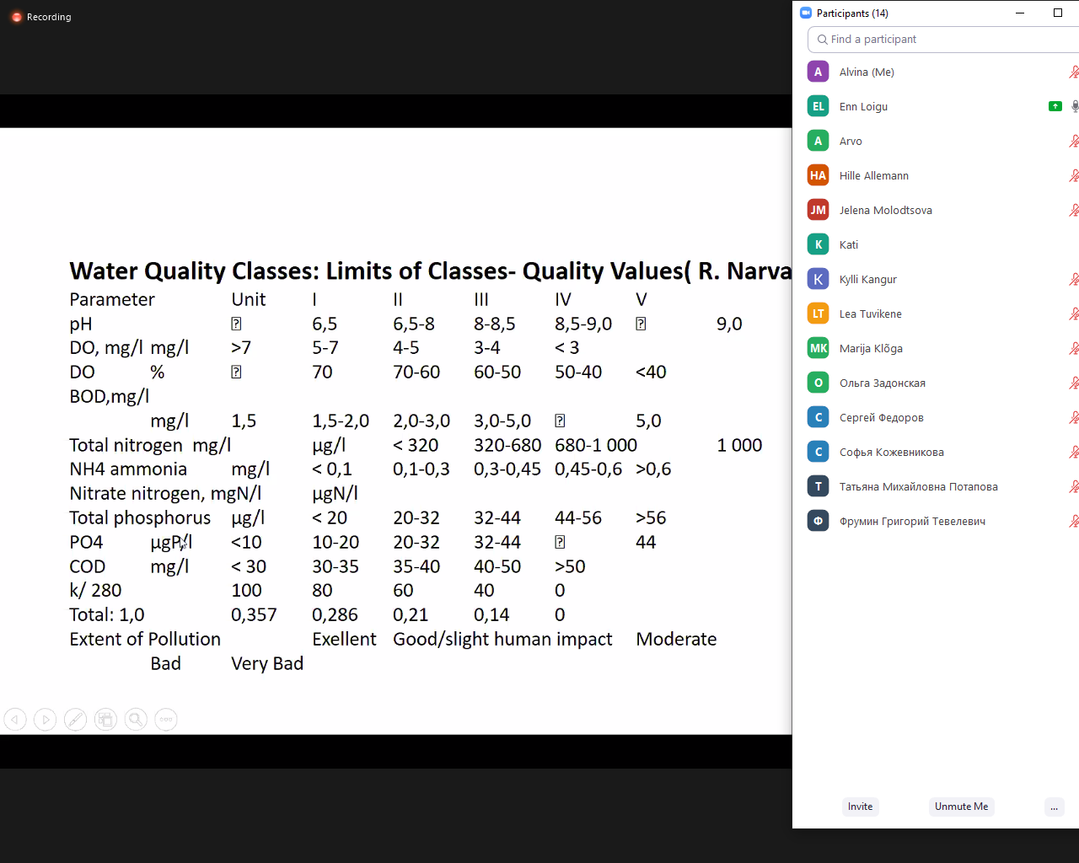

Annex 4. Table with proposed parameters and their limits.
Nr | Parameter | Waters with low humic substance content | Waters with high humic substance content | Narva river
1 | pH | 6,5-8,5 | 6,5-8,5 | 6,5-8,5
2 | Dissolved oxygen saturation, %  Winter (dec – apr)  Warm time (may – nov) | 70  80 | 60  70 | 70  80
3 | Electroconductivity | ? | ? | ?
4 | Color of water | ? | ? | ?
5 | BOD₅; mgO₂/l | 2,3 | 2,3 | 2,0
6 | COD_{Cr}; mgO/l  COD_{Mn}; mgO/l | 30  ? | 40  ? | 30  ?
7 | Total nitrogen; mgN/l | 1,5 | 1,5 | 0,8
8 | Ammonium (NH₄⁺); mgN/l | 0,2 | 0,2 | 0,1
9 | Nitrate (NO₃⁻); mgN/l | 1,0 | 1,0 | 0,3
10 | Total phosphorous; mgP/l | 0,07 | 0,06 | 0,05
11 | Phosphate (PO₄³⁻); mgP/l | 0,02 | 0,04 | 0,02
12 | Total iron; mg/l | 1,0 | 1,0 | 0,25
13 | Manganese; mg/l | 0,05 | 0,1 | 0,05
14 | Copper; mg/l | 0,003 | 0,005 | 0,003
15 | Zink; mg/l | 0,01 | 0,01 | 0,01
16 | HCO₃⁻, mg/l / acidity | ? | ? | ?

