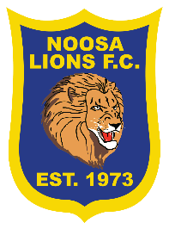
SUMMER 6S 2021
 | 6.50pm | 7.35pm | 8.20pm
 | FIELD 1A | FIELD 1A | FIELD 1A
12th JAN | ALI BABAS KEBABS  V  LOCALE | OLD GOLD  V  PORRIDGE | OZ GURI  V  RUSSION DOLLS
19TH JAN | OLD GOLD  V  OZ GURI | ALI BABAS KEBABS  V  PORRIDGE | LOCALE  V  RUSSIONS DOLLS
26TH JAN | ALI BABAS KEBABS  V  RUSSIAN DOLLS | LOCALE  V  OLD GOLD | OZ GURI  V  PORRIDGE
2ND FEB | LOCALE  V  PORRIDGE | OLD GOLD  V  RUSSIAN DOLLS | ALI BABAS KEBABS  V  OZ GURI
9TH FEB | RUSSIAN DOLLS  V  PORRIDGE | LOCALE  V  OZ GURI | ALI BABAS KEBABS  V  OLD GOLD
16TH FEB |  | SEMI FINALS
23RD FEB |  | GRAND FINALS
MEN’S BLUE DRAW

