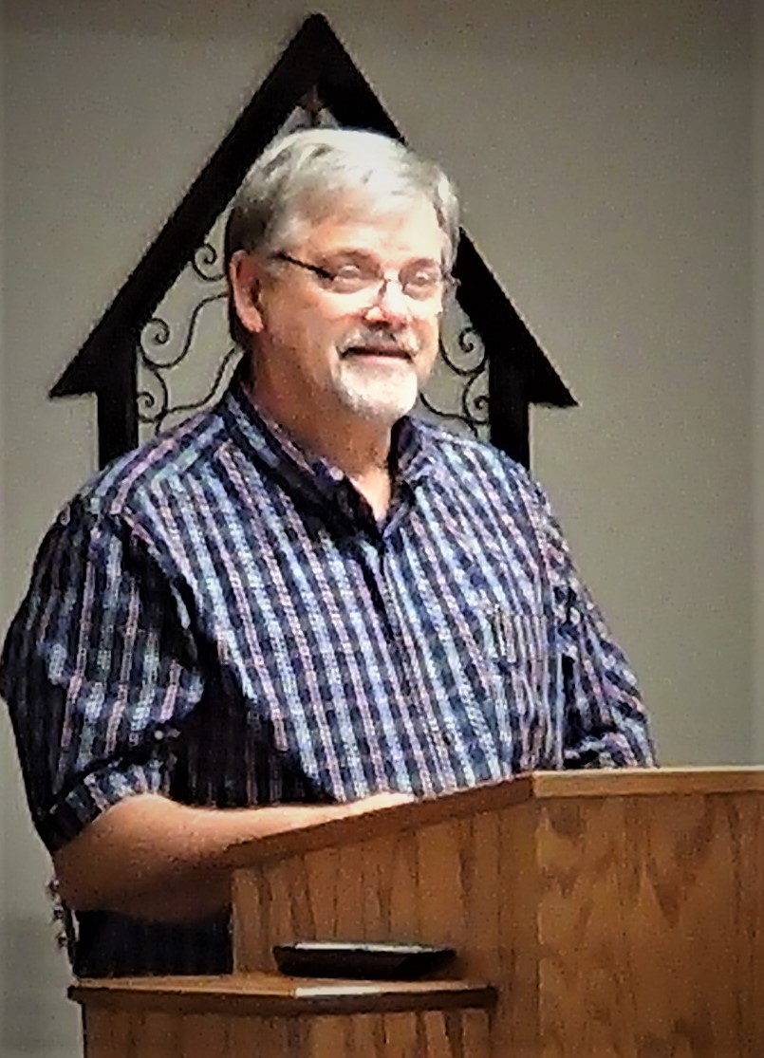

Send This Guy Packing!
Help Us Get This Guy Out Of The Country!

All The Proceeds
go to Windows for Widows, a Mission for Hurricane relief in Puerto Rico.

Send Pastor Zack to Puerto Rico!

