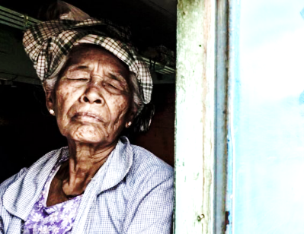
Windows For Widows
A Mission for Christ Jesus to
The People on Culebra Island, Puerto Rico

Thank you for your support!
Your donation partnered us in this very worthy outreach
into the lives of people who have needs.
They have a need for repairs to their homes
and they also have a need to hear the gospel.
The Good News they received is because
you have heard and responded to their needs!
Just a reminder, the support you sent was not to me,
but it was sent to Christ. It was a gift to Him!
I am sending you this note of thanks, but I assure you
He has something much greater for you than I can ever convey!

Mark 9:41 For whosoever shall give you a cup of water to drink in my name, because ye belong to Christ, verily I say unto you, he shall not lose his reward.

Pastor Zack

