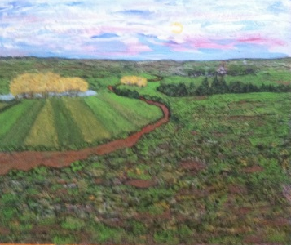 Landscape #1, Acrylic, 16 x 20, 2016, 350.00

Landscape #2, Acrylic, 30 x 40, 2015, 350.00

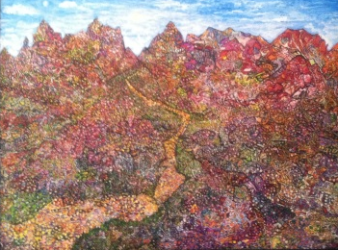 Valley of the Mountains, Acrylic, 30 x 40 , 2016, 350.00

Landscape #3, Acrylic, 18 x 24, 2015, 350.00

The Lagoon, Acrylic. 16 x 20, 2015, 350.00
View from Over There. Acrylic, 16 x 20, 2014, 350.00

The Barn, Acrylic, 16 x 20, 2015, 350.00

A Matter of Say-So, Acrylic, Water Color, 22 x 30 n/a

The Old Barn, Acrylic, 16 x 24, 2016, 350.00

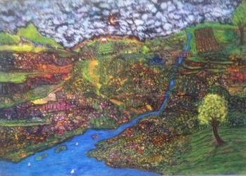 The Tier, Acrylic, 20 x 30, 2016, 350.00

Summer Sails, Acrylic, 16 x 20, n/a

Copper Mountain, Acrylic, 16 x 20, 2016, 350.00

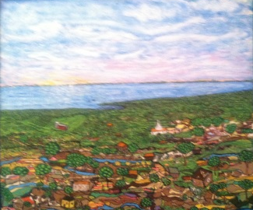 Our Town, Acrylic, 32 x 32, 2014, 350.00

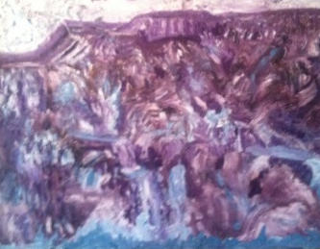 Purple Mountain Majesty, Acrylic, 30 x 40 n/a

Arctic Sail, Acrylic, 22x 28, n/a

Life on the Farm, Acrylic, 11 x 13, 2015, 100.00

Sunrise, Sunset, Acrylic, 24 x36, NFS, 500.00

French Landscape, Acrylic, 16 x 20, 2012, 200.00

Johnny Appleseed, Acrylic, 36 x 36, 2015, 350.00

Landscape in Green, Acrylic, 13 x 18, 2015, 200.00

Morning Mountains, Acrylic, 11 x 12, 2015, 75.00

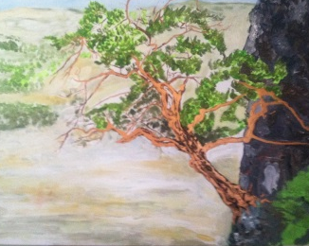 The Tree, Acrylic, 36 x 36, 2016, 350.00

Landscape #4, Acrylic, 16 x 18, 2016, 250.00

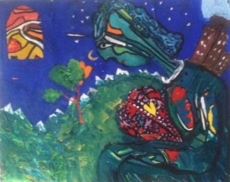 All of My Heart, Acrylic, 9 x 12, n/a

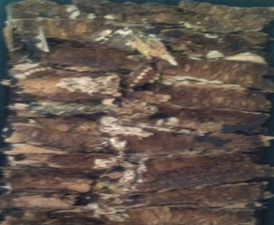 Relief in Wood, Wood, 20 x 24, n/a

Prairie Farm, Acrylic, 5 x 7 2016, 45.00

Bull, Acrylic, 16 x 20, 2014, 2000.00

Birch Trees in Blue, Acrylic, 16 x 20, 1976, NFS , 1,000.00

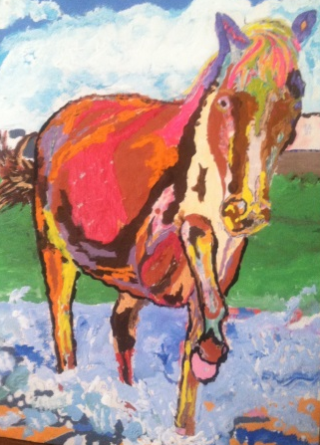 Fauves Horse, Acrylic, 9 x 12, 2014, n/a

