Good News Story – Emotional Resilience Project

As we come to the end of the 2nd year of our Emotional Resilience Project, we want to share some of the amazing work our commissioned providers have been doing to improve the emotional resilience of young people in Allerdale, Barrow and Copeland. By the end of year two 3,913 young people have been engaged onto our programmes and a further 1,248 people have been reached through training, design and consultation, and awareness courses. Of those providers whole used the Outcome Star as an evaluation tool we have seen a huge increase in confidence and self-esteem as well as:
Choices and Behaviour – 64% increase
Communication/ Confidence – 89% increase
Education and Work – 71% increase
Well-being – 79% increase
Hopes and Dreams – 62% increase
Making a Difference – 57% increase

We want to thank all those involved in making this possible below are just a few examples of the work we have all been doing.
Spiral who have been carrying out anti-bullying and confidence workshops. One young person said that the confidence building workshop and cyberbullying workshop gave her the courage to speak to her teachers about her experiences of bullying. Another young person expressed that they are now more confident to speak about their mental health because they “understand that it makes me unique”.
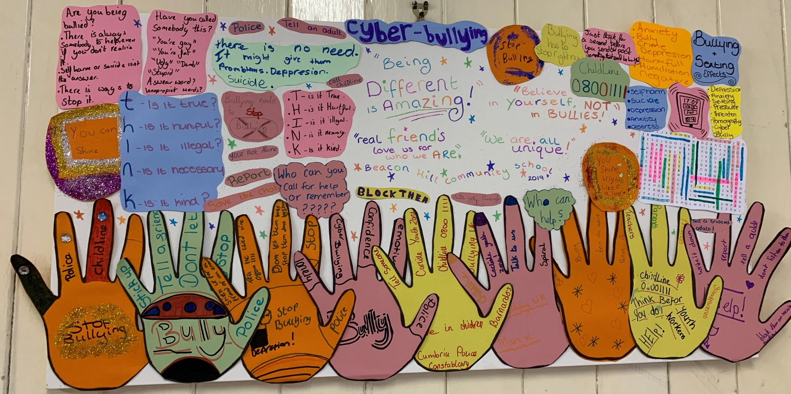

Together WE who have been delivering exam stress and body image workshops within schools and youth clubs around Allerdale and Copeland. Extremely positive feedback has been received around the workshops.

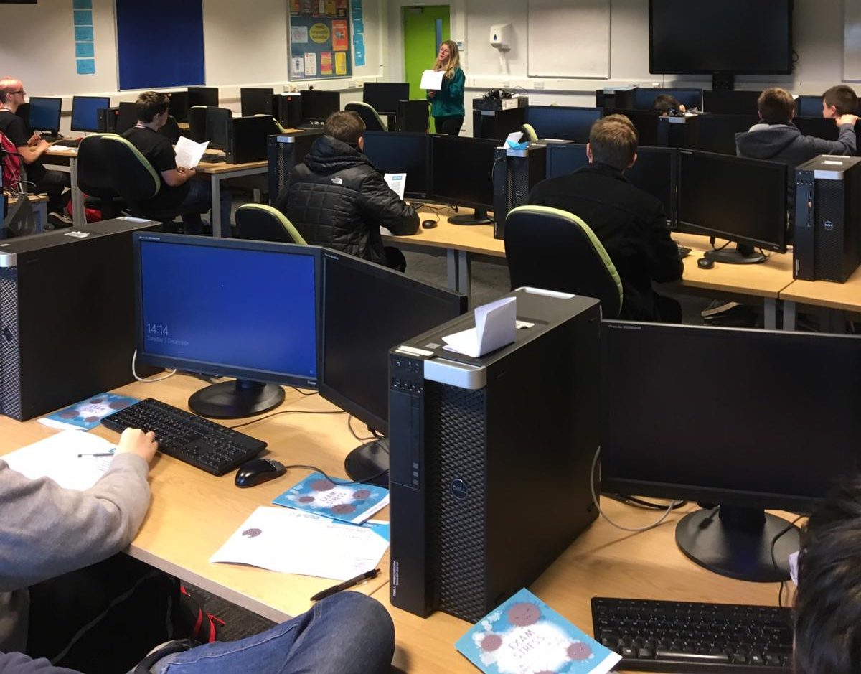

Wigton Youth Station who have been planning and organising an event around positive relationship. The date and location of the event will be on our Facebook page soon so keep an eye out!

Thank you to everyone for another successful year! Now for year 3!

