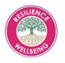
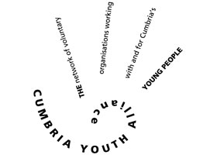
Name
Address and post code
Contact telephone number
Email Address
Gender

Cumbria Youth Alliance – Online learning registration from

This must be completed for all individual registrations – return the form to Sophie@cya.org.uk to receive your unique registration number

Please answer the following

Are you a young person? If yes, please state your age
Are you a young person already working with Cumbria Youth Alliance, if yes please add your key workers name
Are you a member of another youth club or youth group? If yes, state club or youth group
Are you an organisation working with Cumbria Youth Alliance? If yes, please state organisation name
Are you a volunteer or staff member working in Cumbria supporting children, young people and families? If yes, please state the name of the organisation you work or volunteer with
Any other information you feel relevant to your online registration

By completing this form, I give permission for my data to be held in the Cumbria Youth Alliance database and agree that the Cumbria Youth Alliance may process personal data relating to me for personnel, administration, statistical and/or management purposes. Cumbria Youth Alliance will hold my data in line with the General Data Protection Regulation (GDPR) as it applies in the UK, tailored by the Data Protection Act 2018

