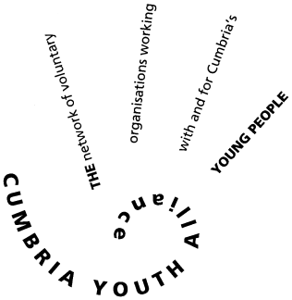

Full time Project Worker Pre-Employment Project West Cumbria
Salary of £19500 -£22500 depending upon experience and qualifications
Generous travel and pension contributions
Short term up to and including the 31st March 2021

Thanks to funding from Cumbria Community Foundation and Coalfields Regeneration Trust we are seeking a full -time project officer on a fixed term post until 31st March 2021.
This may be extended if additional funding can be secured.
The key role is to support 20 young people 16- 24 who are some distance from the labour market and provide them with a holistic support package which will allow them to be job ready and able to compete in the local jobs market. This will include assessing need and developing a suitable training and development package for each young person, so they progress toward employment. Many of the young people will have additional support needs such as poor emotional resilience or basic skills needs and a holistic asset-based approach will be required to enable them to overcome barriers to entering the labour market.
(Youth work approach working with the young person where they are at)
You will be based in the Workington office, but some contact work can be done from home and you will be part of a wider team at Cumbria Youth Alliance addressing youth unemployment across West Cumbria with a variety of partners. Young People will come from a variety of communities across West Cumbria and you may be required to travel to meet young people in a public space.
You will be supplied with a lap- top and mobile phone for work use.
Mileage is paid for all miles undertaken but does not cover travel to your place of work at CYA.

Role/job description
You will be responsible for interviewing young people to assess suitability for the programme
You will be working with referral agencies to generate referrals and reporting back to them on young people’s progress
You will carry out initial assessments using the Outcomes Star Tools (training provided)
You will alongside the young person develop/agree a training and development plan using the results of the Outcomes Star assessment and based on the young person’s aspirations
You will provide support one to one and in small groups delivering training sessions to build on existing skills and knowledge and address barriers to employment. This will cover employability and work preparation as well as improving mental health and confidence building.
Deliver where identified ASDAN qualifications to boost employability
You will measure the impact of the support on the young person as they progress through the programme and be able to accurately repot on the impact your work has upon the lives of the young people who take part.
Refer them to other programmes internally and externally when they are ready so they may progress into employment or require additional support needs from other agencies.
You will manage a small budget and gather data to provide evidence trail for the funders on expenditure
You will comply with the paperwork requirements of the funders and maintain records to a satisfactory standard to meet external audit requirements. These records will be both paper based and electronic.
You will have previous experience of supporting young people who are unemployed and be committed to using an asset- based approach in all the work you do.
You will provide monthly reports on what has been achieved directly to your line manager
Training and development support will be available for the post holder

This post is subject to DBS checks and provision of references one of which must be from your current or most recent employer. The post may be extended if follow on funding can be secured.
please request an application pack by phoning Cumbria Youth Alliance on 01900 603131
For more information please email cath@cya.org.uk

