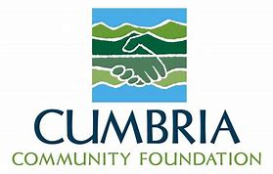
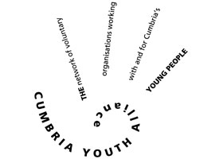
Name:
Address and post code:
Contact telephone number:
Email Address:
Gender:

Cumbria Youth Alliance – Tackling Gaming Addiction Registration Form

This must be completed for all individual registrations – please return the form to Sophie@cya.org.uk to receive your unique code.

Please answer the following:

Are you a young person? If yes, please state your age
Are you a young person already working with Cumbria Youth Alliance? If yes, please add your key workers name
Are you a member of another youth club or youth group within Cumbria? If yes, please state the club or youth group
Are you an organisation working with Cumbria Youth Alliance? If yes, please state the organisation’s name
Are you a volunteer or staff member working in Cumbria supporting children, young people and families? If yes, please state the name of the organisation you work or volunteer with
Any other information you feel relevant to your online registration

By completing this form, I agree to complete a short survey monkey upon completion of the free training.

I also give permission for my data to be held in the Cumbria Youth Alliance database and agree that Cumbria Youth Alliance may process personal data relating to me for personnel, administration, statistical and/or management purposes. Cumbria Youth Alliance will hold my data in line with the General Data Protection Regulation (GDPR) as it applies in the UK, tailored by the Data Protection Act 2018.

