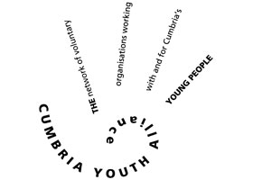

Name:
Address and post code:
Contact telephone number:
Email Address:
Gender:

Cumbria Youth Alliance – Training Registration Form

Please complete and return the form to katie@cya.org.uk to be registered.

Please answer the following

Are you a young person? If yes, please state your age.
Are you a young person already working with Cumbria Youth Alliance? If yes please add your key workers name.
Are you a member of another youth club or youth group? If yes, please state club or youth group.
Are you an organisation working with Cumbria Youth Alliance? If yes, please state organisation name.
Are you a volunteer or staff member working in Cumbria supporting children, young people and families? If yes, please state the name of the organisation you work/volunteer with.
Any other information you feel relevant to your online registration?
Which of the following would you like to sign up for?
Tackling Gaming Addiction [yes/no]
Embrace Learning Modules [yes/no]
Tackling Underage Gambling Addiction [yes/no]
Understanding Adverse Childhood Experiences (ACE’s) [yes/no]

By completing this form, I give permission for my data to be held in the Cumbria Youth Alliance database and agree that the Cumbria Youth Alliance may process personal data relating to me for personnel, administration, statistical and/or management purposes. Cumbria Youth Alliance will hold my data in line with the General Data Protection Regulation (GDPR) as it applies in the UK, tailored by the Data Protection Act 2018

