Short-term joint staff training event
WEB 2.0. TOOLS AND ROBOTICS

Petrijanec, Croatia, June 5-9 2019.

Disclaimer: This publication reflects the views only of the author, and the Commission cannot be held responsible for any use which may be made of the information contained therein.
Content
1. Interactive pictures 3
1.1. Piktochart 3
1.2. Thinglink 4
2. Easy collaboration 5
2.1. Padlet 5
2.2. Noteapp 5
3. Making newspaper and timelines 6
3.1. Penzu 6
3.2. Timeglider 7
4. Tools for making comics 8
4.1. ToonDoo 8
4.2. Pixton 9
5. Tools for making movies 9
5.1. Stupeflix 9
5.2. Kizoa 11
6. Tools for making animated videos 12
6.1. PowToon 12
6.2. Moovly 13
7. Tools for possitive classroom atmosphere 14
7.1. ClassDojo 14

Author of this publication: Jasminka Belščakk, Petrijanec, Croatia

Interactive pictures

Piktochart
link: https://piktochart.com/
- create infographic, presentations, reports, flyers, poststers
- limited, not free

- add text and graphic (shapes, icons, animated icons, lines. photos, frames)
- upload your pictures
- choose background and color scheme
- use tools
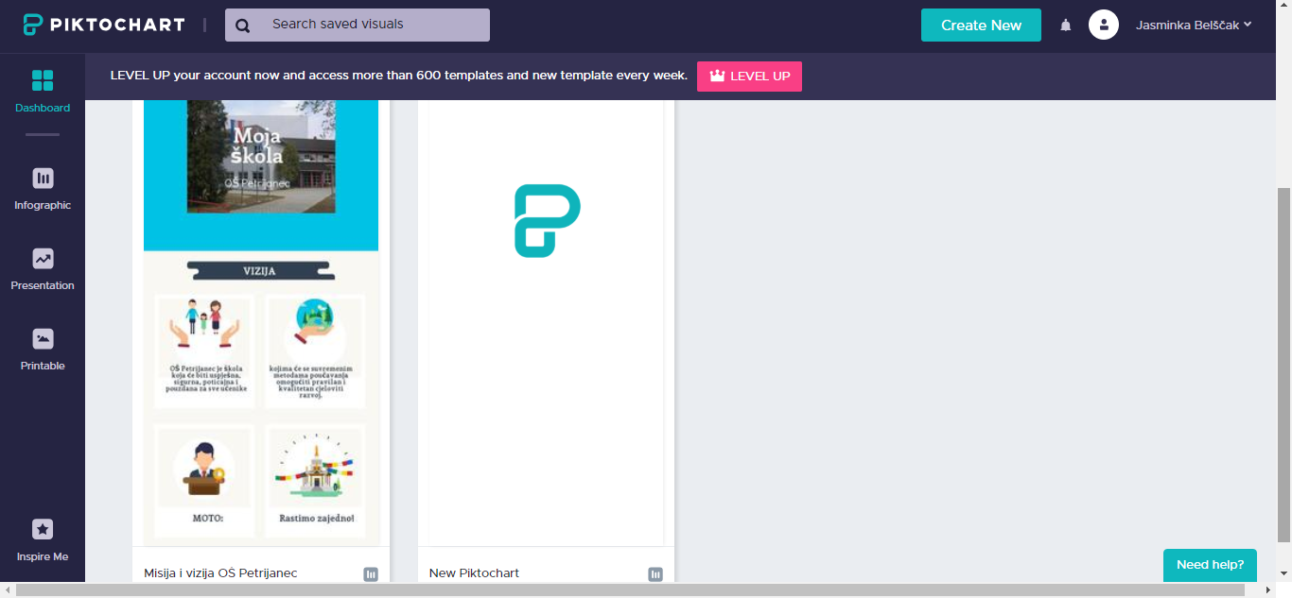
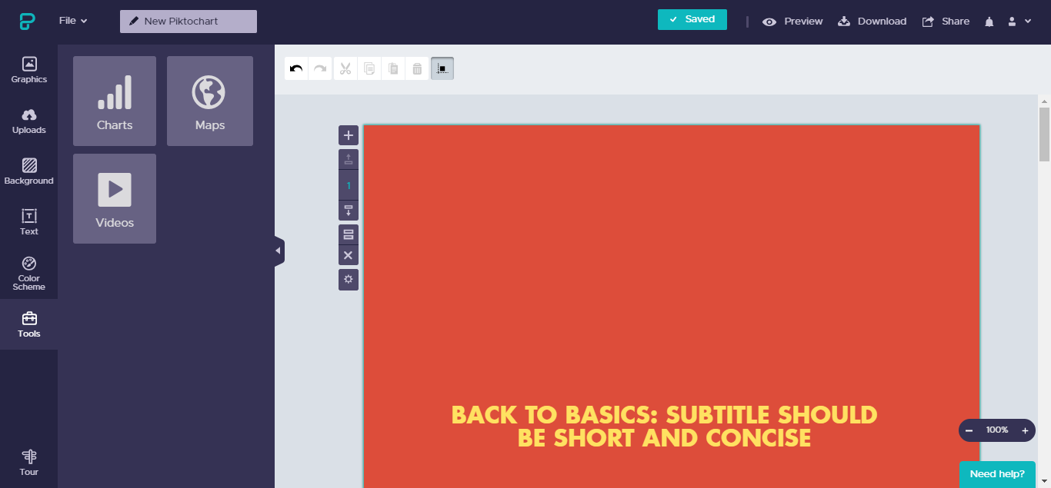

Thinglink
link: https://www.thinglink.com/
- create image, video, 360°, VR image
- free
- insert image
- choose icon image
- add tags with links, text, images or audio
- save and share (link, social, embed)

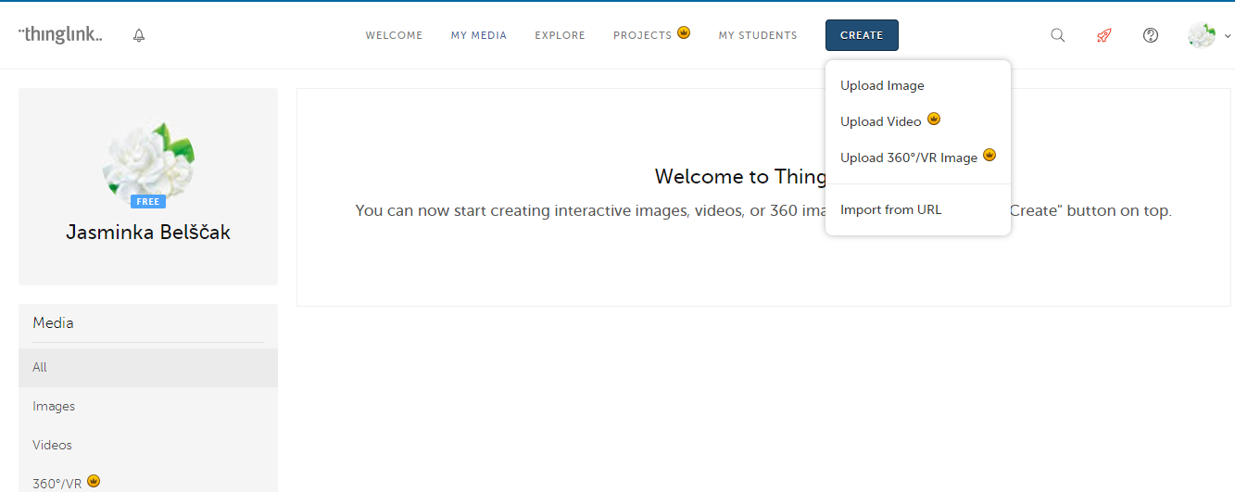
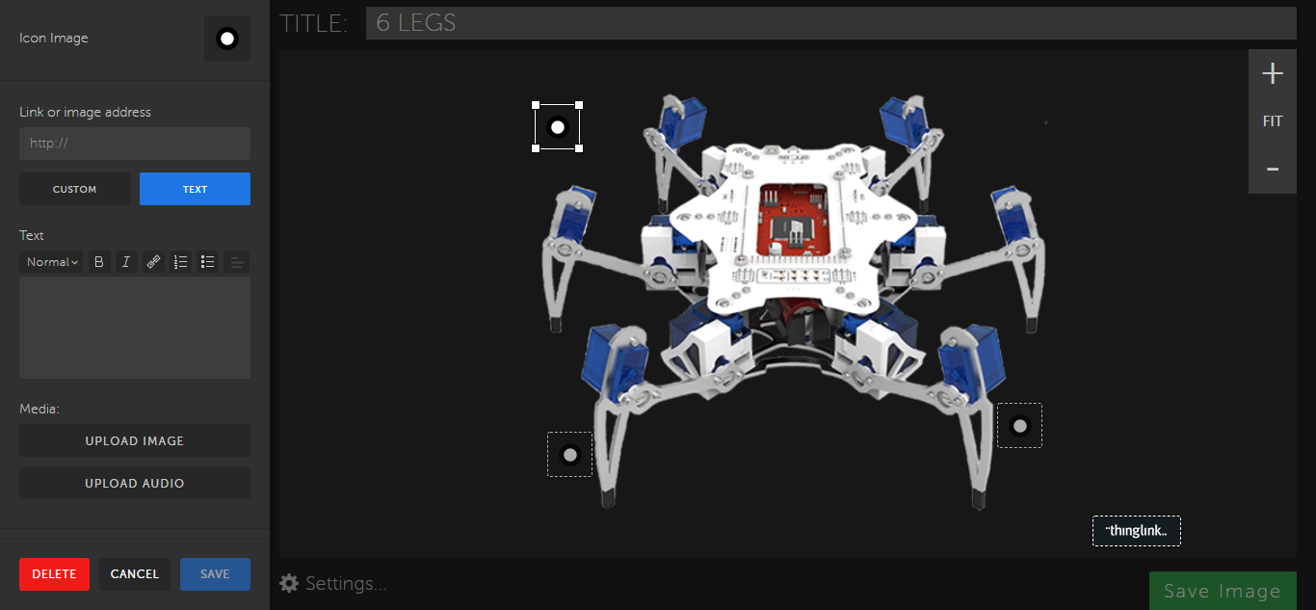

Easy collaboration

Padlet
link: https://padlet.com
- free
- make a Padlet (wall, canvas, stream, grid, shell, backchanel)
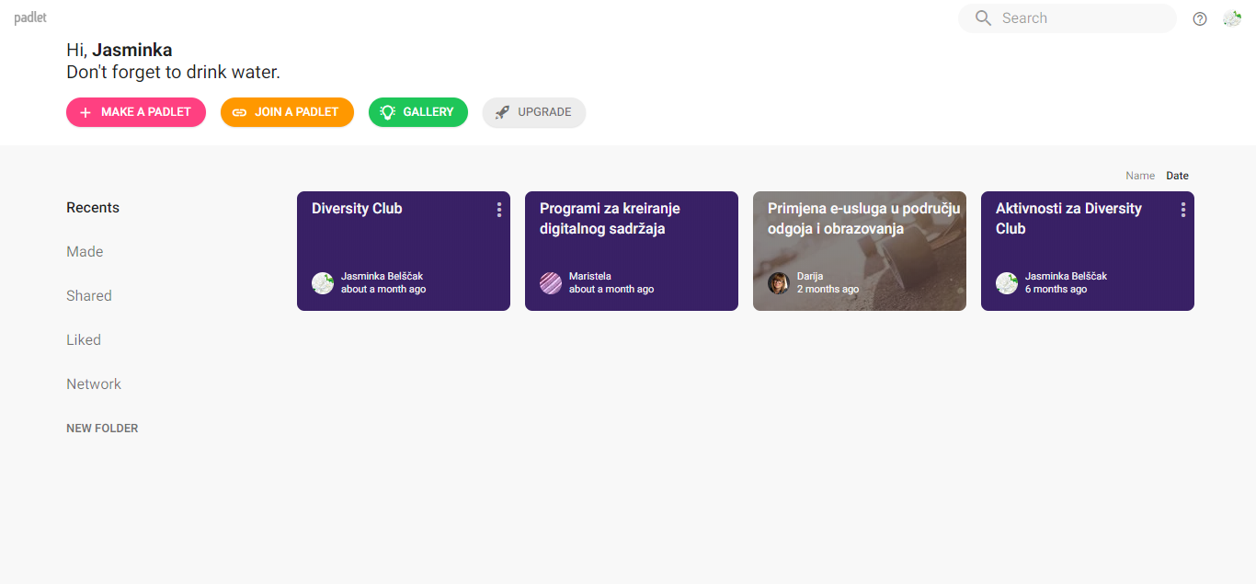

Noteapp
link: https://noteapp.com/
- free for one board
- add a board
- add name
- Settings: design, permissions…
- klick to add note
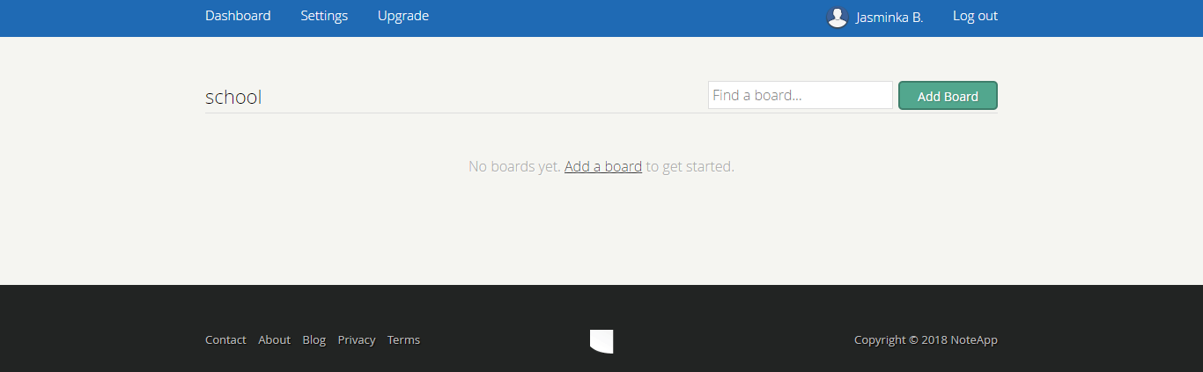

Making newspaper and timelines

Penzu
link: https://penzu.com/
- online journal
- free for 1 newspaper
- choose theme (background, font)
- insert entry
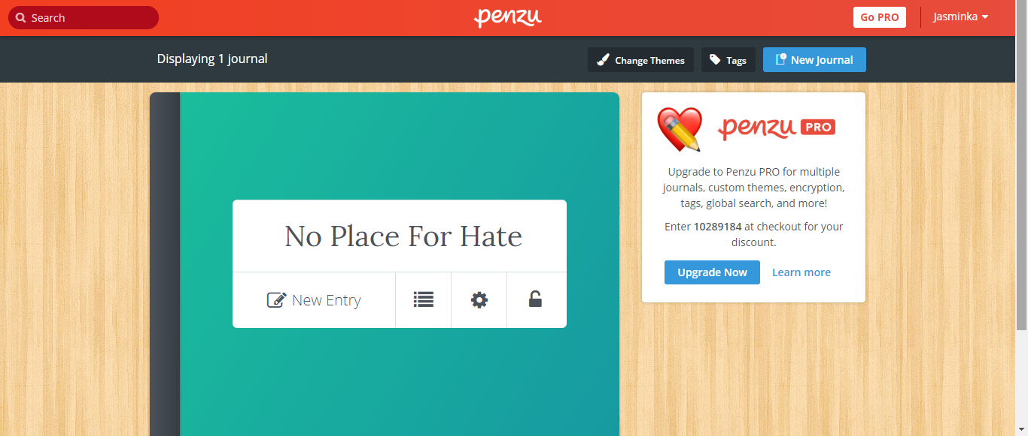

Timeglider
link: https://timeglider.com
- making timelines
- add event (date, time, text or picture)
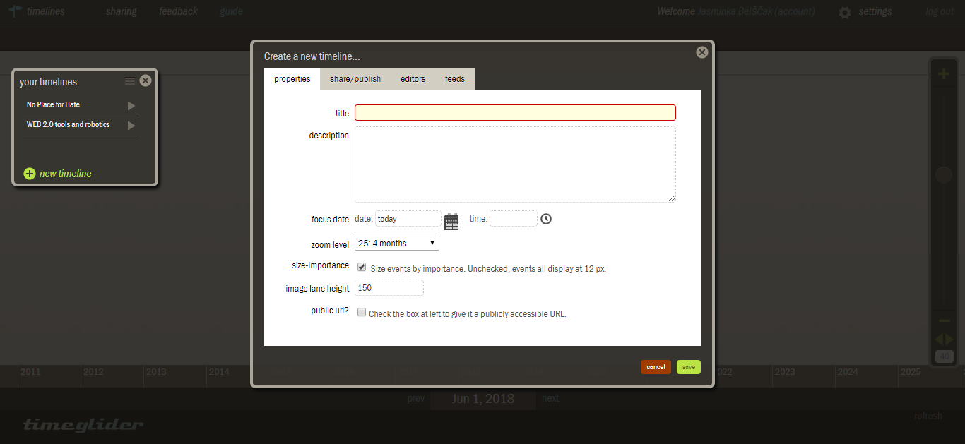
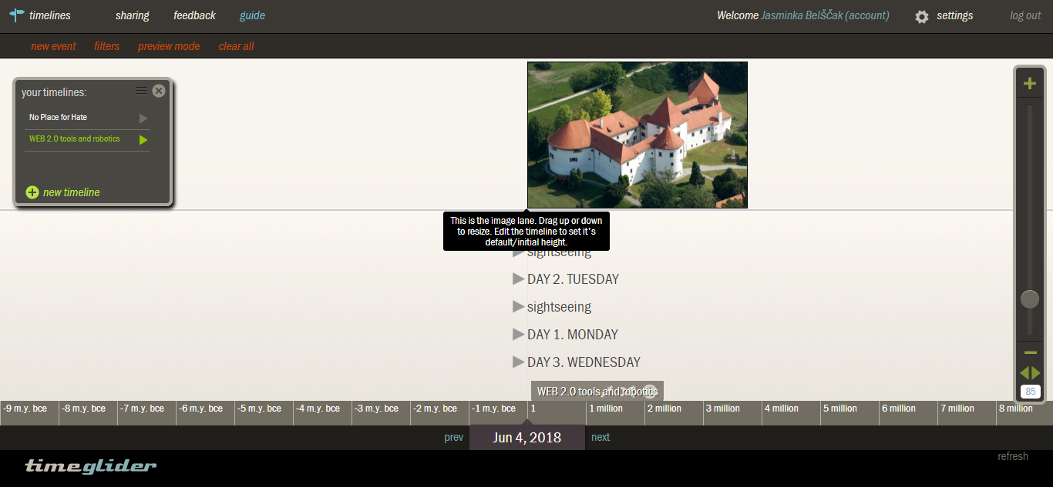

Tools for making comics

ToonDoo
link: http://www.toondoo.com/
- Aplication for creating comic strips and cartoons
- Create Toon, books
- Choose character, background, insert new characters ....
- Save and share finished books

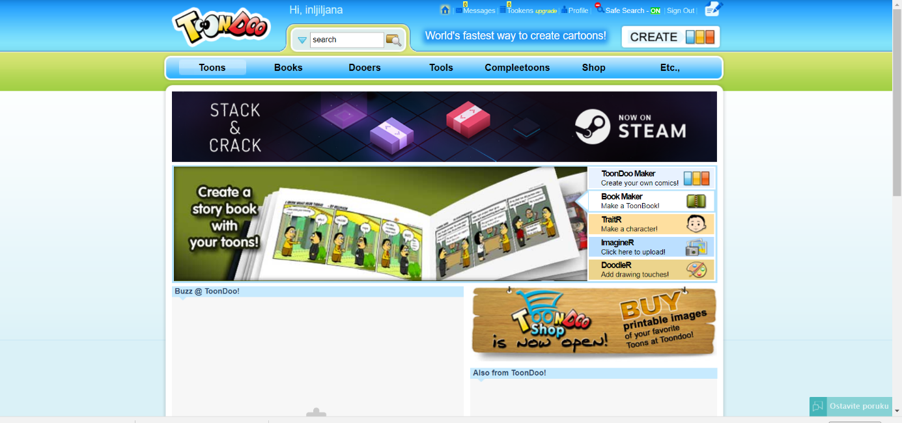
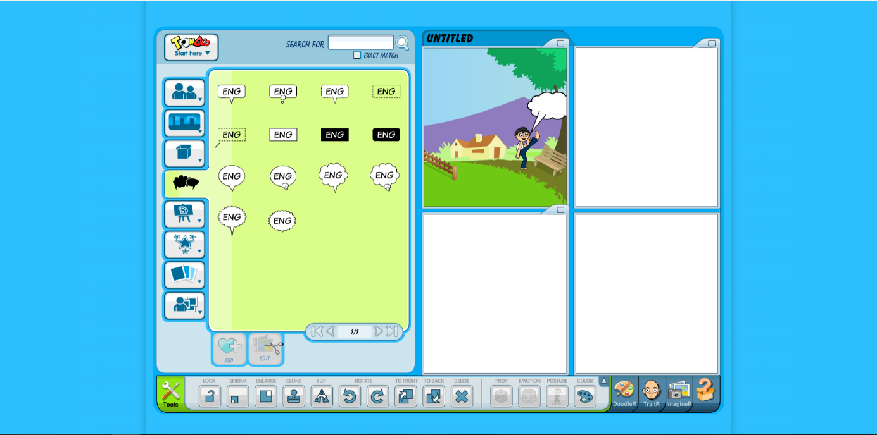

Pixton
link: https://www.pixton.com/
- Aplication for creating comics and storyboards
- Choose character, background, insert new characters
- Choose avatar, comics, characters, books

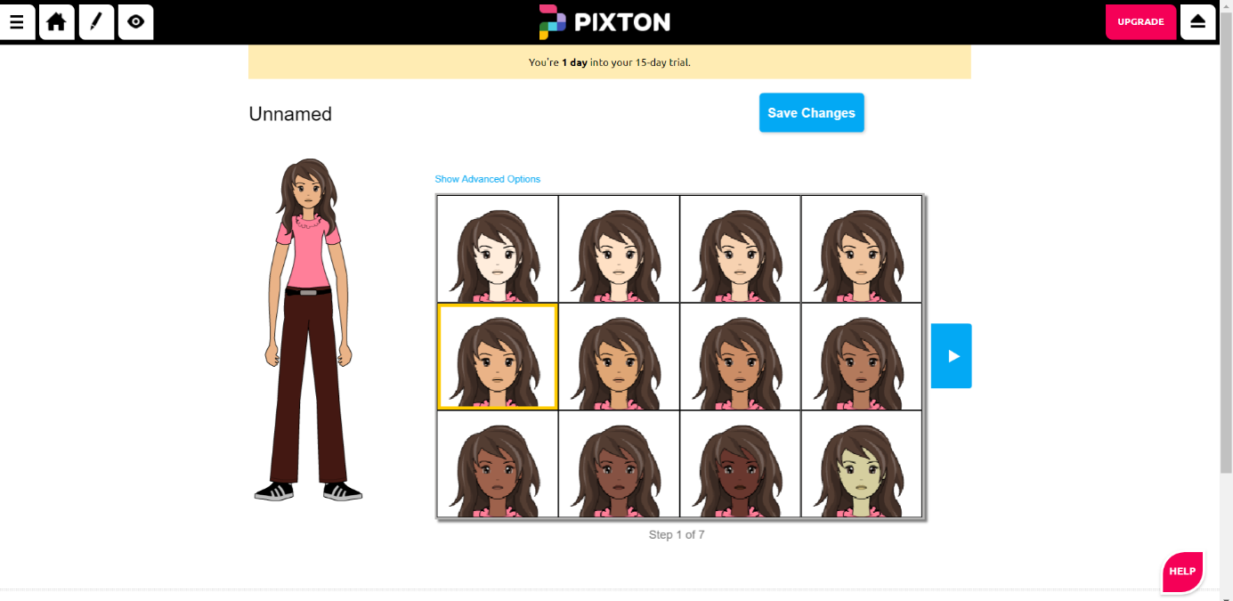
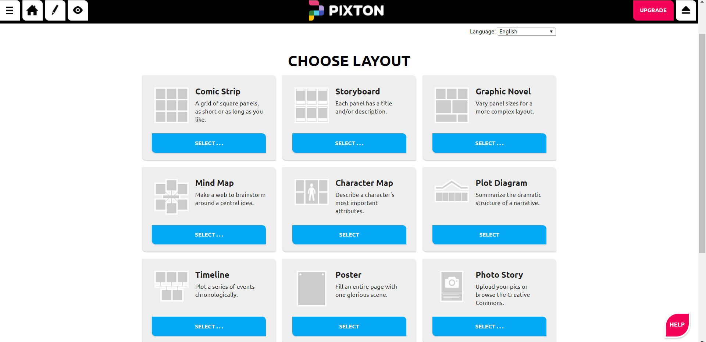

Tools for making movies

Stupeflix
link: https://studio.stupeflix.com

- Add photos, videos, music, text
- Choose a movie template
- Choose animations, effects, transitions
- Save, dowload and share movie
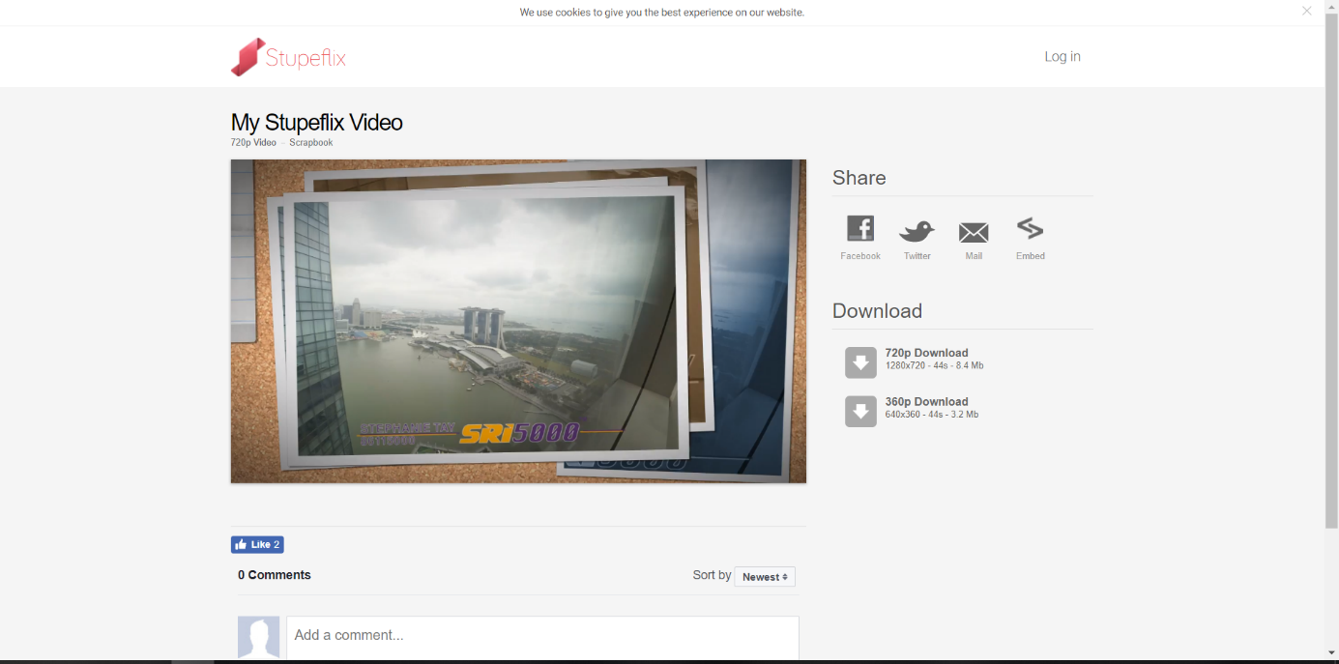

Kizoa
Link: https://www.kizoa.com/

- Add photos, videos, music, text
- Choose a movie template
- Choose animations, effects, transitions
- Save, download and share movie
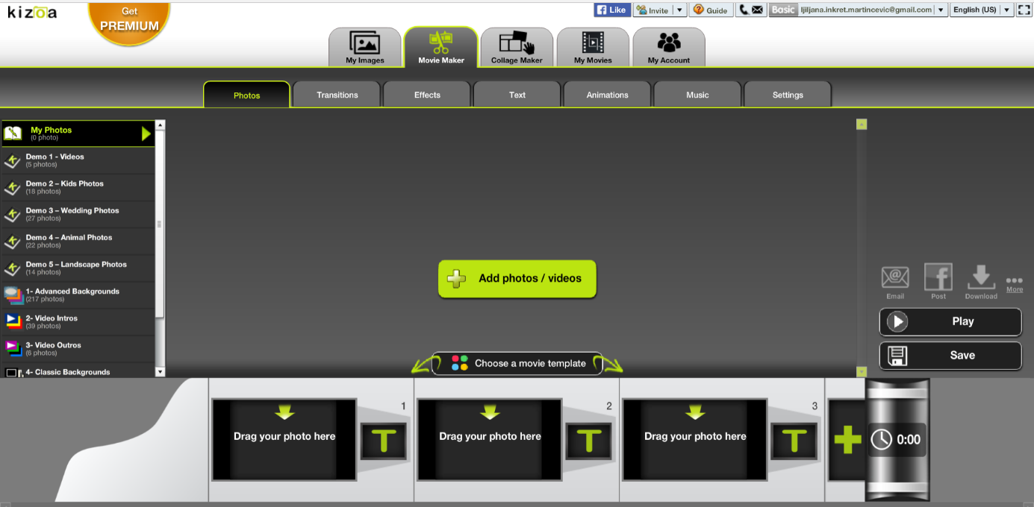
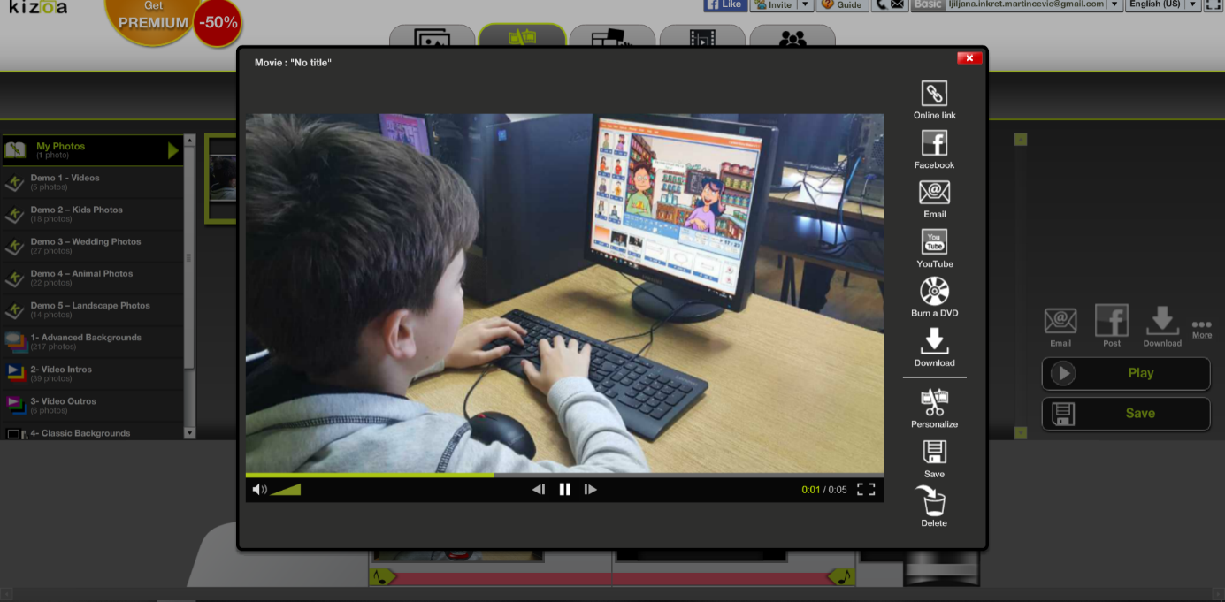

Tools for making animated videos

PowToon
Link: https://www.powtoon.com
- Create video or presentation
- Choose Powtoon
- Choose template, storyboard
- Save, download and share videos, presentations

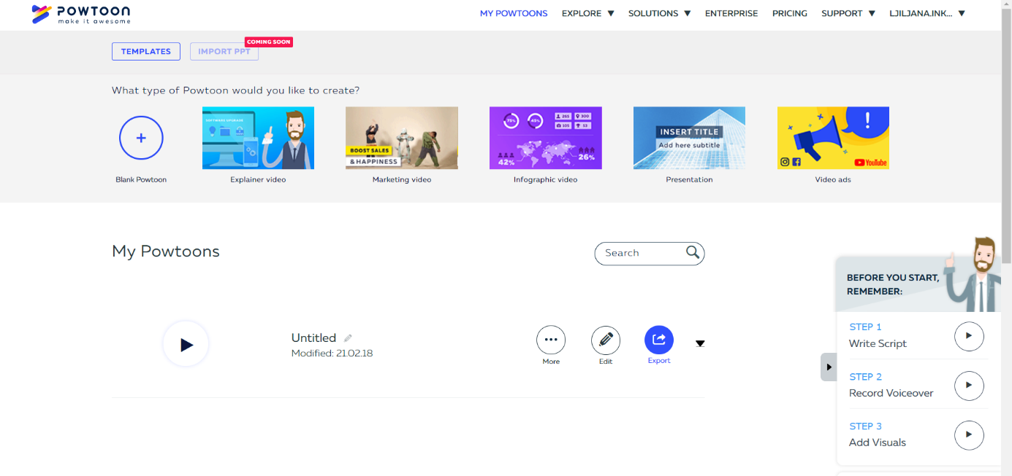
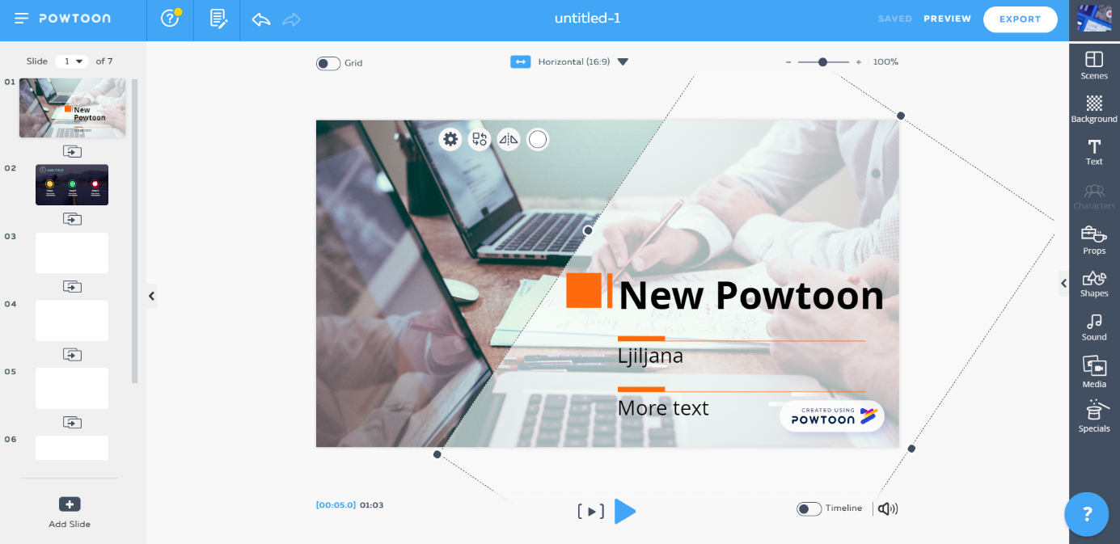

Moovly
Link: https://dashboard.moovly.com
- Create video or presentation
- Choose Powtoon
- Choose template, storyboard
- Save, download and share finished videos, presentations

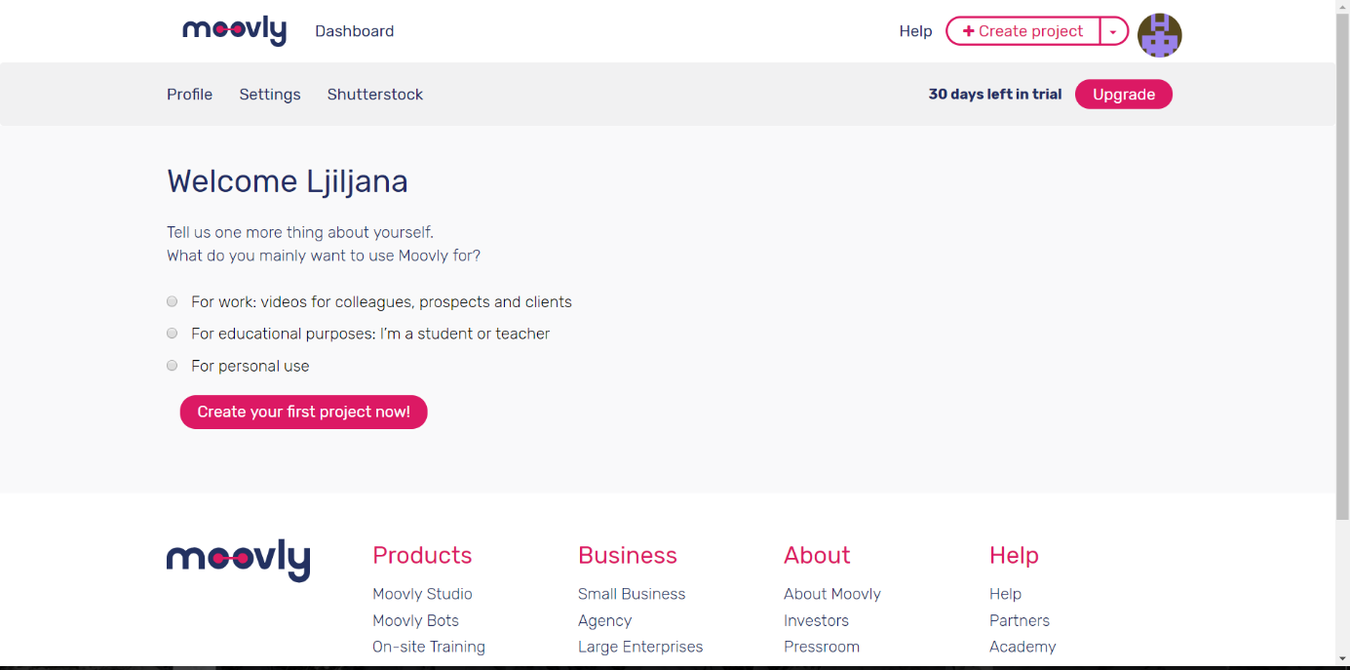
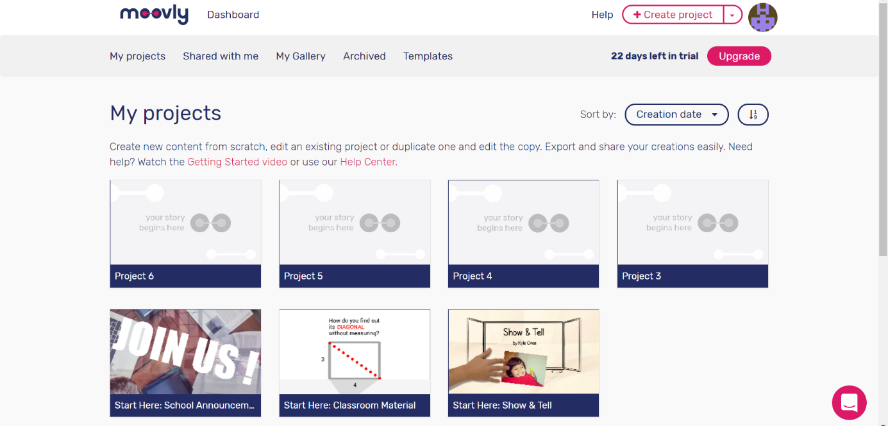

Tools for positive classroom atmosphere

ClassDojo
Link: https://teach.classdojo.com/
Build wonderful classroom communities with parents and students
- Create and select class
- Add students
- Add positive and negative elements
- Comunication toolkit
