Basic Dart Aeroplane

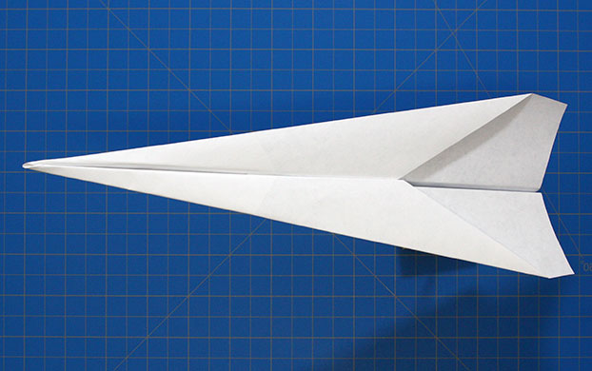

1. 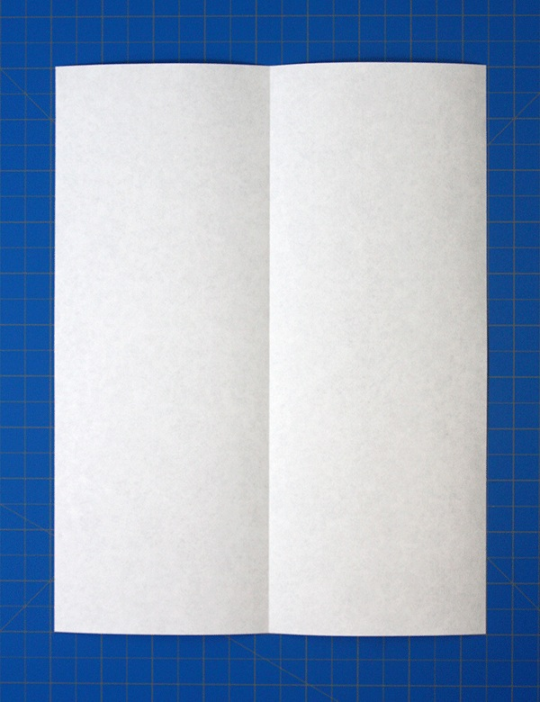

Fold the paper in half

1. 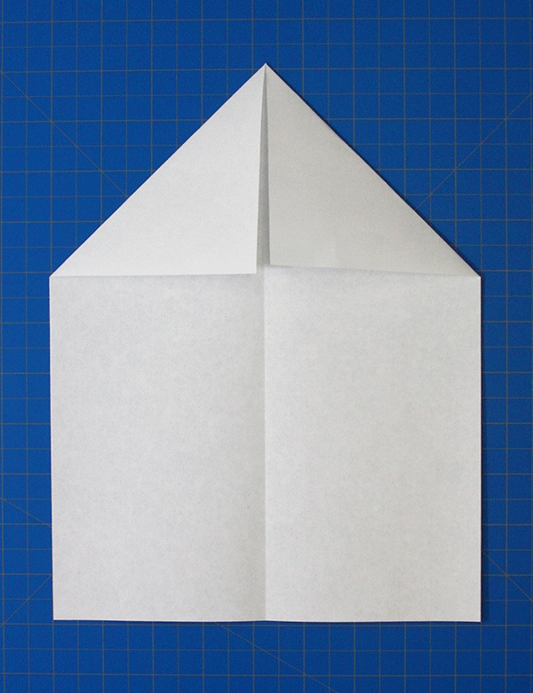

Unfold and the fold the corners into the centre line

1. 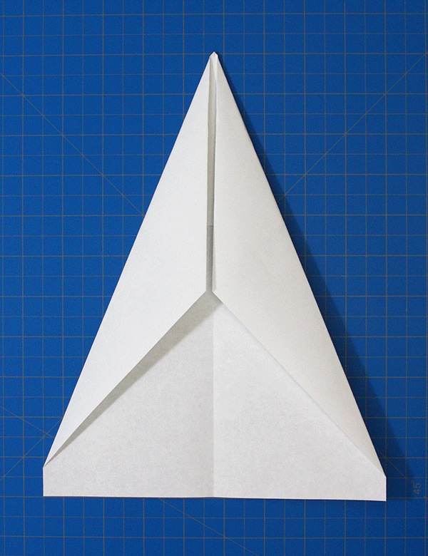

Fold the top edges to the centre

1. 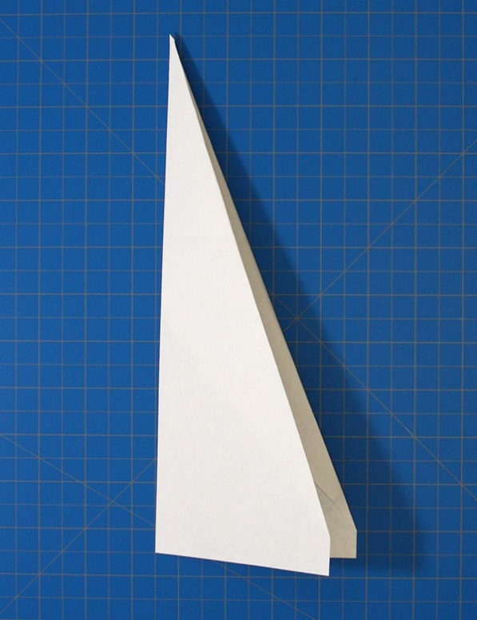

Fold the plane in half

1. 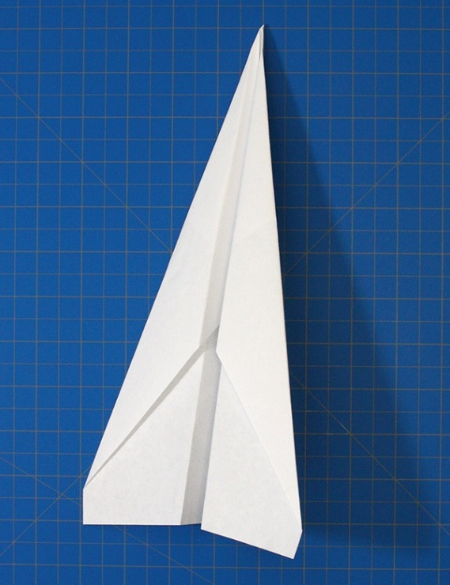

Fold the wings down to meet the bottom edge of the plane’s body