Mindful breathing
Being mindful includes ‘training’ our minds to focus on what we choose to focus on.
Practice focusing your attention on your breathing.
Sit or lie comfortably and bring your attention to your breathing.
- What does is feel like?
- Is your body moving as you breathe in and out?
- Is the air hot or cold?
After a while, your mind will probably wander to something else.
When you notice that this has happened, gently bring back your attention to your breathing.
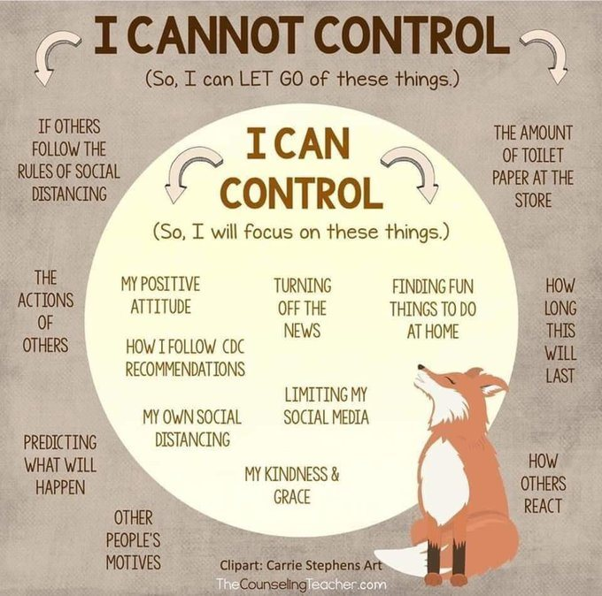
Your mind will probably wander again, and when it does, notice what has happened, and bring your attention back to your breathing.

What can you control? | What can you not control?

Visualisation exercise
This exercise involves using an image as a way to focus the mind. Create in your mind an ideal spot to relax. It can be:
- Real or imaginary
- Somewhere you will find restful, calming, safe and happy
- A place you would want to return to whenever you feel the need to relax
Imagine it in as much detail as you can – use your senses to make it as real as possible – and see yourself comfortably enjoying this place.
Now close your eyes and take a slow, regular breath in through your nose. Become aware of your breathing. Focus on your relaxation place in all its detail and breathe out through your mouth.

Emotions are like waves – they come and go
To fully get to know your emotions and to test out your predictions about them, it is important to ‘ride out the wave’.
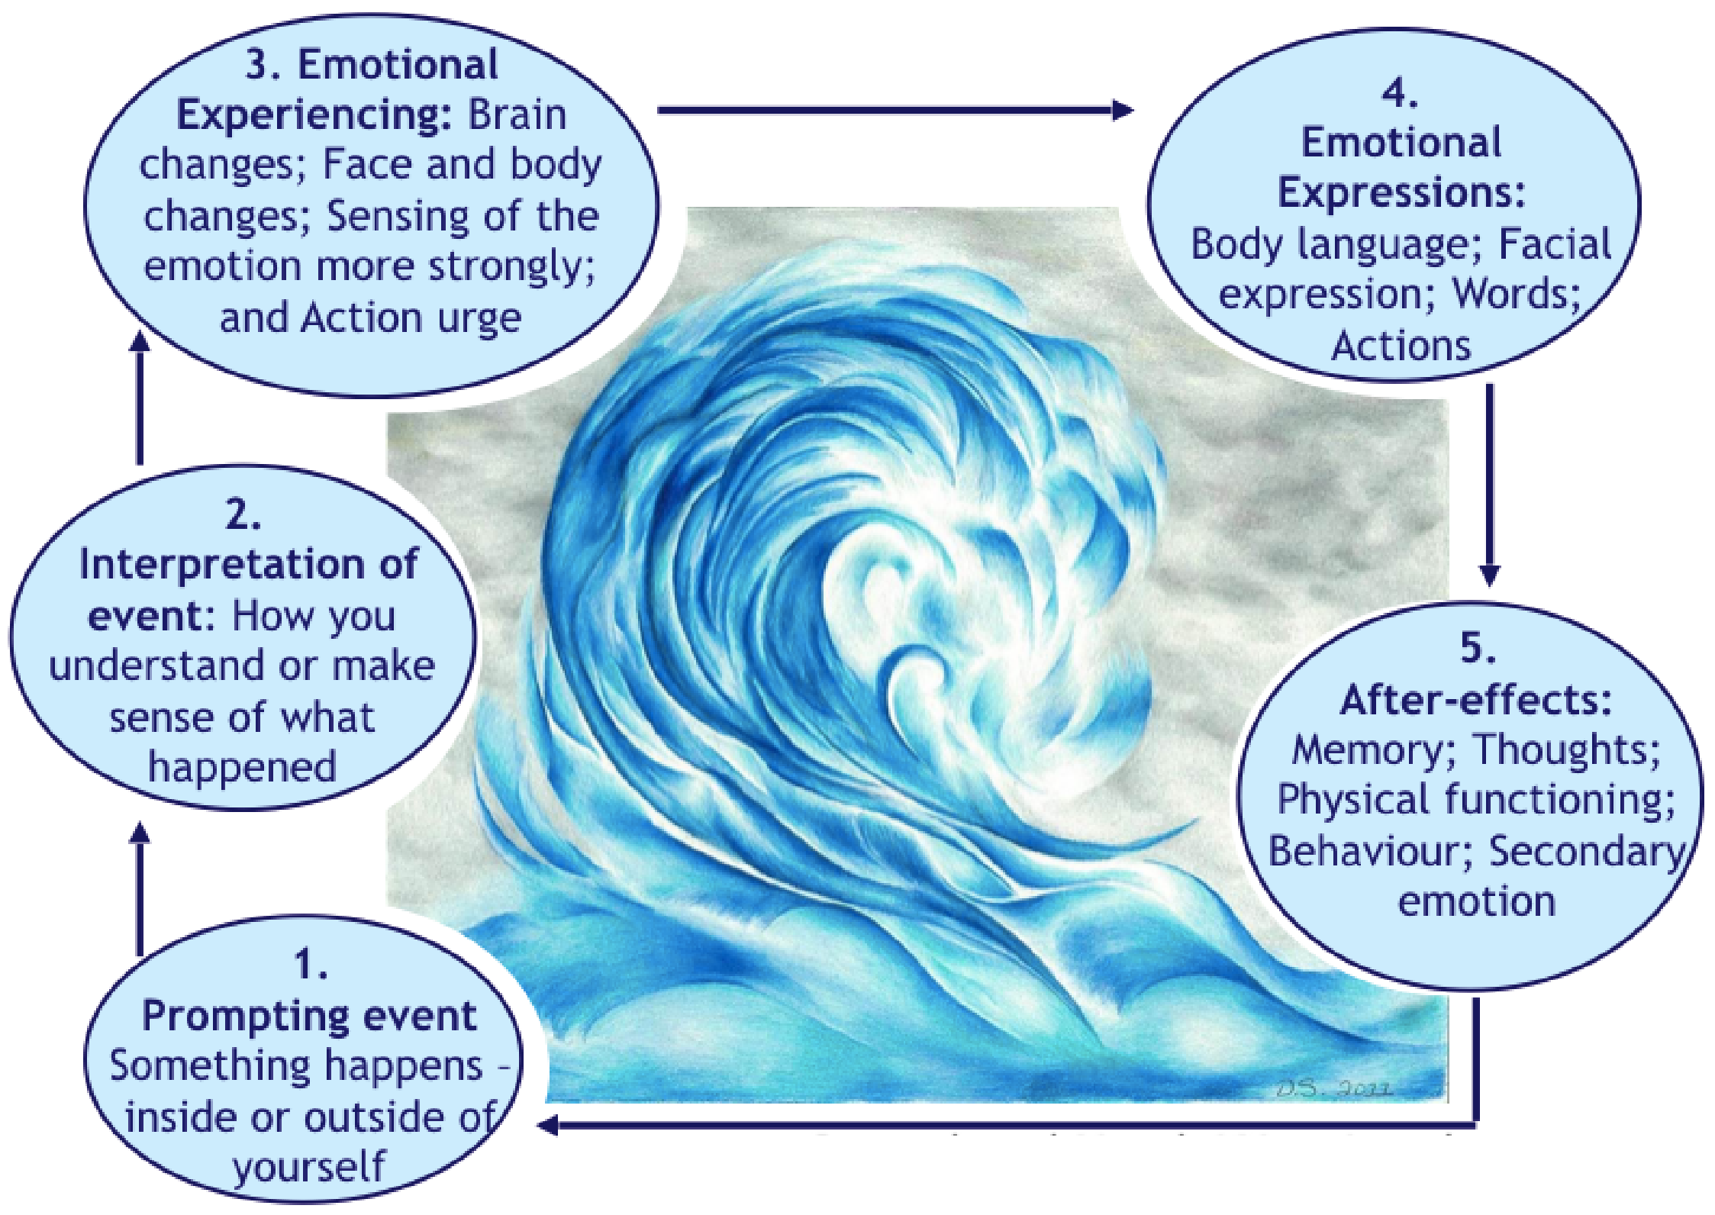
The 5 stages of describing an emotion cover the whole ‘wave’ from start to finish. It starts at the trigger of the emotion and ends at the after-effects.

Some poses are a little harder than others, so don’t worry if you can’t do them all. Just improvise and do what you can. You may find this routine calms you down, helps you sleep or makes your sore back feel better. Try it out and see if it works for you.

Radical Acceptance
Instead of resisting the pain and the emotional distress:

Accept
Accept, non-judgementally that what is happening is happening, that what you feel is what you feel and that the situation is the situation. Only then can you look at what you can change.
Remember: accepting isn’t the same as approving!
The key concept here is:

Radical Acceptance
It is letting go of fighting reality. It is the way to turn suffering that cannot be tolerated into pain that can be tolerated.

Trying to avoid pain or solve it is not effective. It actually makes it worse. So everyone has to tolerate and accept distress at times.
Remember: Pain x Resistance = Suffering

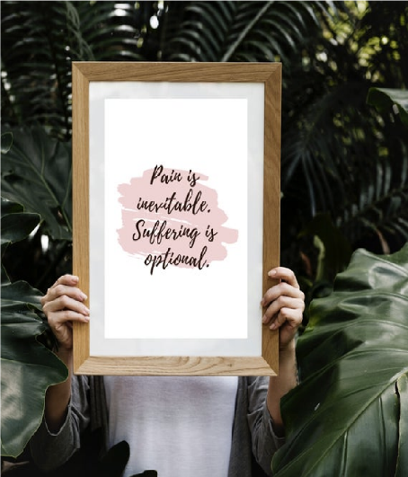

Checking In and Checking Out
- It is tough to be away from our friends and family, especially when there is a lot to worry about.
- If everything was as normal, we would be in small group and workshops and checking in and out.
- It might be a good idea to check in and out at the beginning and end of every day, just like we do in small group and workshops. We all need to work very hard to protect ourselves and our mental health during these difficult times.
- You could use this sheet to help you check in and out.
- There are some questions for you to answer in the morning and in the evening.

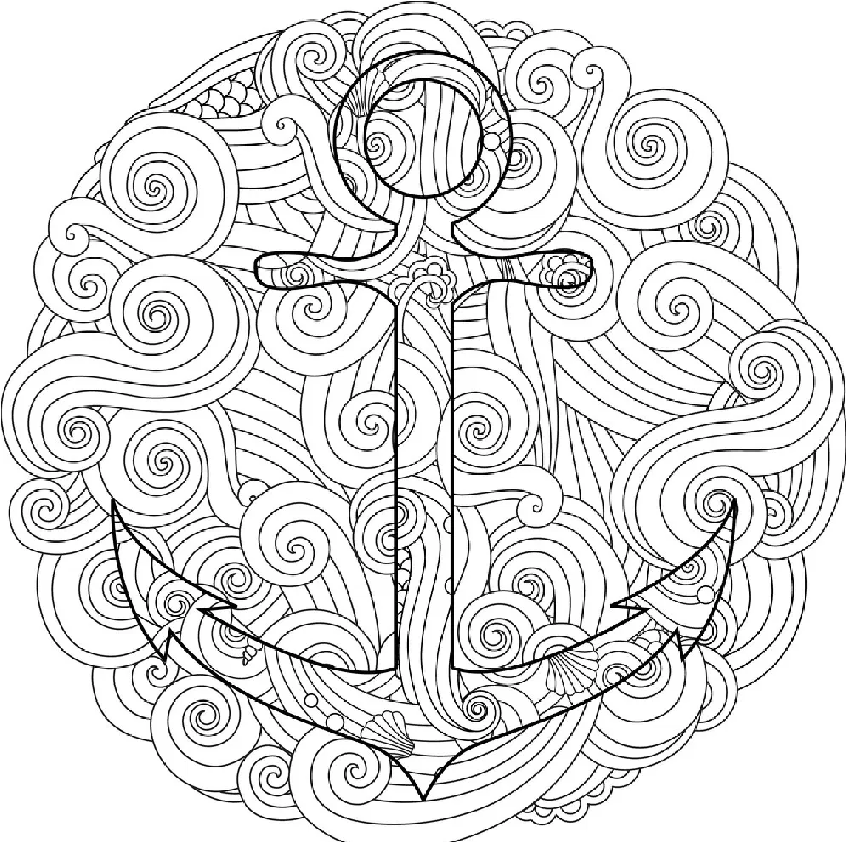

Drop your anchor mindfulness
Close your eyes, if you like, and place both your feet on the floor. Breathe in through your
nose for the count of four, and out through your mouth for the count of six. If you drift off into
your thoughts, gently escort your mind back to the present moment and anchor yourself there.
Notice the feeling of your feet on the floor, your body as it moves with your breathe, and the
experience of gently breathing. You have the capacity to soothe and ground yourself in times
of stress.

Circle what you feel when you wake up:
What am I feeling today?
Happy Calm Anxious
Sad Hopeless Disgust
Content Confused Angry
Worried Fearful Lonely
Frustrated Uncomfortable Hopeful

Something positive I would like to do today for myself:
Write positive thing you could do for yourself today:

Examples:
Some exercise for my health.
Listen to my favourite song.
Watch a good film.
Read old letters.
Look at old pictures.
Think of a happy memory.
Write a letter.

Circle what you feel this evening, before bed:
What am I feeling today?
Happy Calm Anxious
Sad Hopeless Disgust
Content Confused Angry
Worried Fearful Lonely
Frustrated Uncomfortable Hopeful

Something positive / something I enjoyed from today:
One Positive thing from today:

1st Stop
Stop: do not just react. Freeze!
Take a step back from the situation
Observe and notice what is going on
inside and outside you
Proceed mindfully and act with
awareness

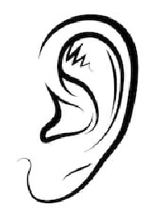
Sense Countdown

Think of:
•
5
things you can see
•
4
things you can touch
•
3
things you can hear
•
2
things you can smell

Wise Mind ACCEPTS
A good way to remember distraction techniques is to think:
Wise Mind ACCEPTS
A Activities  C Contributing  C Comparison  E Emotions  P Pushing away  T Thoughts  S Sensations | Distract yourself from negative thoughts and feelings. Engage in exercise or hobbies; call or visit a friend.  Refocus your attention onto what you can do for others. Do something for another person.  Compare your situation to others less fortunate than you, gaining a new perspective on your distress.  Leave the situation or block it from your mind. Build an imaginary wall between yourself and the situation; put the pain on a shelf, box it up and put it away for a while.  Distract yourself by finding other thoughts to concentrate on. Count to 10; count colours in a  Distract yourself with intense sensations. Squeeze a rubber ball; stand under a hot shower. Change the temperature of your face with cold water or an ice pack for 30 seconds, it changes your body chemistry.

Function of emotions
Emotion | Trigger | Function | Physical response | Action urge
Anger | Threat | Defence | Hot, sweaty, tense, adrenaline, heartbeat up | Fight / Attack
Sadness | Loss | Processing and adjusting | Tearful, heavy, withdraw, go quiet, empty, pain | Hide or seek support
Joy | Gain / Connection | Rewards / social strength | Smile, light, energetic, flushed face, feeling open, excited | Smile – get closer- talk  more
Shock/ Surprise | Threat | Be prepared | Freeze, tense, heartbeat up, eyes wide, alert | Be vigilant
Disgust | Offense and contamination | Prevention of ‘pollution’ | Nausea, withdrawal, gagging | Move away
Fear | Threat | Protection | Breathlessness, tense, adrenaline, heartbeat up | Flight/Freeze
Shame/Guilt | Breaking of social expectation | Repair / stick to social norms | Hot red face, jitteriness, suffocating, heavy chest | Hide
Jealousy/ Envy | Threat and loss | Holding on to something | Fast heartbeat, breathless, tension | Attempt to control

We have a lot of different emotions and different names for them, but their aim is the same:
- To tell you that something is going on for you (communicate something to yourself)
- To communicate to others
- To motivate us to act (which can be both helpful and unhelpful)

Urge Management Plan
- Identify the urge and rate the intensity from 0-10
- Use a ‘15 minute’ rule and start your timer (delay the urge)
- During your 15 minutes you can:
  - Use ACCEPTS, e.g. do something incompatible with the urge; do something to create a different emotion/urge or to decrease the urge.
  - Make a list of Pros and Cons
- Re-rate the intensity of the urge from 0-10. If the urge is the same or higher, repeat numbers 1-4. If the urge has decreased, move on with your day

Pros and Cons
- Make a list of the pros and cons of TOLERATING distress – coping by using skills.
Pro of tolerating distress | Con of tolerating distress | Pro of not tolerating distress | Con of not tolerating distress
e.g., Getting used to emotions, won’t lash out, won’t lose my job, ............ | e.g., Uncomfortable, I won’t know what to do, no release ....... | e.g., release of emotion | e.g., might lash out at someone else, feels bad, holding the tension
Try for yourself…
- Make another list of the pros and cons of NOT TOLERATING the distress – coping by doing something impulsive. Focus on: - long-term goals - positive consequences of tolerating the distress. - negative consequences of not tolerating your distress

Interpersonal Effectiveness
How to get what you want
Within the context that you are in and without disrespecting other people’s boundaries and needs
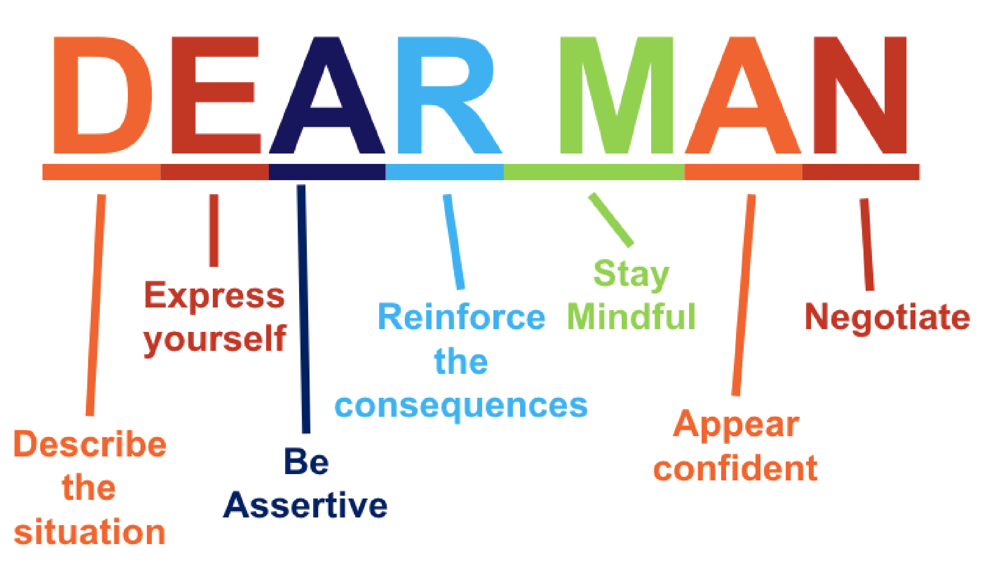
How to keep a good relationship

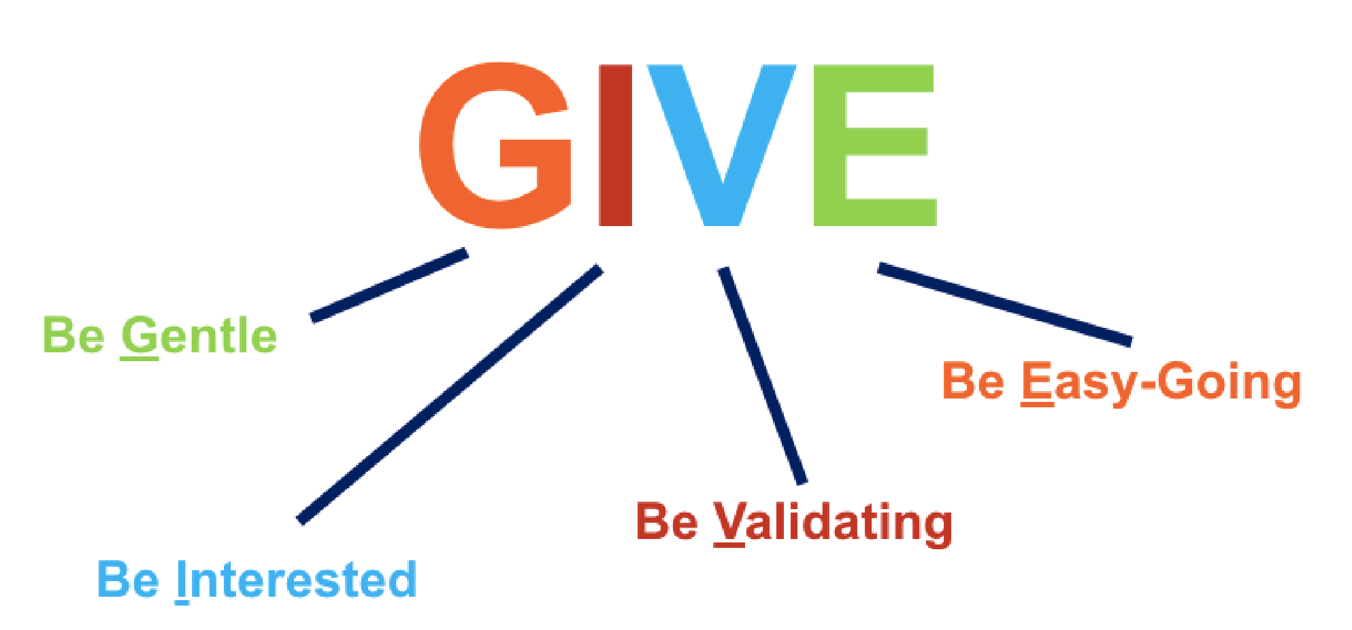

How to keep self-respect
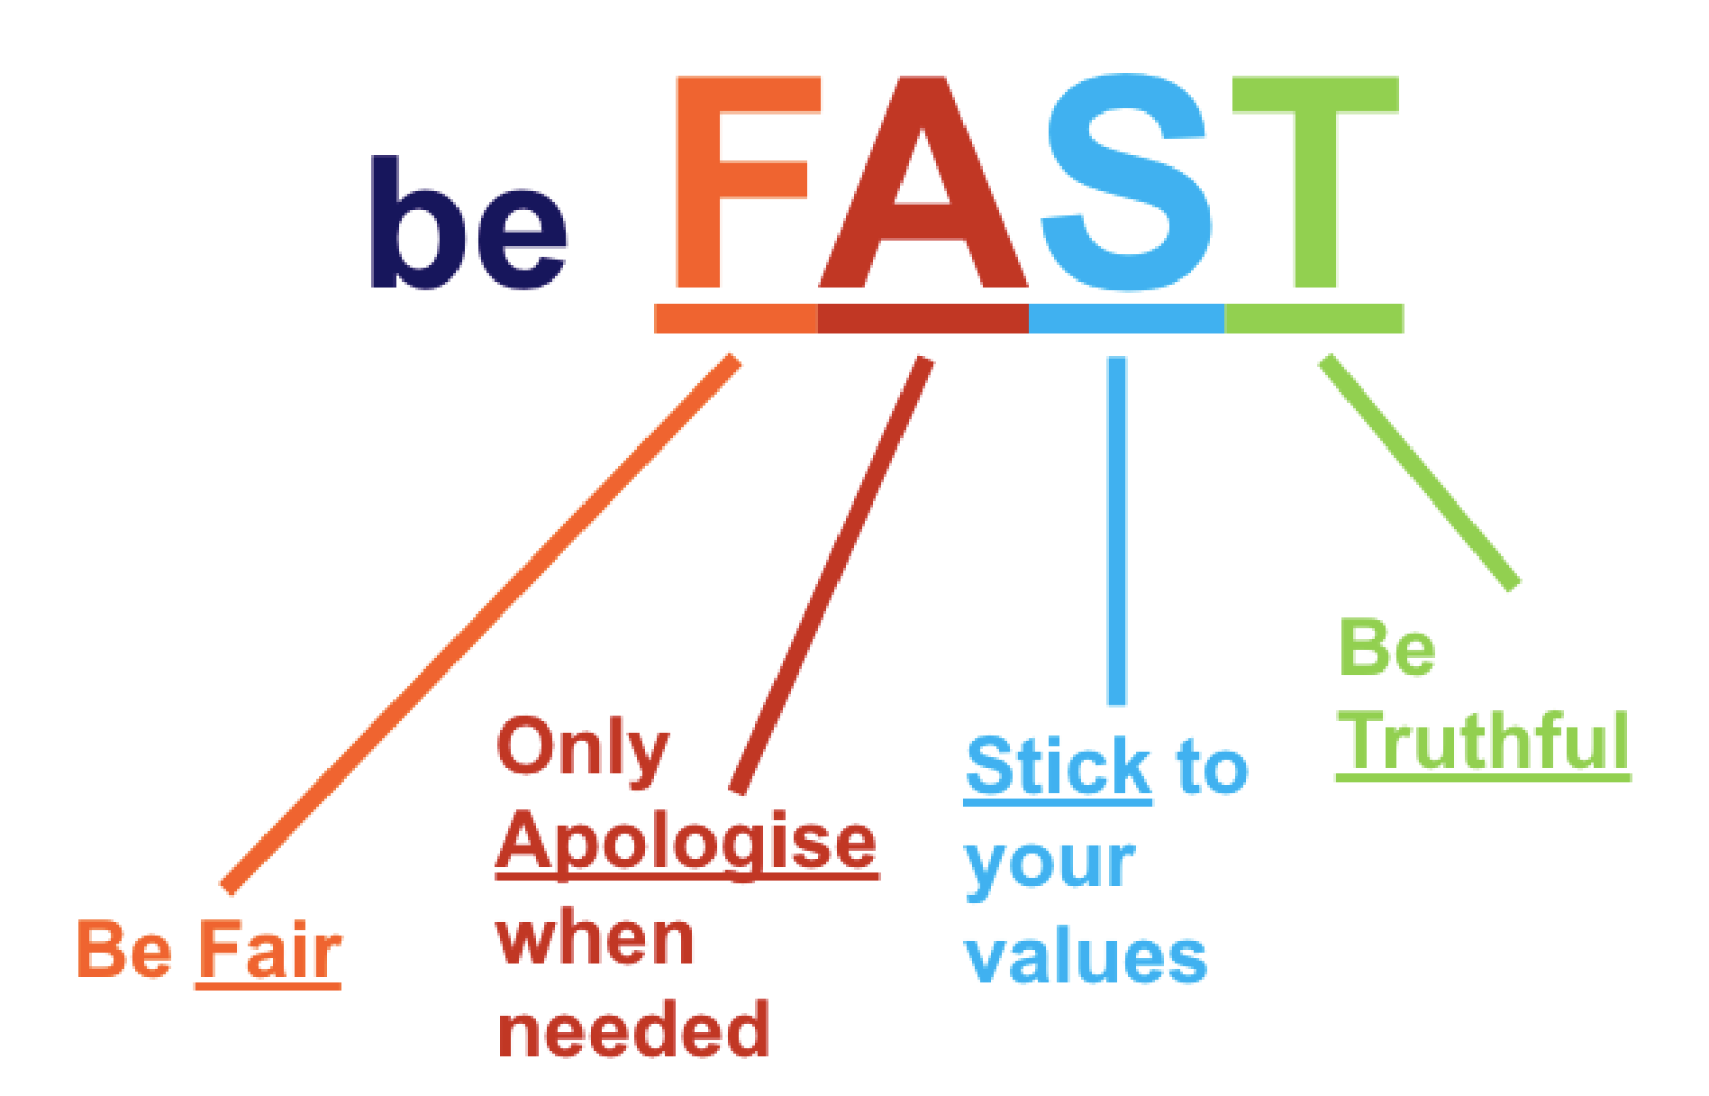
Practice
Using DEAR MAN: work through a situation in which DEAR MAN could help you reach your goal.
- Describe the current situation. Stick to the facts.
- Express your feelings and opinions about the situation.
- Assert yourself by asking for what you want or saying no clearly.
- Reinforce the reward to the person ahead of time.
- Mindfully keep your focus on your objectives.
- Appear confident.
- Negotiate by being willing to give to get.

Metaphors

Metaphor for willingness
Life is like a game of cards – You never know what hand you may be dealt, but you play with that hand anyway.

Metaphor for DBT
Having a personality disorder is like when a house has been built with wonky walls, a crooked roof, bad plumbing and dodgy electricity. Learning DBT skills is like getting builders to train you how to make the walls straight and how to fix the electricity so you can go in and make your own walls straight, fix the roof, the plumbing and electricity - bringing warmth and love in to your home.

Metaphor for learning DBT skills
When you buy a tent you make sure to put it up in the garden first as a practice and
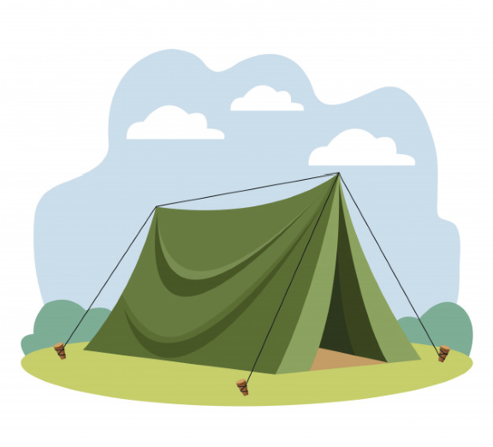
to make sure you have all the right parts for the tent. You wouldn’t wait until you were on the side of a mountain in a storm to put it up as it would be very difficult. This is like learning DBT skills it’s important to practice your skills when you are calm and in a safe space so you can use them later on in difficult situations.

Metaphor for learning mindfulness
When you are teaching a puppy to learn tricks you don’t tell the puppy off or judge the puppy negatively for wondering away and not being able to do the tricks straight away. This is like learning mindfulness - don’t judge yourself negatively for finding mindfulness hard at first or get annoyed at yourself if your mind wanders just gently bring it back.

Managing Anxiety during the Current Health Crisis

The outbreak of coronavirus disease 2019 (COVID-19) may be stressful for people. Fear and anxiety about a disease can be overwhelming and cause strong emotions in adults and children. Coping with stress will make you, the people you care about, and your community stronger.

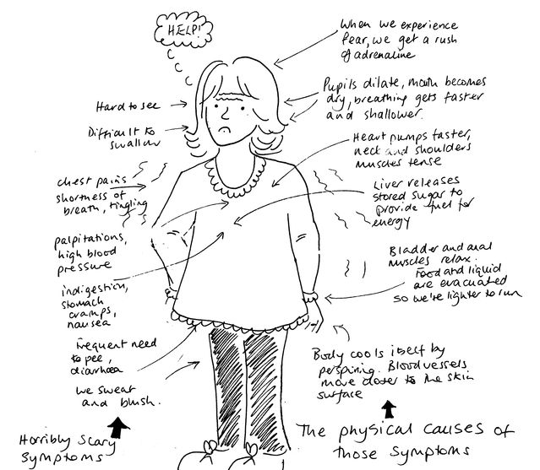

- Turn off the news. First, if it’s important, you’ll find out anyway. Secondly, a lot of what is being shared isn’t true. If you find it hard to tune out of updates completely, check in once or twice a day and no more.

- Remember, we are prone to thinking negatively. Our minds are made to protect us. As such, we are prone to pay attention to potential threats.
- When you find yourself swept up in thinking about the scary things that could happen, it’s important to remember this tendency to overestimate the likelihood of a bad outcome.
- Anxiety is linked to fear. Humans are, of course, animals, and just as it pays a mouse, for instance, to think that a rustle of feathers might be an owl about to swoop down so it can run and hide, so it pays for us to think the worse so we can protect ourselves.

- When statistics say there is a 1 percent mortality rate, we hear that much more loudly than we hear the fact we have a 99 percent chance of surviving.

- Anxiety is often worse in the mornings so start slow and build up gradually. A ‘stress’ hormone and builds up in the body in the night so when you wake up, your body is full of it. Take it one step at a time, and not try to think too far ahead. Plan bite size chunks in your day. A lot of anxiety is related to overthinking about the future – catastrophizing – and, unfortunately, we can’t control what is going to happen.

- Remember anxiety feeds on itself. One of the cruelest tricks of anxiety is that panicking about panic makes it much worse. It makes your stress hormones (adrenaline, mainly) go into alert state and then we can get caught in a big cycle of worry.
- Attempt to distract yourselves by reading a book. Stories in all forms are a brilliant way of taking our minds off our worries – pick up a novel that will transport you away from the world of panic and your anxiety levels will naturally subside.

- Don’t underestimate your resilience. Although dealing with a pandemic is not an experience many of us have had, there have been times we have lived through a crisis and survived. Remember that you usually have more strength and coping skills than you imagine, particularly when you are stressed.

- Last, but not least, remember that in feeling anxious you are not alone and what you are experiencing is completely normal. Anxiety is not permanent and the feelings will pass. You have the ability to help manage these feelings. We can’t change the situation we are in but we can take steps to change how we feel about it.

