DEFINITION
Hand Hygiene – A process that reduces the number of microorganisms on hands. Hand hygiene is a general term applying to the use of soap/solution (non-antimicrobial or antimicrobial) and water or waterless antimicrobial agent to the surface of the hands (eg. Alcohol based hand rub) Hand hygiene is the single most important method in preventing the spread of infection.

Decontaminate Hands – Application of either an antimicrobial soap/solution and water or an alcohol based hand rub product, to the surface of the hands. This process reduces microbial counts on hands

Hand washing – The application of non-antimicrobial soap and water to the surface of the hands. Gloves are not a substitute for good hand washing.

Hand Hygiene Action – A hand hygiene action can be undertaken either by rubbing with ABHR, or hand washing with soap and water.
Alcohol Based Hand Rub (ABHR) is recommended for all routine hand hygiene in all health care environments except where hands are visibly soiled. There is no limit to the number of times this can occur.

SCOPE
District Nursing Services, Palliative Care Services and PSRACS
CLINICAL ALERT
- Cuts and abrasions to be covered with an occlusive dressing
- Hand and wrist jewellery to be removed prior to performing hand decontamination and a routine procedure
- Ornate jewellery is not to be worn
- Nails: are to be kept short and clean.
- Artificial nails are not to be worn.
PROCEDURE
When should Hand Hygiene occur? – 5 HAND HYGIENE MOMENTS (See Appendix 1)
A moment is when there is a perceived or actual risk of pathogen transmission from one surface to another via the hands. Health Care Worker’s hands will come in contact with many different types of surfaces while undertaking a succession of tasks.
The 5 moments of Hand Hygiene are;
Moment 1: Before touching a client
Moment 2: Before a procedure
Moment 3: After a procedure or body fluid exposure risk

Moment 4: After touching a client
Moment 5: After touching a clients surroundings

HAND HYGIENE IN THE COMMUNITY
Indications for Hand Hygiene
- Wash hands with soap and water when visibly dirty or visibly soiled with blood or other body fluids or after using the toilet.
- If exposure to potential spore-forming pathogens is strongly suspected or proven, including outbreaks of Clostridium difficile, hand washing with soap and water is the preferred means
- Use an alcohol-based hand rub as the preferred means for routine hand antisepsis in all other clinical situations listed below, if hands are not visibly soiled
- If alcohol-based hand rub is not obtainable, wash hands with soap and water

Perform Hand Hygiene
- Before and after touching a client
- Before handling an invasive device for client care, regardless of whether or not gloves are used
- After contact with body fluids or excretions, mucous membranes, non-intact skin or wound dressings
- If moving from a contaminated body site to another body site during care of the same client
- After contact with inanimate surfaces and objects (including medical equipment) in the immediate vicinity of the client
- Before handling medication or preparing food perform and hand hygiene using an alcohol based hand rub or wash hands with either plain or antimicrobial soap and water

HAND HYGIENE TECHNIQUES

Alcohol based hand rub (ABHR)
Alcohol Based Hand Rub is recommended for all routine hand hygiene in all health care environments except where hands are visibly soiled. There is no limit to the number of times this can occur.

When decontaminating hands with an alcohol based product
- Dispense the recommended amount onto your hand (1 pump)
- Rub the product over hands and between fingers, ensuring all surfaces are covered.
- Allow the product to completely dry (See appendix 2)

Hand washing
Hand washing is indicated when hands are visibly soiled. (See appendix 3)
Conduct a risk assessment on entering the home
- Assess access to hand decontamination facilities
- Risk of contamination to client and staff member

If no access to clean water or clean physical environment
- Single use toilettes (impregnated with detergent) may be used to remove macroscopic soiling of the hands
- Hands must then be decontaminated with an alcoholic hand rub to destroy any remaining micro organisms.
- Hands should then be washed with liquid soap hand wash and running water at the first opportunity

When decontaminating hands with water in the community
- Wet hands,
- Apply a pH neutral soap and lather vigorously.
- Continue washing all surfaces of hands and fingers for 10 to 15 seconds.
- Rinse hands under running water
- Pat dry using a clean, dry towel provided by the client. Paper towels should be used in cases where clients are unable to provide a clean towel.

- If access to clean water is difficult
  - Clean (drinkable water) may be transported in a clean canister
  - The canister can be fitted with a tap for easy access

SKIN CARE HINTS

- Rinse hands thoroughly – Detergent remaining on skin has a drying effect
- Use warm not hot water – Hot water contributes to excessively dry skin
- Patting skin dry rather than rubbing prevents any stripping effect
- Use alcoholic hand rub whenever possible, natural oils are retained
- Use of powder free gloves, moisturisers and emollients when possible will protect skin from drying
- Latex allergy is becoming more common – exclude its possibility
- The use of an oil-containing lotion or a barrier cream three times a shift can substantially protect the hands of vulnerable healthcare workers against drying and chemical irritation, preventing skin breakdown
- It is important to ensure that the selected ABHR, soaps, and moisturising lotions are chemically compatible to minimise skin reactions among staff
Factors that may contribute to dermatitis include:

- Fragrances and preservatives. Commonly the cause of contact allergies; these should be kept to a minimum or eliminated when selecting an ABHR
- Washing hands regularly with soap and water immediately before or after using an ABHR is not only unnecessary, but may lead to dermatitis
- Donning gloves while hands are still wet from either hand washing or applying ABHR increase the risk of skin irritation ⁽¹⁾
- Using hot water for hand washing
- Failure to use supplementary moisturizers
- Quality of paper towels
EXPECTED OUTCOME
- All health staff will maintain standard precautions in all interactions with clients / residents.
- Staff will demonstrate an appropriate hand hygiene technique
- Microbial transmission to health care personnel and clients will be minimized
- Microbial contamination of equipment will be minimised

REFERENCES
- Australian Government Department of Health and Ageing. Infection Control Guidelines Infection control in specific Health care settings Accessed via http://www.health.gov.au/internet/main/publishing.nsf/content/icg-guidelines-index.htm July 2014.

- Bisset, L (2007) Skin care: an essential component of hand hygiene and infection control. British Journal of Nursing, 16 (16) 976-981

- Gould, D (2002) Hand decontamination. Nursing Times. 46 (98) 48 – 49. Accessed via http://www.nursingtimes.net/nursing-practice-clinical-research/hand-decontamination/205842.article July2014

- Hand Hygiene Australia accessed via http://www.hha.org.au/About/ABHRS/abhr-limitations/hand-care-issues.aspx June 2014

- Nazarko L (2009) Potential pitfalls in adherence to hand washing in the community. British Journal of Community Nursing. 14 (2) 64-68

- The Australian Commison on Safety and Quality in Health Care (2009) Hand Hygiene Australia. 5 Moments for hand Hygiene. Commonwealth of Australia via http://www.hha.org.au/home.aspx June 2014

- World Health Organization Hand hygiene technique accessed via http://www.who.int/csr/resources/publications/surveillance/Annex5.pdf on 08/10/2009.

AUTHOR/S
Marianne Cullen - Latrobe Community Health Service – Gippsland Regional Wound Project Clinical Nurse Consultant
Jan Inglis – Latrobe Community Health Service -Gippsland Regional Wound Management Project Nurse
VALIDATION
Gippsland Regional Wound Management Steering Committee

APPENDIX 1 – 5 moments of Hand Hygiene

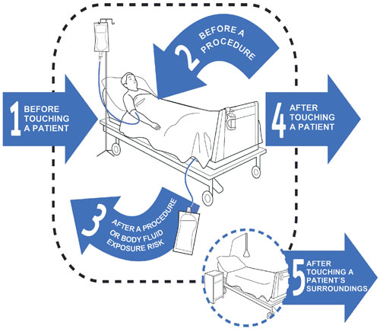
1 | Before touching a patient | When: | Clean your hands before touching a patients and their immediate surroundings
1 | Before touching a patient | Why? | To protect the patient against acquiring harmful germs from the hands of the HCW
2 | Before a procedure | When: | Clean your hands immediately before a procedure
2 | Before a procedure | Why? | To protect the patient against acquiring harmful germs (including their own) from entering their body during the procedure
3 | After procedure or body fluid exposure risk | When: | Clean your hands After procedure or body fluid exposure risk
3 | After procedure or body fluid exposure risk | Why? | To protect the HCW and the healthcare surroundings from harmful patient germs
4 | After touching a patient | When: | Clean your hands After touching a patient and their immediate surroundings
4 | After touching a patient | Why? | To protect the HCW and healthcare surroundings from harmful patient germs
5 | After touching a patient’s surroundings | When: | Clean your hands after touching any objects in the patient’s immediate surroundings when the patient has not been touched
5 | After touching a patient’s surroundings | Why? | To protect the HCW and healthcare surroundings from harmful patient germs

APPENDIX 2 - How to use Handrub

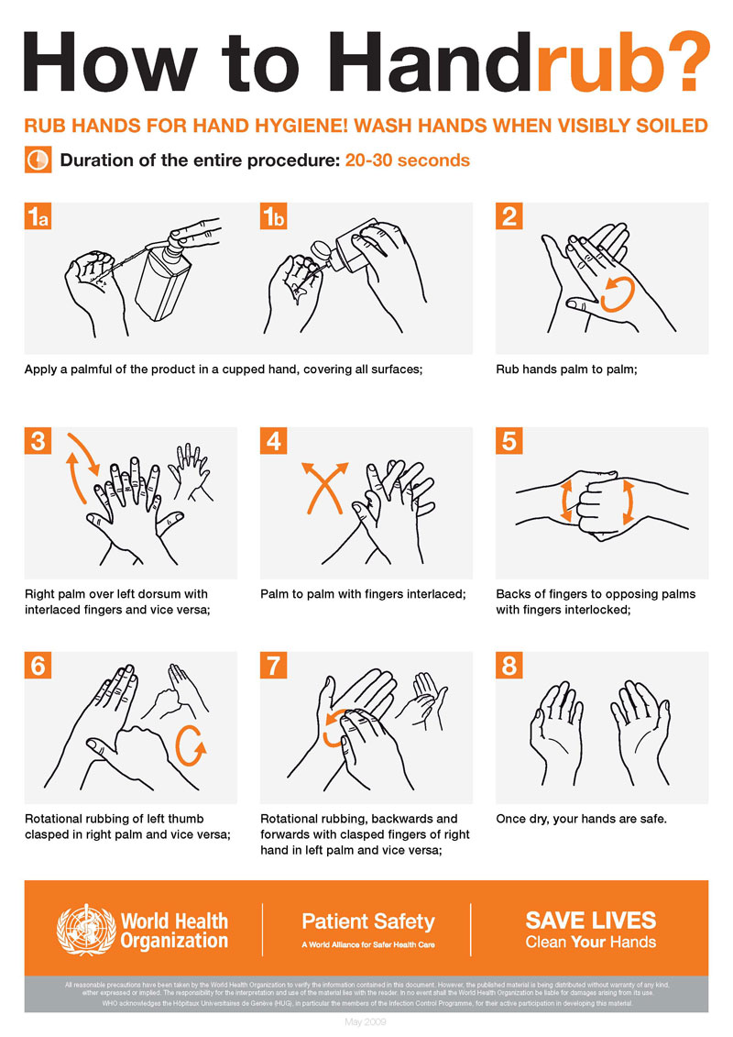
APPENDIX 3 - How to Handwash



