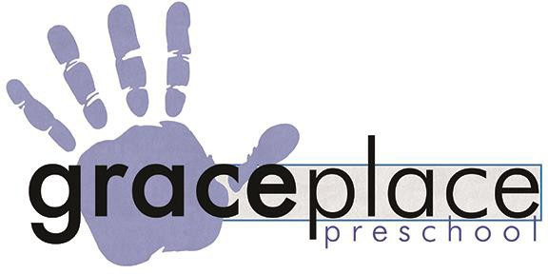
Grace Place Preschool 4001 Brooken Hill Dr Fort Smith, Ar 72908 graceplace@gracefs.com Office Hours 8am – 3pm
Operating Hours 7am – 5:30pm

2021/2022 School Year
Weekly Rates
Class 3 Days 4/5 Days
Infant Pod | $130 | $160
Upper Pod | $115 | $145

*Sibling Discount Available
* Referral Credit Available – one time $50

Registration Fee $150 (Non-Refundable) | Supply Fee $200* (Non-Refundable):
Early Enrollment Options:  $75/child paid between Feb 8-12, 2021  $100/child paid by Feb 15-19, 2021  $150/child paid after Feb. 21, 2021 | Supply Fee will be billed in two $100 payments, one  in August and one in January.

NOTE: Regular enrollment and payment is required. Each child gets one "vacation week” per year. Ie; spring break, gone from being ill, winter break, etc. Each family can choose one week they do not have to pay tuition.

Child's Name ___Date of Birth ______ _______
Parent/Guardian's Name _ Address Zip Code Phone
Email Address

Office Use Only
Class Days | State Date:
Cash/Check Registration Supply | Received By/Date
Shot Record Up To Date: Yes No Printed | Door Code:
Rates subject to change.

