“King Caspian” Lewis was seen for a kitten wellness exam on May 16th, 2019. King Caspian was found to be a healthy and happy kitten. He was tested for feline leukemia and FIV and was found to be NEGATIVE/free of either disease. I have included an image his negative test result.

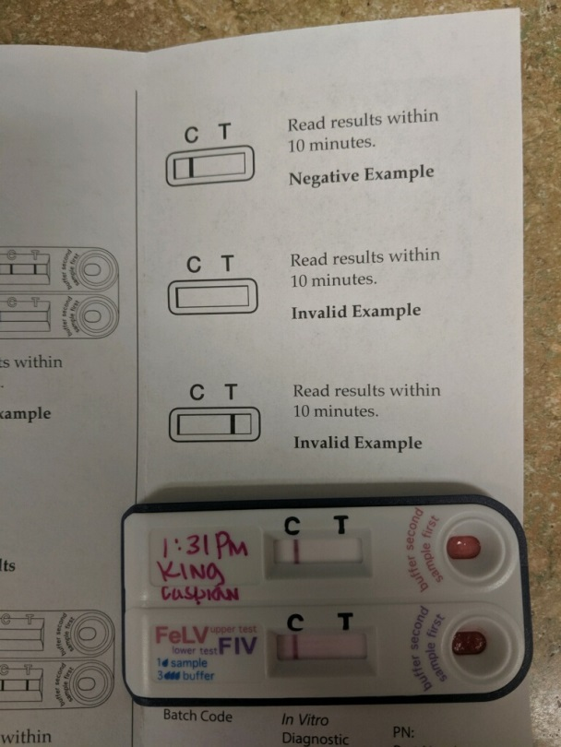

Please feel free to contact me with questions or concerns regarding King Caspian.

Sincerely,

Ryan Reusch, DVM

