“Harmony” Lewis was seen for a kitten wellness exam on July 11th, 2019. Harmony was found to be a healthy and happy kitten. She was tested for feline leukemia and FIV and was found to be NEGATIVE/free of either disease. I have included an image her negative test result.

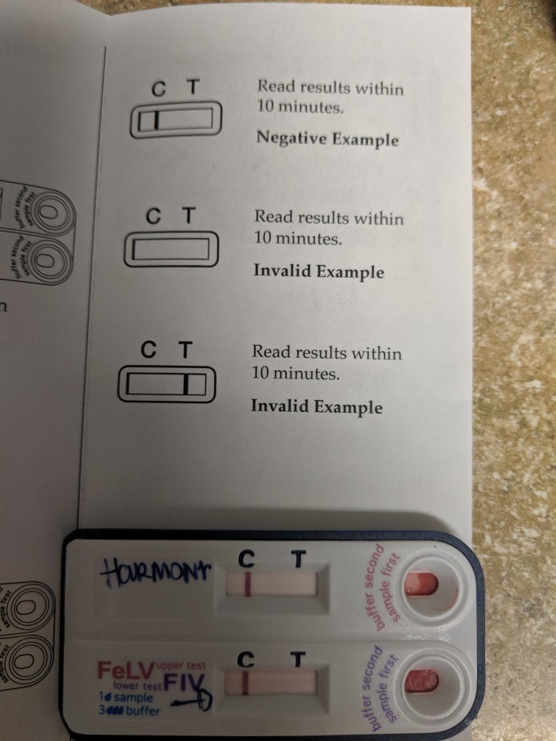

Please feel free to contact me with questions or concerns regarding Harmony.

Sincerely,

Ryan Reusch, DVM

