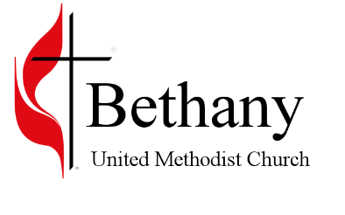
2415 Laveen St. / Latrobe, PA 15650 / 724-539-2259
www.bethanylatrobe.org

6/22/2020

Greetings All,

This letter is to inform you of Bethany’s Green Phase Guidelines for reopening the church. The copy that you have is based on CDC guidelines (which the Conference will strictly hold the churches to). You will find that some of the guidelines are restrictive, inconvenient, and are not normal, but these are not normal times. If we are going to try and open the church back up, we need to follow these guidelines. Please understand that Pastor Les, Pastor Corben, the Trustee chair, SPPRC chair, the Worship chair, and all the Administrative Council have had a chance to weigh in on these guidelines. At this time this is what we will have to follow to stay in compliance with the CDC and Conference.

As a Council we cannot stress enough the compliance to these guidelines for a safe and successful reopening. The wearing of masks seems to be a sticking point with some. I will be the first to tell you that I hate wearing a mask, as I am sure there are others that feel the same way, but it must be done. I myself cannot put my inconvenience ahead of the health of others. It would be selfish and inconsiderate on my part to not take into consideration those who have a problem with their immune system or other health issues. All of us want to see the church reopen, but it must be done with consideration for all.

Some of you may have seen the news about the five churches in West Virginia. Two weeks ago they decided to reopen and there is some concern that they did not follow the CDC reopening guidelines, now there are 79 people infected with the virus. God forbid that if this was to happen to us at Bethany, for we would most likely have to shut the church down again. Even though we plan on enforcing the guidelines, this is not going to be a confrontational action. We would hope and pray that all will remember where they are at and have consideration for others. With that being said, we would like to try and reopen the church sometime after the 4th of July. We will provide you with information on an opening date when that information becomes available. Until then read over the Guidelines, stay save and God bless.

Your brother in Christ and Worship Chair,
Keith Mathias

