SOUNDS OF THE WAVES
March 2021

Here we are again, The year is flying by and we have much to report on.

Well!!!! A huge surprise to everyone was hearing that our
Bowls Club had won this award. Did anyone know we were nominated???? It would have been nice if some of our Bowlers could have attended the night.

FROM THE PRESIDENT
The Committee have met and due to the resignation of Greg Burrows, have decided that John Leonard will assume the role of President and the Vice President position will remain vacant until the next election.
Message from John:
“As your new President as elected by the committee following Greg’s departure, I’m keen to continue the work that we have already started.
Receiving the Queensland best Bowls Club award was a welcome surprise and we should all be proud of being recognised with such an achievement but there is still much more to do and be assured your committee is focused on making our club and your bowls experience even better.
We ask for your support in what we do and look forward to your constructive comments and feedback”
Change to Greens – firstly the renumbering of the rinks on our No. 2 green to 1 – 7 and 8-14 on our No. 1 green.
Additionally the lines on both greens running East to West will be marked permanently following which, all roll-ups will be required to be played in that direction.
This will help with even wear and tear and the longevity of our greens.

DATES TO REMEMBER
Waves Fiesta 12th April 2021
Ladies District Singles 10 & 11 April at Coolum. Ladies Club Championship Singles 8th April
Men’s Club Championship Singles 10th April.

Entries are now open for this year’s Winter carnival. Online entries are available to all of the SCDMBA events, July 2nd to July 16th simply login into our website www.sunshinecoastmenslawnbowls.com.au<http://www.sunshinecoastmenslawnbowls.com.au> click onto the icon EVENTS then scroll down to ENTRY FORMS and then to WINTER CARNIVAL entries, this will open up the entry form for you, enter your name, address, phone & email details then enter each event you wish to play in. Should you wish to enter more than 1 team into an event press add entry and another entry line will open up for you. Once you’ve nominated the events you wish to play in scroll down to the bottom and click onto the box CONFIRM AMOUNT, this will tell you the cost of your entries, next you indicate which payment option you are going to use, either paying on the day ,by cheque or by direct deposit. Once you’ve completed the entry press SEND, a confirmation message will be displayed. You will then receive a confirmation email within 24 hours.
If you have any questions you can call me on the number below or email me at bowlsdev@coolumbeachbowls.com.au<mailto:bowlsdev@coolumbeachbowls.com.au>
Please feel free to share the Booklet File with any of your Bowling Friends.
Regards Tim Phillips
SCDMBA Winter Carnival Marketing Director
0419 277 203
For a Laugh
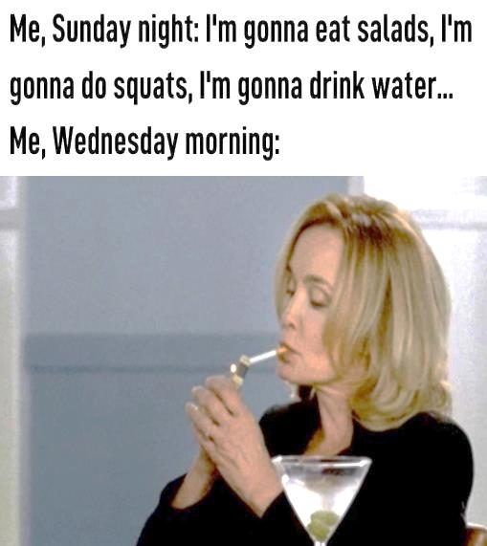

PROFILE OF THE MONTH

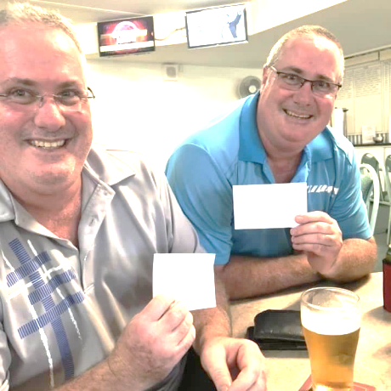
Our story this month is about the only twins we have playing for our club, Scott (the oldest) and Craig McKenzie.
Born in Sydney they moved around quite a bit growing up as their parents were camp site managers (Father a Chef and Mother a Jack of all Trades) in various towns in Queensland. From Bundaberg, Mt Isa, Weipa, and Ingham where they attended boarding school in years 11 and 12.
Both married, with 2 children each. Scott and his wife Shannon have 2 boys Tyler 18 and Josh 21, while Craig and his wife Lisa have a son Samuel 23 and a daughter Hayley 22.
They both have a love of sport and played cricket and soccer. They also enjoyed swimming.
In 1997 Craig joined the Navy for 4 years while Scott worked for Private Enterprise. Both men still work full time which of course limits their time on the green.
Both keen golfers, they transferred their interest to Lawn Bowls Christmas 2016 because of illness. Keen competitors they have been finalists in Pairs, Triples and Fours.
Since joining they have introduced Shannon’s Mum Karen to play and is now a popular member of our ladies Club. Also Josh is showing potential of becoming a star on the green.
Quotes from the twins. “I remember when we were at primary school. We ditched school this one day, anyway, mum had driven past us and waved and said have a good day boys and we thought bloody hell what’s wrong with her she didn’t realise until she had gotten home that we were supposed to be at school she wasn’t happy!
Also we on holidays at South Molle Island, the 3 of us hired one of those water tricycles and we ended up getting swept out to sea. Bloody hell the 3 of us were panicking big time. We tried and tried to pedal the stupid thing back to shore but it wasn’t happening. Thank God Mum and dad finally couldn’t see us anymore and we were rescued! It wasn’t funny at time but when we look back it was stupid things like that we did. It was just boys being boys I suppose. Also when we were up in Weipa we got drunk for the first time we were probably 15 and our younger brother would have been 12 and our parents were at another party, so we rode our bikes over there drunk to ask if we could stay the night. We fell off our bikes a few times. By the time we had got there anyway they said yes (just so we would go I think and didn’t embarrass them anymore). We were all sick through the night and had spewed all over our clothes so we borrowed our mates footy shorts to go home, we had no shirts and when we got there, as punishment, Mum had made us scrambled eggs which we didn’t want but she made sure we would remember how we felt that morning hoping we would never drink again! Well, we now know that didn’t work.” Scott and Craig, we’re all very happy that you have chosen to be a part of our great Club.

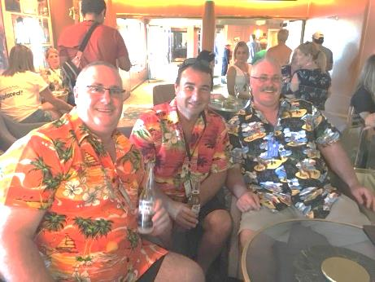
SUNDAY ROLLERS
A weekend in Harvey Bay was undertaken by our Sunday Rollers. Apparently what goes on in Harvey Bay stays in Harvey Bay.

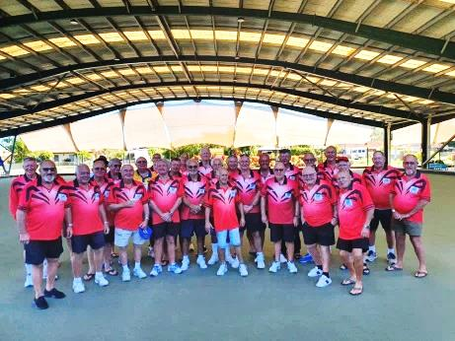
Under the cover at Urangan

THE CLAYTONS NEW ZEALAND TOUR
All dressed up and nowhere to go. These boys were all excited about their NZ trip but unfortunately Covid struck
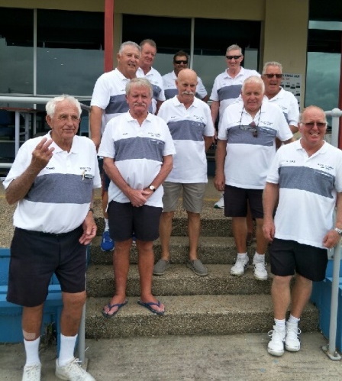

MIXED PAIRS
The mixed Pairs final was contested between Des and Margie Shaw and Ray and Marie Williams with the latter being successful. Congratulations Ray and Marie. Well played by all.
Marie informed me that they have won the mixed pairs at the 3 clubs they have played at.

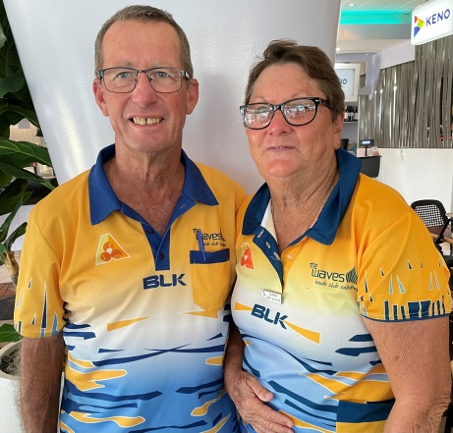

MIXED FOURS
The final of the Mixed fours is scheduled to be played between Des Shaw’s team and Brian Green’s team. Due to inclement weather the games were interrupted and unfortunately couldn’t be completed on the due date.
Good luck to all in the final.

Two of our favourite ladies, June Cooper and Dawn Young at Woombye.

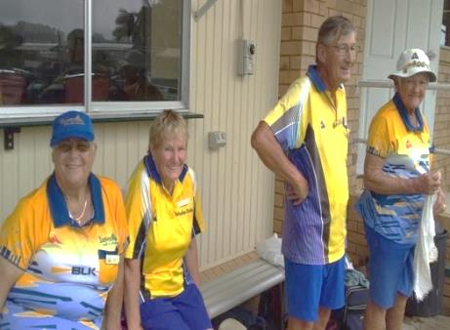

LADIES PAIRS
Rain didn’t deter our ladies
from playing in the pairs. Our Pairs champions 2021 are Elaine Knights and Neeta Chant defeating Daphne Daley and Mary Kelly. Congratulations to our winners and all who participated.
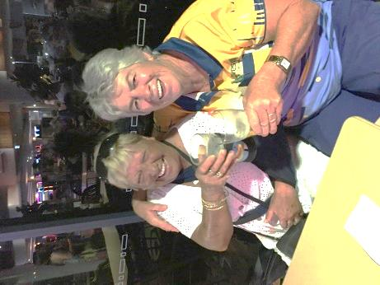
GREAT 8S
Our Division 5 Men’s team and our Division 1 and 3 Ladies teams were successful in making the finals in 2021 Great 8s challenge.
The final results unfortunately didn’t favour us as our teams were all defeated in the semi-finals. Our Division 1 ladies went down by 1 shot. Our Division 3 ladies won their quarter final against a strong Albert team and then lost to Bribie.
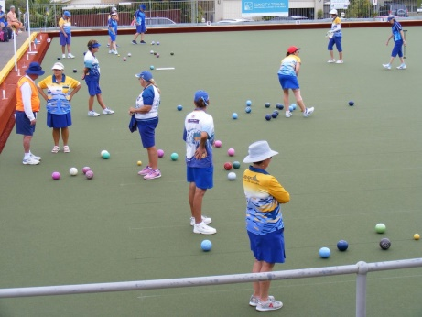
Division 3 on the green.

Financially we covered the cost of entering the teams with our winnings. Our Division 5 Men were our highest winners.
I’m sure with a little more experience and more of our top players available, next year we will go one better. Great work everyone.

Girls just wanna have fun! 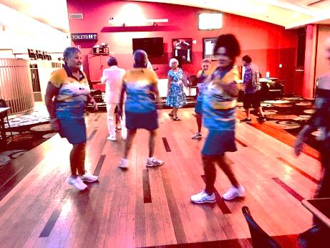Johno & Lainie Boogie fever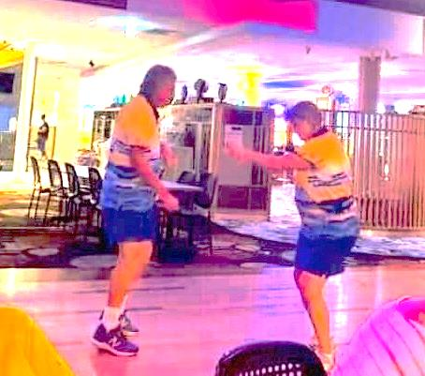Teach us your moves Pete!.
Katrina celebrating Waves style
SICK MEMBERS

As you have probably noticed, Elaine had a fall, resulting in a dislocated shoulder and a chipped bone. The only thing that worried her was quote: “I was sober at the time” We hope you’re back in action really soon Elaine. Yours truly is still out of action recovering from knee surgery. Climbing the walls. Grrrrrrr!!!
Jan Davidson and Judy Holmes are still waiting for surgery although Jan looks like being In Hospital very soon.
CAUGHT ON THE GREEN SCREEN
Had to laugh at the name of the skip in the NSW Champion of Champion pairs. Nickname is “SQUID” Apparently his parents had a sense of humour all those years ago.
CALOUNDRA STARS
Might have to get a bib for someone Kay?
Every week we have a lunch at a different venue. Lots of fun and stories told. Everyone is welcome.
This month we visited Golden Beach Tavern CBX and Waves Caloundra. We intend to visit Maroochy Surf Club after Easter.

THE BUDDY SYSTEM
Some of our new members seem to be at a loss as to where to find out information as to what’s happening and where to find information about the running of our club. I would like to suggest that any member who has this knowledge be assigned to every new member to help establish them in the club.
Any suggestions would be appreciated.

NEW MEMBERS
Ian Borkett
iborkett1@yahoo.com
Joe Robinson
bundyjoerobbo@gmail.com
John Annakin
silversp@bigpond.net.au

Thank you Alan Johnson for providing this information.

THOUGHTS

For lovers of Pinot

To our sponsors, a heartfelt thank you for your support
(GARDEN FINANCIAL SERVICES
SUNCITY TRAVEL
REVOLUTION AUTOCARE
AAA SOFT FURNISHINGS
ACTIVE LIFE REHABILATION
WHITE LADY FUNERALS
NORTHCOAST SEAMLESS FLOORS)

The miracles of Easter. .

As we are in another Covid situation in Queensland, let’s try to remember the reason for the season this Easter.

