Bishop Andrew Daubon Biography
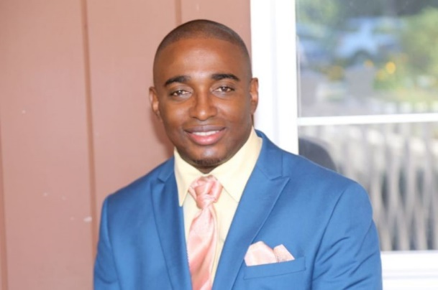
Bishop Andrew Daubon was born in Kingston Jamaica, grew up in Clarendon and attended the Edwin Allen High School.

Not long after he graduated high school he returned to Kingston and joined the Escarpment Road New Testament Church Of God, where he served as assistant, and then as youth director. He also served on the Eastwood Park District Youth Board. He worked as a Science teacher and head of the Science Department of the Windward Road Junior High, Kingston Jamaica.

Upon migrating to the US in 1999, Bishop Daubon and his wife served as Youth Pastors at the King's Chapel C.O.G. in Hartford CT for several years. In his secular employ, he was the first person of color to serve as a manager of the biggest employer FAVARH, in Canton CT, an agency serving individuals with developmental disabilities. He worked there for over nine years. He worked briefly at the State Of Connecticut’s Cedarcrest Mental Health Hospital before accepting the position of senior pastor of Celestial Praise C.O.G.

Bishop Daubon is a graduate of the Mico University College in Jamaica, the University of Hartford and was valedictorian for his Church of God MIP (Ministerial Internship Program) class. He is currently enrolled in the Masters of Arts in Counseling at Pentecostal Theological Seminary.

Bishop Daubon is an Ordained Bishop with the Church Of God. He is a member of SNE COG Regional Executive Council and is the District Overseer for the Springfield District of churches. He currently serves as the Vice President of the Greater Springfield Pastors’ Council.

He is author of the book “Marriage A Loveseat for Two” and with his wife, has been conducting marriage enrichment events in the US, Canada and Jamaica. They also provide premarital and marital coaching in the US and oversees, and currently make monthly appearances on NBC’s channel 22 Mass Appeal TV show in Western MA to speak on relationship matters.

Bishop Daubon is married to the “Eighth Wonder of the World,” Michaelia, who partners with him in ministry as the pastors of the Celestial Praise Church of God, Springfield MA since August 2010. They have two beautiful daughters, Anthia and Maliha. Under their leadership, Celestial Praise is in the process of coming out of over $2.6 million in debt, added over 50 new members, has almost doubled and redone the parking, and has made key updates to the building inside and out.

As one who was once told by a teacher that he would never be able to speak proper English, he has experienced that “with God all things are possible, to them that believe and are called according to His purpose”.

