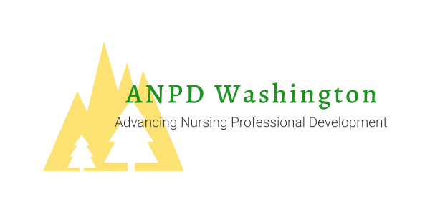
Micro Learning
Presented by Marta DeVolt, MN, RN-BC, RNC-OB
Tuesday, November 19th, 2019 at 12:00 PST
Webinar Series Provided by ANPD WA, an affiliate of ANPD
Marta DeVolt is a Program Manager for the transition into practice programs at the system level for the Providence St Joseph Health System Clinical Academy. Her specialties include perinatal, neonatal, and NPD fellowship. She is certified in both nursing professional development and inpatient obstetrics and she has been active in the ANPD and obstetric communities through local and national presentations. Her professional background includes obstetric nursing, professional development, and simulation development and facilitation. Marta lives in North Bend, WA with her husband (who is also a nurse), her three young children, and her chinchilla! When she is not working and caring for her family, she enjoys reading, knitting or sewing, and spending time outside.
Target audience: NPD practitioners, RNs interested in NPD specialty, nursing leaders
Learning Objectives:
- Differentiate between use of micro-learning in just-in-time learning and within a larger “learning campaign”
- Identify appropriate scenarios for using micro learning as an educational approach
- Begin to create a micro learning experience for just-in-time training
- Begin to create a micro learning experience for a “learning campaign”
- Identify ways to make the case for micro learning as a learning approach

Contact Hours: Provider approved by the California Board of Registered Nursing, Provider Number 16541 for 1.0 Contact Hours (pending).
None of the instructors, planners, or faculty/content specialists has any conflict of interest or will be discussing any off-label product use. This class has no commercial support or sponsorship, nor is it co-sponsored.
Successful Completion: View webinar in its entirety, complete online evaluation.
For more info and to Join ANPD WA, visit https://www.anpdwa.org/

